Cultural Tourism Accelerator
FAQs

Is this the same as the RAF?
No. It is delivered through the RAF structures, but this is a new and unique program, aimed at increasing visitation to existing arts and cultural venues, events and programs.
This is not a fund for new projects.

What is “visitation” in this context?
Physical attendance by someone whose postcode is different from that of the project location they are visiting.

Does it include digital attendance?
No, it only includes physical attendance at a venue, event or program location.

Can individuals apply?
Individuals are eligible to apply, but we suggest a stronger application would be made by partnering with an organisation or a business.

Who can apply?
Individuals, Australian Incorporated Associations and Local Government organisations that are located in MM2-MM7.

What is MM2 – MM7?
MM stands for Monash Model, it is an Australian Government regional classification system that is used by the Regional Arts Fund to determine eligibility.
To find out if your location is eligible:
- Go to https://www.health.gov.au/resources/apps-and-tools/health-workforce-locator/health-workforce-locator
- Click on Modified Monash Model 2019
- Enter your address in the “find address” button
- Click ‘search location’ and you MM classification will be shown
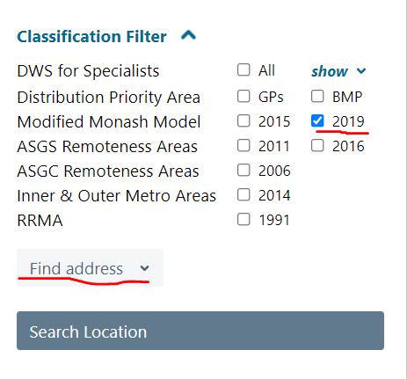

Can small business/private business apply?
No, but we encourage businesses to partner with individual artists or arts organisations who can apply. Small business and private business project partners are greatly encouraged.

What grants are available?
There are Campaign grants and Initiative grants:
- Flash Marketing Campaign $2,500 – watch video explainer
- Targeted Marketing Campaign $10,000 – watch video explainer
- Experience Initiative $10,000 – watch video explainer
- Partnership Initiative $15,000 – watch video explainer

Can I apply for all four?
No, you can apply (and be successful) for one Campaign and one Initiative, but not to cover the same costs – the projects must be different.

Do I have to have an existing project/venue/event?
Yes, this is an accelerator program, designed to value-add to existing venues, projects, events, and festivals. The application form will ask for details of your existing program/venue/event.

How long have I got to spend the funds?
All funds must be spent and acquittal complete by 31 October 2022. Your existing project/event or venue might be continuing on after this date, but the Campaign or Initiative MUST be complete by 31 October 2022.

Does my Campaign have to have an arts and cultural outcome?
Yes, this is a cultural tourism program. Your outcome must be linked to a creative, cultural or artistic program, venue or event.

How do I apply?
Through your local RAF Regional Program Administrator:
NSW: Regional Arts NSW
NT: Darwin Community Arts / NT RAF
Qld: Flying Arts Alliance
SA: Country Arts SA
Tas.: RANT Arts Ltd
Vic.: Regional Arts Victoria
WA: Regional Arts WA

Can I apply for a project that has no confirmed funding?
No. This program is for existing project, events, venues and programs. You must have at least some confirmed funding or resources and already be planning to deliver something.

Can I apply for marketing costs through other funding sources?
Yes, this program aims very specifically to increase visitation through a campaign or initiative. Other general marketing costs can be covered by other funding sources. Your application may be cross checked with other Australian Government programs such as Festivals Australia, Playing Australia, Indigenous Languages and Arts, RISE and Australia Council funding programs.

