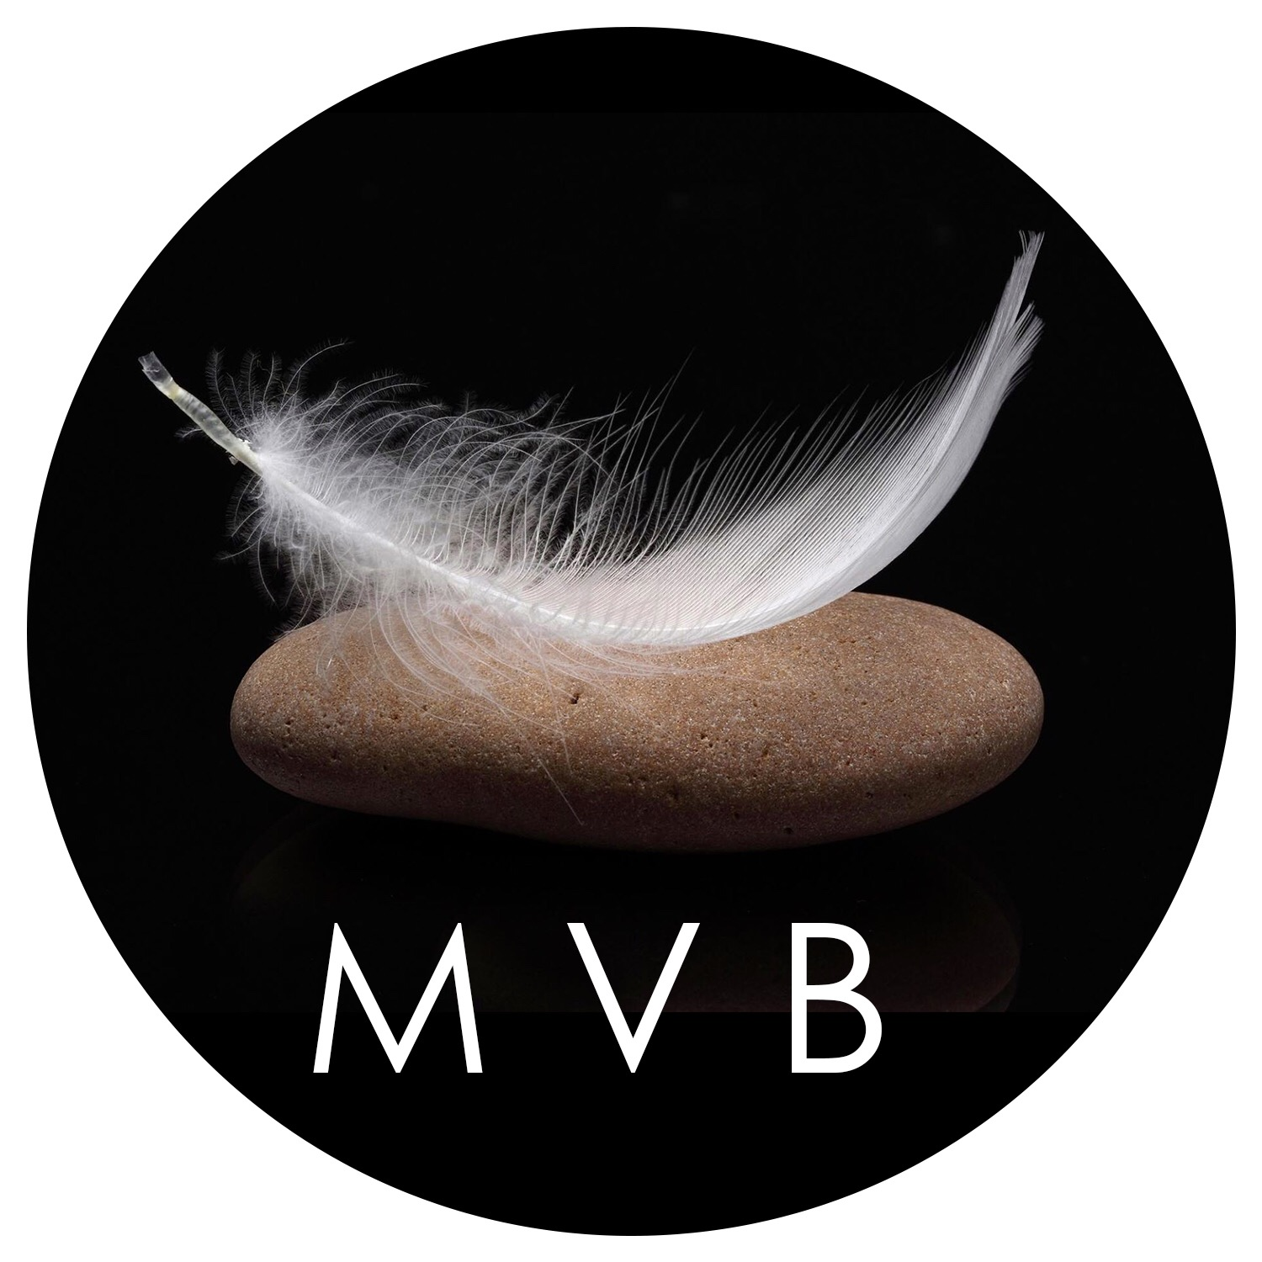
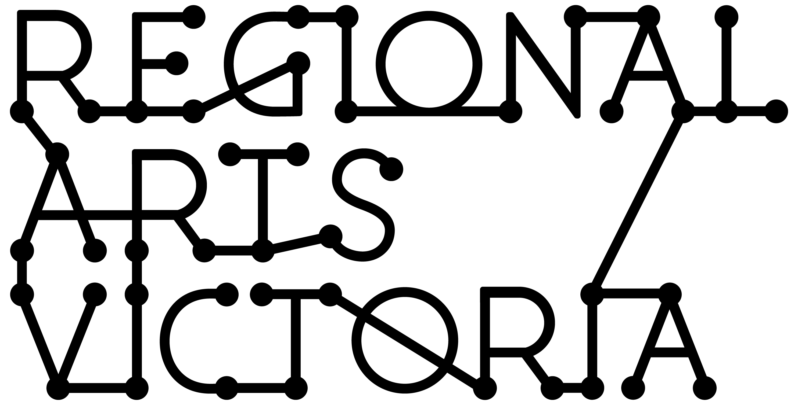
“My vessels and figures espouse that all life comes from a vessel which has held and nurtured the gestating form from conception to emergence – be it an egg, a cocoon, a uterus, a bud, a seedpod, a shell - the reality is Universal”
Meg Viney-Bell
Meg Viney-Bell Fibre Art Fellowship
GUIDANCE MATERIAL

2019

Contents

This guidance material outlines the objectives and eligibility criteria for the Meg Viney-Bell Fibre Art Fellowship, delivered in 2019 by Regional Arts Victoria.

This information is available in a standard PDF version, and an accessible word version. If you require further assistance accessing the Guidelines please contact us on (03) 9644 1800 or email grants@rav.net.au.

Introduction: What is the Meg Viney-Bell Fibre Art Fellowship? 2
What are the objectives of the Meg Viney-Bell Fibre Art Fellowship? 2
Who Can Apply? 2
Who is not eligible? 3
Relevant Dates 3
How to apply. 3
Apply Online via SmartyGrants. 3
Assessment process and criteria. 3
Support Material: Letters, CVs and examples of previous work. 4
Privacy. 4
If you are successful. 5

Introduction: What is the Meg Viney-Bell Fibre Art Fellowship?

Meg Viney- Bell is a fibre artist living in Gippsland. From 1971 to 1978 Meg did a Bachelor of Fine Arts at Fiberworks (affiliated with San Francisco University). The teachers she had were all graduate students of the Department of Textiles run by Ed Rossbach, the so-called father of Textiles in the United States. They were all brilliant - Meg felt privileged to be a student of theirs, and was cognizant of this during those years.
Upon return to Australia in 1983 she felt this privilege even more acutely, given that fibre arts were undeveloped here, and knew that, in some way, she needed to express my gratitude.
Through her teaching years Meg gave to her students all she could. Her teaching philosophy has always been that 'students are not vessels to be filled, but candles to be lit'. Seeing the faces of young students when they recognize the 'I can, I understand, and now I can create' is pure joy for Meg.
However, as the years have passed she has thought about what more she could do. Recently Universities and Colleges have phased out Textile/Fibre Art studies, and this presented her with an opportunity to realize how she can make a contribution. Meg conceived the idea of a Fibre Art Fellowship as a means by which Fibre Arts can have a resurgence - one that could benefit many artists and the community in general.

What are the objectives of the Meg Viney-Bell Fibre Art Fellowship?

The Meg Viney- Bell Fibre Art Fellowship has been developed to nurture a resurgence of the traditional fibre arts. Fibre arts in the context of this fellowship is defined as materials consisting of natural fibres. The focus of the fellowship will be on the materials and the manual labor of the artist and prioritises aesthetic value over utility. Work resulting from the Meg Viney-Bell Fellowship must emanate from a personal concept and be expressed creatively.

The objectives of the fellowship are to:

- Increase the opportunity for artists to grow their practice in fibre arts
- To provide opportunities to learn from mentors or teachers of their choice
- To allow fibre artists to explore their work and develop new skills.

Who Can Apply?

Individuals who are 18 years and over can apply to the Meg Viney-Bell Fibre Art Fellowship if they:

- have a primary place of residence in Wellington, South Gippsland, Bass Coast, East Gippsland, Latrobe or Baw Baw shire at the time of application and for the duration of the fellowship.
- have a minimum of 2 years’ experience in fibre arts
- are willing to abide with all of the conditions of application

Who is not eligible?

- Applicants who are not fibre artists
- Applicants who do not have a primary residence in the specified Gippsland shire areas
- Applicants under 18 years of age
- Applicants who have been or are on a current Meg Viney-Bell Fellowship assessment panel
- Applicants who are employed by Wellington Shire Council or Regional Arts Victoria.

Relevant Dates

Applicants are limited to one Meg Viney-Bell Fellowship in a lifetime. If the fund continues into the future, successful applicants will not be eligible to reapply. Funding is offered for the period 1 January 2020 – 31 December 2020.

Opening Date 9:00am, Thursday 1 August 2019
Closing Date 5:00pm, Wednesday 30 October 2019

Please note: The Fellowship will finish on 31 December 2020.

How to apply.

Apply Online via SmartyGrants.

All applications are to be submitted online using the SmartyGrants system.

All applicants must contact Tim Dakin, Creative Arts Facilitator prior to applying. tdakin@rav.net.au
Ph: 0428 403 386
Links to the forms can be found on our website: rav.net.au

Assessment process and criteria.

Fellowships are assessed by Meg Viney-Bell, delegates from Regional Arts Victoria and the Gippsland Arts Gallery (Sale). An independent artist may also be invited onto the panel.

Applicants who are shortlisted will be contacted on the Tuesday 19 November. They must be available for an interview on Wednesday 20 November 2019. This may be via video link or phone if necessary.

All applications will need to address the following:
- What is your concept and how will you benefit from this fellowship?
- What is your envisaged outcome?
- How could this outcome impact the art community and how could it benefit the community/ public in general?
- Evidence of experience via provision of an artist biography, artistic statement on current works and images of current fibre art works created over the past 2 years that demonstrates the calibre of your work.
- Provision of a proposed time line/schedule for the full year of the fellowship.
- Provision of a proposed budget that outlines how the funding will be spent.
- Provision of evidence of acceptance or an offer into a residency a learning experience, placement, mentoring etc in Australia and overseas if this is what is planned for the fellowship.
- Provision of letters of support.
- Your willingness to produce diary documentation of your working process. For example a traditional visual diary or an online blog etc.
- Willingness to negotiate a workshop, exhibition or talk in their chosen regional community.
- Willingness to undergo monthly mentoring with Meg Viney-Bell. This could be via Skype, Facetime, phone and or in person.
- Your willingness to have a public outcome to be negotiated and applied for via the Gippsland Art Gallery (Sale) during or after the fellowship. This could take the form of an exhibition, workshop or artist talk and will be via curatorial process (application required including CV, exhibition brief and images).

NOTE: If an exhibition occurs at the Gippsland Art Gallery (Sale) one artwork from the exhibition will be donated to the Gippsland Art Gallery pending approval from the gallery staff and advisory committee. The work will be chosen by the Gippsland Art Gallery Director in consultation with the artist. No payment will be required from the artist to the gallery and no artist fee will be paid from the gallery to the artist.

Support Material: Letters, and examples of previous work.

Applicants must supply their CVs which cannot exceed more than two pages. CVs must demonstrate your work in relation to this fellowship. Other support material can be uploaded to online applications. You will only be able to upload:

- One support letter from each of your referees. These could be from former mentors, Gallery Directors etc but should verify your commitment to your work. Maximum of five
- Maximum of five extra written material documents (must not exceed more than five pages each)
- Maximum of five photographs and images such as art works or examples of past projects
- Maximum of five direct links of website, social media, audio, images or video (no greater than three minutes in length per video)
- Video support statement

Support material gives you the chance to provide evidence with regards to your application.
Fellowships will require support material and letters that provide evidence of experience, commitment to your work and significance of your practice as an artist in the community.

Privacy.

Regional Arts Victoria values applicants’ privacy. For details on how we collect, store and use information, applicants should review our Privacy Policy at rav.net.au or contact us at enquiry@rav.net.au or call (03) 9644 1800 for a copy.

This information may be used for promotion and reporting purposes. The Directors of Regional Arts Victoria and their representatives may also use this information to conduct research so that we may better understand community needs and can improve service delivery.

When submitting an application to the Meg Viney-Bell Fellowship, you will be providing permission for this personal information to be used in this way.

If you are successful.
Notification of the outcome will be during the week of the 25 November, 2019.

Successful applicants will be sent a contract and information about invoicing and reporting on the project.

Funds will be provided once Regional Arts Victoria receives an invoice with a valid ABN. If you do not have an ABN you will be required to engage in an agreement with an auspice organisation who will manage the funds on your behalf.

After the project an acquittal will need to be submitted 3 months after the project’s end date.

Information about what will be required should an application be successful is available on our website: rav.net.au/funding-opportunities/meg-viney-bell-fellowship

