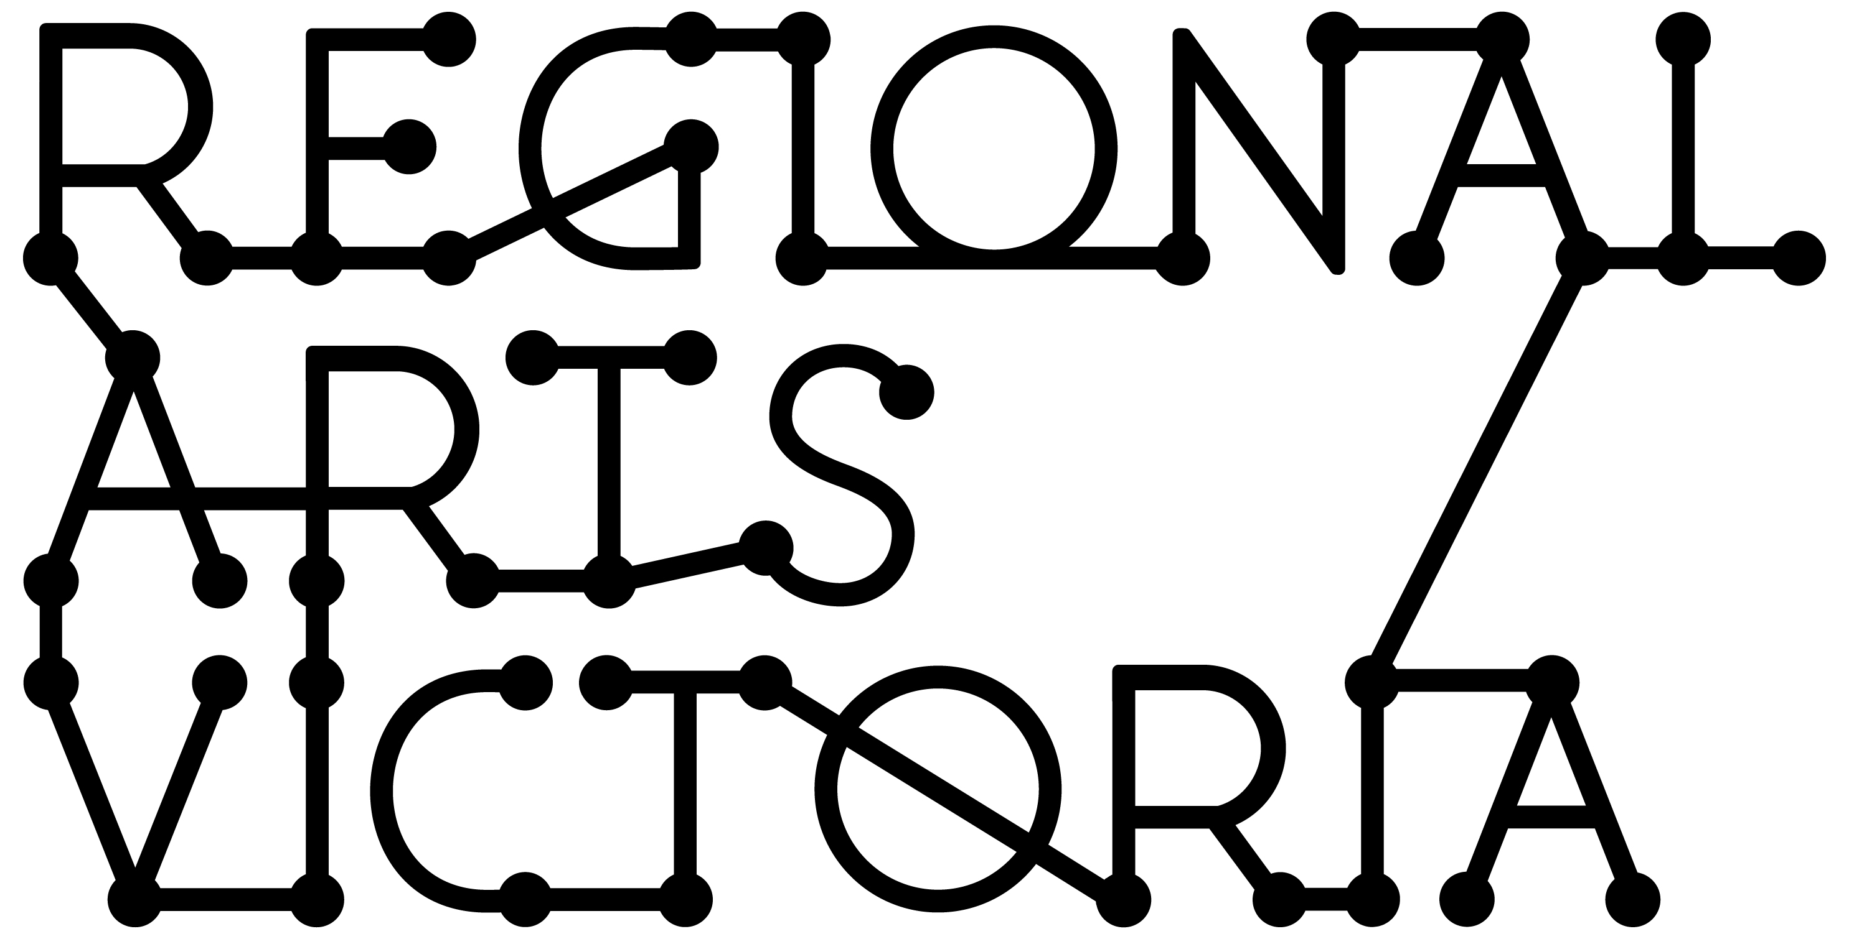

SUBMISSION GUIDELINES
Connecting Places Program
Expressions of Interest for 2023 Touring

The Connecting Places program is seeking a limited number of companies to be part of the 2023 program. Expressions of interest for artists/producers to apply to be part of the 2023 program Open 3pm Wednesday 30 March 2022
Close 3pm Tuesday 3 May 2022

Regional Arts Victoria’s Connecting Places program delivers high quality performing arts experiences to community-run venues across the state. The Connecting Places program is designed to support touring to small halls, libraries and other multi-purpose spaces in regional areas.

If selected for the program, Regional Arts Victoria will endeavor to coordinate a viable tour by on-selling your project to our network of community presenters.

Please note: Equity and diversity across our touring programs is a priority of Regional Arts Victoria. Expressions of Interest from First Nations, Culturally & Linguistically Diverse and/or regionally based artists/companies are welcomed. Please contact Regional Arts Victoria for more information.

Connecting Places Selection Criteria:
- The project is innovative, high-quality and entertaining
- Preferred Artforms: Theatre, music, cabaret, comedy, live performances for children/families including circus, puppetry and/or dance, performance projects with community engagement components
- The project is ‘tour ready’: has already had at least one season and is relatively easy to remount
- The project is affordable: maximum per show fee of $3,500 and maximum touring party of four people. Refer to Live Performance Award guidelines for recommended artist fees
- The project is relevant to regional communities
- The company has included quality marketing materials in their application
- The company’s technical requirements are adaptable to a variety of performance spaces with limited technical provision from the venue
- The project is able to bump in and perform on the same day
- The company understands the context of working with volunteer community groups who aim to connect with and enrich their regional communities through the arts
- The touring party is available for two to four weeks between April and November 2023
- Across our program, the range of projects selected reflect Regional Arts Victoria’s equity and diversity goals
Visit Regional Arts Victoria’s website for the works included in the current Connecting Places program.

APPLICATION PROCESS

To ensure the project is suitable for this touring program, and aligns with the selection criteria above, applicants are strongly encouraged to contact us prior to commencing the EOI to discuss their project’s suitability to the program. 15 minute phone appointments to discuss your application are available throughout the EOI open dates can be made here.

Expressions of Interest are to be submitted via an online form. We recommend you download the Drafting Tool to prepare your responses prior to starting your online application. This tool also offers further guidance on how to respond to each section.

You can also download the Budget Drafting Tool to support you to create a budget outlining your Artist Fees.

Incomplete EOI's will not be eligible and cannot be assessed.

If you have access requirements and would like the option to submit your EOI in a different format, please be in touch directly with Bindi Green so we can support you to make your application.

If your work is specifically intended for children, please submit your application via our Arts & Education EOI process, which is the portal for works for this audience, and indicate in your form that you would like to be considered for both programs. The Arts & Education program caters specifically to primary and secondary age audiences, and EOIs will open in the coming weeks. Productions selected through this process are available to the Connecting Places network of presenters, as well as schools. Please sign up to our E News to be advised when this opens.

If you are unsure which touring program is the best fit for your production, applicants are strongly encouraged to also contact Pippin Davies, Senior Manager, Arts & Education (pdavies@rav.net.au) prior to commencing your EOI to discuss your project’s suitability.

IMPORTANT DATES
Wednesday 30 March 2022 – 3pm | Expressions of Interest Open | Link to Expression of Interest form
Thursday 7 April 2022  12pm – 1pm  Tuesday 3 May 2022  3pm | Online Webinar  Expressions of Interest  Close | Introduction to the Connecting Places program and talk through the EOI application. Register via the website  Late submissions will not be accepted
Late May 2022 | Shortlisting Process | All applicants will be notified at the end of the shortlisting process
August 2022 | 2023 Program Launched | Program launched

Prior to applying to Connecting Places 2023 Program, please contact us for information and support:

Book in for a 15min phone appointment via our website.

Bindi Green
Connecting Places Manager
bgreen@rav.net.au
The following is a list of information/materials you will be asked to provide as part of your Expression of Interest:

COMPANY INFORMATION
- Company Information
- Producer Contact Details

PROJECT INFORMATION
- Project type & artform
- Project description
- Community engagement activities (if applicable)
- Creative team
- Equity & diversity
- Presentation & touring history

TOURING PARTY INFORMATION
- Size of touring party
- Availability
- Transport requirements

FEES & ROYALTIES
- Per performance fee
- Royalties (if applicable)
- Music licensing obligations (if applicable)

MARKETING INFORMATION
- Tagline
- Short & long show synopsis
- Key themes
- Age range
- Warnings
- Target audiences
- Reviewer & audience quotes
*If you would like to discuss the marketing material required, please contact Adam Fawcett, Programing Communications Coordinator at afawcett@rav.net.au to arrange a time to chat.

MARKETING LINKS
- Hero images
- Other images
- Promo video
- Other video
- Logos & acknowledgements
- Creative team biographies

TECHNICAL SPECIFICATIONS
- Bump In, Performance and Bump Out durations
- Theatre formats & staging requirements
- Lighting, audio & AV requirements
- Set & transport requirements

SUPPORT MATERIALS (optional)
- Relevant licences, letters of support, project documentation such as workshop descriptions, technical plans and specifications

