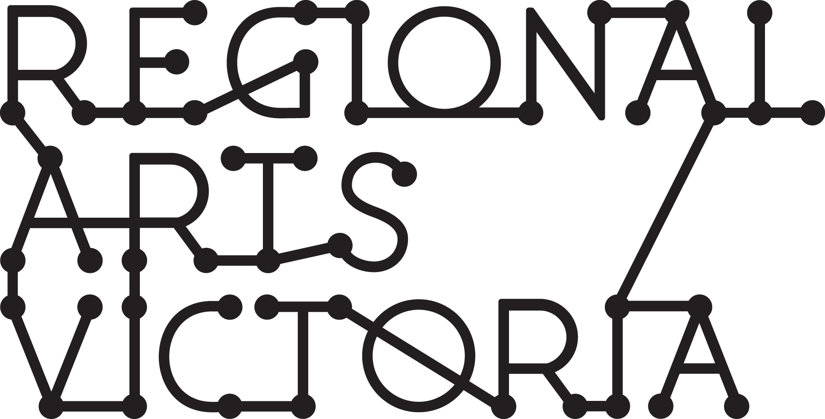

SUBMISSION GUIDELINES
Connecting Places Program
Expressions of Interest for 2022 Touring

Regional Arts Victoria’s Connecting Places program delivers high quality performing arts experiences to community-run venues across the state. The Connecting Places program is designed to support touring to small halls, libraries and other multi-purpose spaces in regional areas.

If selected for the program, Regional Arts Victoria will endeavor to coordinate a viable tour by on-selling your project to our network of community presenters. Read more about this program on our website.

The Connecting Places program is seeking a limited number (2-3) of companies to be part of the 2022 program. Expressions of interest for artists/producers to apply to be part of the 2022 program open from Tuesday 27 April 2021 – 12 pm Tuesday 25 May 2021.

Please note: Equity and diversity across our touring programs is a priority of Regional Arts Victoria. Expressions of Interest from First Nations, Culturally & Linguistically Diverse and/or regionally based artists/companies will be prioritised. Please contact Regional Arts Victoria for more information.

Connecting Places Selection Criteria:
- The project is innovative, high-quality and entertaining
- Preferred Artforms: Theatre, music, cabaret, comedy, live performances for children/families including circus, puppetry and/or dance, performance projects with community engagement components
- The project is ‘tour ready’: has already had at least one season and is relatively easy to remount
- The project is affordable: maximum per show fee of $4,000 and maximum touring party of five people. Refer to Live Performance Award guidelines for recommended artist fees
- The project is relevant to regional communities
- The company has included quality marketing materials in their application
- The company’s technical requirements are adaptable to a variety of performance spaces with limited technical provision from the venue
- The project is able to bump in and perform on the same day
- The company understands the context of working with volunteer community groups who aim to connect with and enrich their regional communities through the arts
- The touring party is available for two to four weeks between April and November 2022
- Across our program, the range of projects selected reflect Regional Arts Victoria’s equity and diversity goals
Visit Regional Arts Victoria’s website for the works included in the current Connecting Places program.

APPLICATION PROCESS

Applicants are strongly encouraged to contact us prior to commencing the EOI to discuss their project’s suitability to the program.

Anna Kennedy
Connecting Places Manager
akennedy@rav.net.au | 0431 376 678

Expressions of Interest are to be submitted via an online form.

If you have access requirements and would like the option to submit your EOI in a different format, please get in touch.

If you feel like your project is relevant to the Arts & Education program as well as Connecting Places, please only submit one application to Arts & Education and indicate in your form that you would like to be considered for both programs.

While eligible applicants are welcome to apply to both programs, selected projects will only be toured via the most appropriate of the two programs. Applicants wishing to be considered for both programs are strongly encouraged to contact the Senior Manager, Arts & Education prior to commencing the EOI to discuss their project’s suitability.

Pippin Davies
Senior Manager, Arts & Education
pdavies@rav.net.au | 0427 211 123

Incomplete EOI's will not be eligible and cannot be assessed.

The following is a list of information/materials you will be asked to provide as part of your Expression of Interest:

PROJECT & COMPANY INFORMATION
- Company & Producer Contact Details
- Project type & artform
- Project description
- Community engagement activities (if applicable)
- Creative team
- Equity & diversity
- Presentation & touring history

TOURING PARTY INFORMATION
- Size of touring party
- Availability

FEES & ROYALTIES
- Per performance fee
- Royalties (if applicable)
- Music licensing obligations (if applicable)

MARKETING INFORMATION
- Tagline
- Short & long show synopsis
- Key themes
- Age range
- Warnings
- Target audiences
- Reviewer & audience quotes
*If you would like to discuss the marketing material required, please contact Adam Fawcett, Programing Communications Coordinator at afawcett@rav.net.au to arrange a time to chat.

MARKETING LINKS
- Hero images
- Other images
- Promo video
- Other video
- Logos & acknowledgements
- Creative team biographies

TECHNICAL SPECIFICATIONS
- Bump In, Performance and Bump Out durations
- Theatre formats & staging requirements
- Lighting, audio & AV requirements
- Set & transport requirements

SUPPORT MATERIALS
- Public Liability Insurance

IMPORTANT DATES
Tuesday 27 April 2021 | Expressions of Interest Open | Link to Expression of Interest form available on the website.
Tuesday 25 May 2021 12pm | Expressions of Interest Close | Late submissions will not be accepted
April 2021 | Shortlisting Process | All applicants will be notified at the end of the shortlisting process
August 2021 | 2022 Program Launched | Program launched

Prior to applying to Connecting Places 2022 Program, please contact us for information and support:

Anna Kennedy
Connecting Places Manager
akennedy@rav.net.au | 0431 376 678

