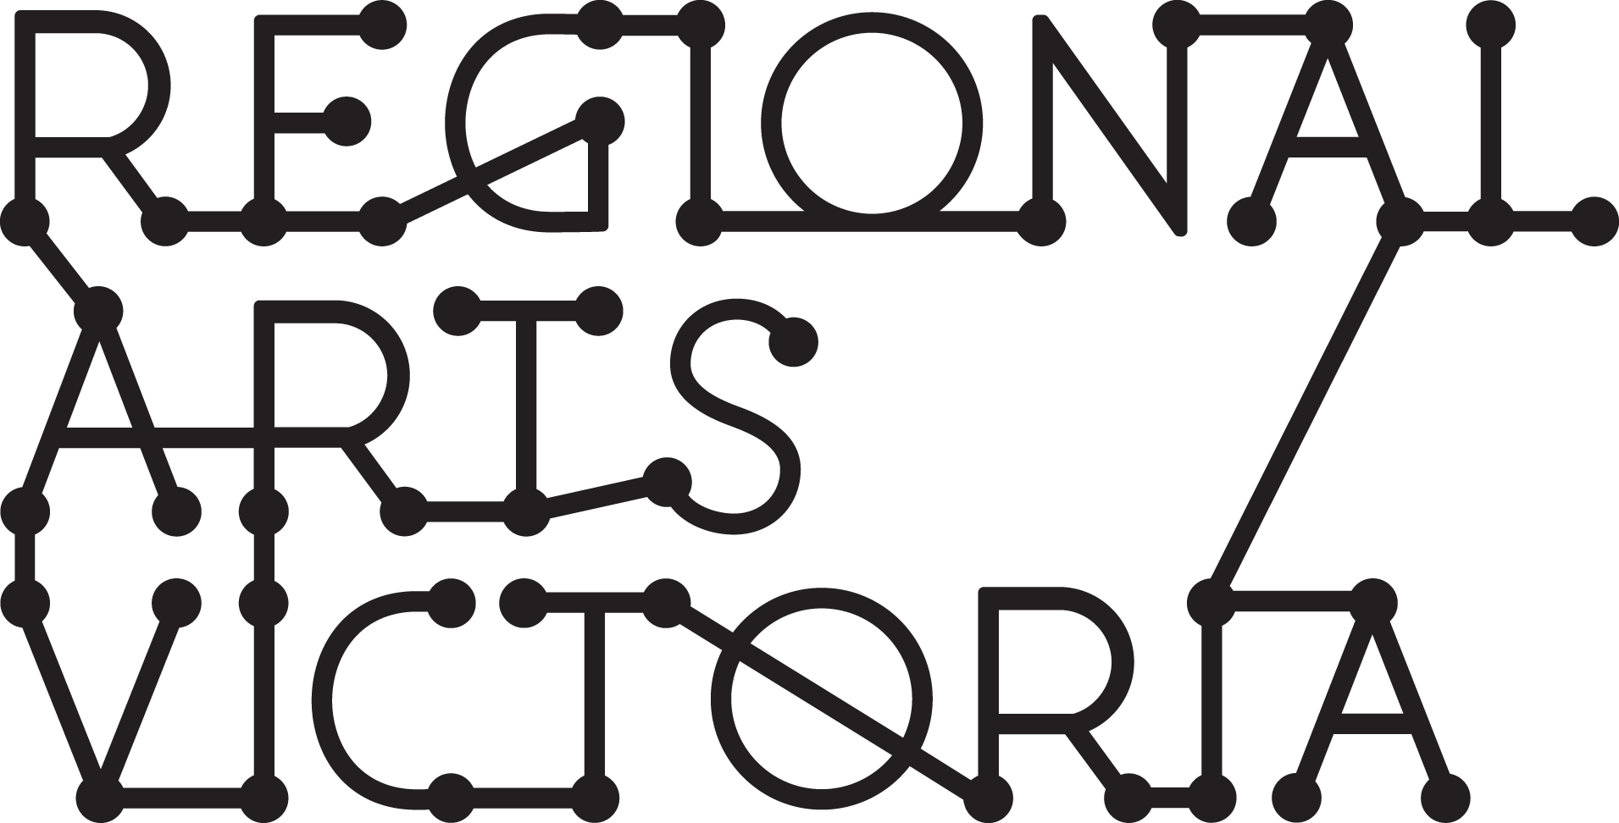

EOI Drafting Document
Connecting Places Program
Expressions of Interest for 2022 Touring

Use this document to draft your application and copy/paste into the online EOI form when you’re ready to submit. Incomplete EOI's are not eligible and will not be assessed.

Read the Submission Guidelines (available as a word doc or pdf) for selection criteria and program information before drafting your application.

As part of your application, you will be required to provide Dropbox links. Please sign up to the online document sharing platform Dropbox and create the following folders to upload files to:
- Hero Images
- Other Images
- Video
- Logos
- Support Material

This platform has a free trial period. To find out how to share a folder in Dropbox, click here.

Expressions of Interest open 9am Tuesday 27 April 2021 and close 12pm Tuesday 25 May 2021 for touring in 2022.

Please contact Regional Arts Victoria to discuss your project before submitting your application:

Anna Kennedy
Connecting Places Manager
akennedy@rav.net.au | 0431 376 678

PROJECT OVERVIEW

1. Project Name:
2. Brief Project Description (50 words max.):
One sentence to describe the project.

3. Company Name:
4. Company Website:

5. Link to Hero Image:
6. Link to Project Trailer or Other Video (optional):
7. Notes on Image/Video (optional):
Include password for access if relevant and any information about intention to update image or video materials.

8. Equity and diversity across our touring programs is a priority of Regional Arts Victoria. Do any key personnel within your project identify as any of the following?
Select all that apply
Aboriginal and/or Torres Strait Islander
Culturally and Linguistically Diverse
Based in regional Victoria
None of the above
Prefer not to answer
Other: _____________________

9. Would you also like to be considered for Arts & Education?
Yes
No
If yes, please close this form and submit your application via the Arts & Education online EOI form

CONTACT DETAILS

10. Primary Contact Name:
11. Preferred Pronouns:
12. Role:
13. Email:
14. Phone:

15. Do you intend to work with Auspicious Arts Projects if selected for this program?
Yes No
If yes, include their details below. If no, include the Company’s details.
16. Business Name:
17. ABN:
18. GST Registered: Yes No
19. Postal Address:
While non-Victorian companies are eligible to apply, costs to travel to and from Victoria are not covered by this program.

PROJECT & COMPANY INFORMATION

20. Project Type
Select all that apply
Performance
Workshop
Residency
Other ____________

21. Artform
Select all that apply
Cabaret and/or Musical Theatre
Children and/or Families
Comedy
Dance
Circus and/or Puppetry
Music (Contemporary)
Music (Classical)
Theatre (Comedy)
Theatre (Drama)
Other ____________

22. Project Description (500 words max.):
Describe the experience of the project, including content, themes, target audiences and brief presentation history. Ask someone who hasn’t seen your work to read this description and explain the project back to you. Include exciting spoilers! This is for the panel’s eyes only…

23. Community Engagement Activities Description (500 words max.):
Please detail any workshop/engagement offerings, including a short description, costs, maximum participants/audience capacity, and what type of space is required. This section is optional.

24. Company Description (250 words max.):
Please briefly describe your company, artistic practice, any experience your company has working with communities and why you would like to be a part of the Connecting Places program.

25. Cast & Creative Team:
List all of the cast & creative team credits for the project including names and roles within the project. Please note any personnel yet to confirm their involvement in this section.

31. Equity and Diversity:
Regional Arts Victoria is committed to equity and diversity. Capturing data on the diversity of applicants to our programs is one of the ways we can measure our progress and set goals for continual improvement. The below section is optional however we would appreciate your assistance by providing the following information.

How many people within the creative team identify as:
Aboriginal and/or Torres Strait Islander:
Culturally and Linguistically Diverse:
Deaf and/or Disabled:
LGBTQIA+:
Women:
Men:
Other gender/s:

26. Is this project showing in Victoria before mid-June 2021? Where and when? (optional):

27. Presentation and Touring History (optional):
Where and when has this project been presented before? In brief, list the performance date/s and corresponding venue/presenter and town/state

TOURING PARTY INFORMATION

28. Size of Touring Party:
What is the total number of cast and crew required on the road for this project?

29. Touring Party:
List all of the cast & crew required for touring, their roles and the location in which they’re based. Note: there must be at least one person in the touring party that holds a current full Australian driver's license and is over 21 years old.

30. Availability (optional):
Indicate any blocks of time or specific months you know you will NOT be available to tour in 2022. Further discussions around availability will occur with successful applicants

FEES & ROYALTIES

The Connecting Places program does not generally offer remount fees as touring shows and workshops are expected to be ready to go. DO NOT include vehicle hire, petrol, accommodation, meals and incidentals or LAHA in your fees as these costs are covered by Regional Arts Victoria when you are on the road. Download our budget template if you require assistance calculating your fees.

31. Per Performance Fee: $
32. Royalties (if applicable): %
Royalties are a percentage of net box office income paid to personnel involved in the creation of the project, or whose script/design/composition/other you use

33. Describe your music licensing obligations (if applicable):
Companies are responsible for registering with OneMusic and paying the applicable fees

MARKETING INFORMATION

The following sections ask for marketing copy and other information that will help community presenters sell tickets to your project to their audiences. Here are some tips for writing great marketing copy:
- Convey a clear message: keep it simple!
- Never assume the audience knows anything you don’t explicitly explain to them
- Watch your grammar, spelling and punctuation!
- Address what audience members can expect to see, hear, feel and experience

34. Tagline (up to 15 words):
A tagline offers information that can be easily remembered and repeated. It should be both enticing and uncomplicated

35. Short Show Synopsis (150 – 250 words):
This is the kind of information you might see in a theatre company’s season brochure. You may wish to include a great quote from a reviewer here, too!

36. Long Show Synopsis (300 – 500 words):
This can be an expanded version of the Short Show Synopsis. Consider expanding on any of the following: how and why it was made, what it’s about, what themes does the project explore, etc.

37. Key Themes:
Name at least three. For example; dealing with grief, acceptance of oneself, regional living etc.

38. Suggested Age Range:
Consider who this work is best suited to. Examples: 15+, children aged 5-10, adults only

39. Warnings:
Include warnings for adult and/or triggering themes & content (be specific), coarse language, sexual references/nudity

40. Target Audiences:
Who is likely to come and see this show? List the target audiences here. For example, seniors, music lovers, romantics, etc.

41. Reviewer & Audience Quotes:
List a selection of key reviewer and/or audience quotes from previous seasons.

MARKETING LINKS

The following sections request links to your Dropbox folders and other social media channels.

42. Hero Images:
Images must be uploaded to Dropbox in high resolution (300 dpi) .jpeg or .png files and provided in both portrait and landscape versions. Files should be named using the following convention: PROJECTNAME_Hero Image 1_Portrait_Image credit PHOTOGRAPHER NAME.png

43. Other Images (optional):
This may include production stills, cast/crew headshots and/or rehearsal images. Images must be uploaded to Dropbox in high resolution (300 dpi) .jpeg or .png files and files should be named using clear conventions that include the project name, image type and image credit.

44. Promo Video:
Short, high-quality videos of your project help sell your work to both presenters and audiences! We recommend 30-60 second promo reels or trailers of less than 4 minutes. This link can be for Dropbox, YouTube, Vimeo or equivalents.

45. Other Video (optional):
This may include archival footage, interviews with creative team members and other relevant video materials. These links can be for Dropbox, YouTube, Vimeo or equivalents.

46. Logos and Acknowledgements:
This must include your company logo and any other logos for collaborators, co-producers and/or funders that you are obliged to include on all promotional materials. Provide a Dropbox link to high res versions of all logos.

47. Creative Team Biographies (optional):
Link to a single word doc or PDF containing biographies for your creative team and/or key personnel. Max. 200 words per person
TECHNICAL SPECIFICATIONS

Presenters and venues that program shows via the Connecting Places program are given the option to purchase a Technical Package for $500, rather than providing the equipment themselves. The producer/company will receive $500 for each venue that opts in for the package so that they (the producer) can hire the necessary equipment to tour with. The following should detail all of the equipment and venue support needed assuming that most Connecting Places venues have little to no equipment and are managed by volunteers. This means that for most venues the touring party will hire, set up and pack down all of the equipment unless otherwise specified.

48. Bump in (hours):
49. Performance (hours/mins):
50. Interval (yes or no):
51. Bump out (hours):

52. Venue Staffing Requirements:
How many venue staff do you need support from? What skills do they need to have? When do you require their support? For example, 1 x venue representative to provide access & induction OR 1 x multi-skilled technician required for bump in, performance and bump out OR 1 x lighting technician and 1 x audio technician for bump in, operating performance and bump out.

53. Theatre Formats
Select all that apply
Black box theatre
Proscenium arch
Community hall
Library
Public Bar
Shed/Barn
Sports Centre
Outdoor Spaces
Other ____________

54. Staging & Seating Formats
Select all that apply
End on
Cabaret style
Flat floor
In the round
Traverse
Raised stage
Thrust
Promenade
Other ____________

55. Minimum Stage Dimensions (metres):
Include minimum dimensions for performance space width, depth, height and wing space

56. Other Venue Requirements:
What other venue infrastructure is essential to your performance? Consider that some venues may have a relaxed, community approach to presenting performances, so be specific about your needs. For example, dressing room requirements/requests, dimensions of stage door if bumping in large set items, black outs are essential (some venues don’t have curtained windows), rigging requirements, risers needed, etc.

57. Lighting Requirements:
Briefly describe your lighting requirements based on your minimum specifications. For example, general wash pus 2 x spotlights (12 fixtures in total), lighting console with min. 4 dimmable channels, 4 x free standing lighting trees, etc. Halls and other community-run spaces generally have limited power sources and little to no rigging, so avoid 3-phase, consider booms/trees when no rig is available, cables/patching needs and some extra power leads, and lighting console/operation requirements.

58. Audio Requirements:
Briefly describe your audio requirements based on your minimum specifications. Consider microphones, foldback, cables (inc. mini-jack and power boards), PA/speakers and stands. Also consider mixing desk requirements/laptop for operation as this may need to be toured with the company.

59. Projection & AV/Other Technical Requirements (optional):
Leave this section if you have no AV or other technical requirements OR Briefly describe your AV or other technical requirements based on your minimum specifications. Consider projector, screen, stands/rigging, control, operation and cables in relation to varying hall sizes.

60. Set Requirements:
List the set items that the company will tour with.

61. Transport Notes:
What vehicles are required for this tour? For example, 1-tonne van and/or station wagon. Consider transporting the equipment and set items, as well as the touring party and their luggage.

SUPPORT MATERIALS

62. Public Liability Insurance Certificate Link:
Please provide a link to Dropbox with a digital copy of your current Public Liability Insurance certificate or a quote for PLI as evidence of your preparedness to tour. Public Liability Insurance is essential for touring with the Connecting Places program. If you are unsure about this process, please contact our team directly.

63. Other Supporting Materials (Optional):
This section is for other essential support materials, such as Working With Children’s Checks for projects that significantly involve young people, letters of support for projects that significantly involve First Nations people, etc. Please only use this section for essential documentation.

THANK YOU!

Thank you for taking the time to complete an application to Regional Arts Victoria’s Connecting Places program.

We will be in touch by mid-year to notify you of the outcome of your application.

In the meantime, please direct any questions to:

Anna Kennedy
Connecting Places Manager
akennedy@rav.net.au | 0431 376 678

