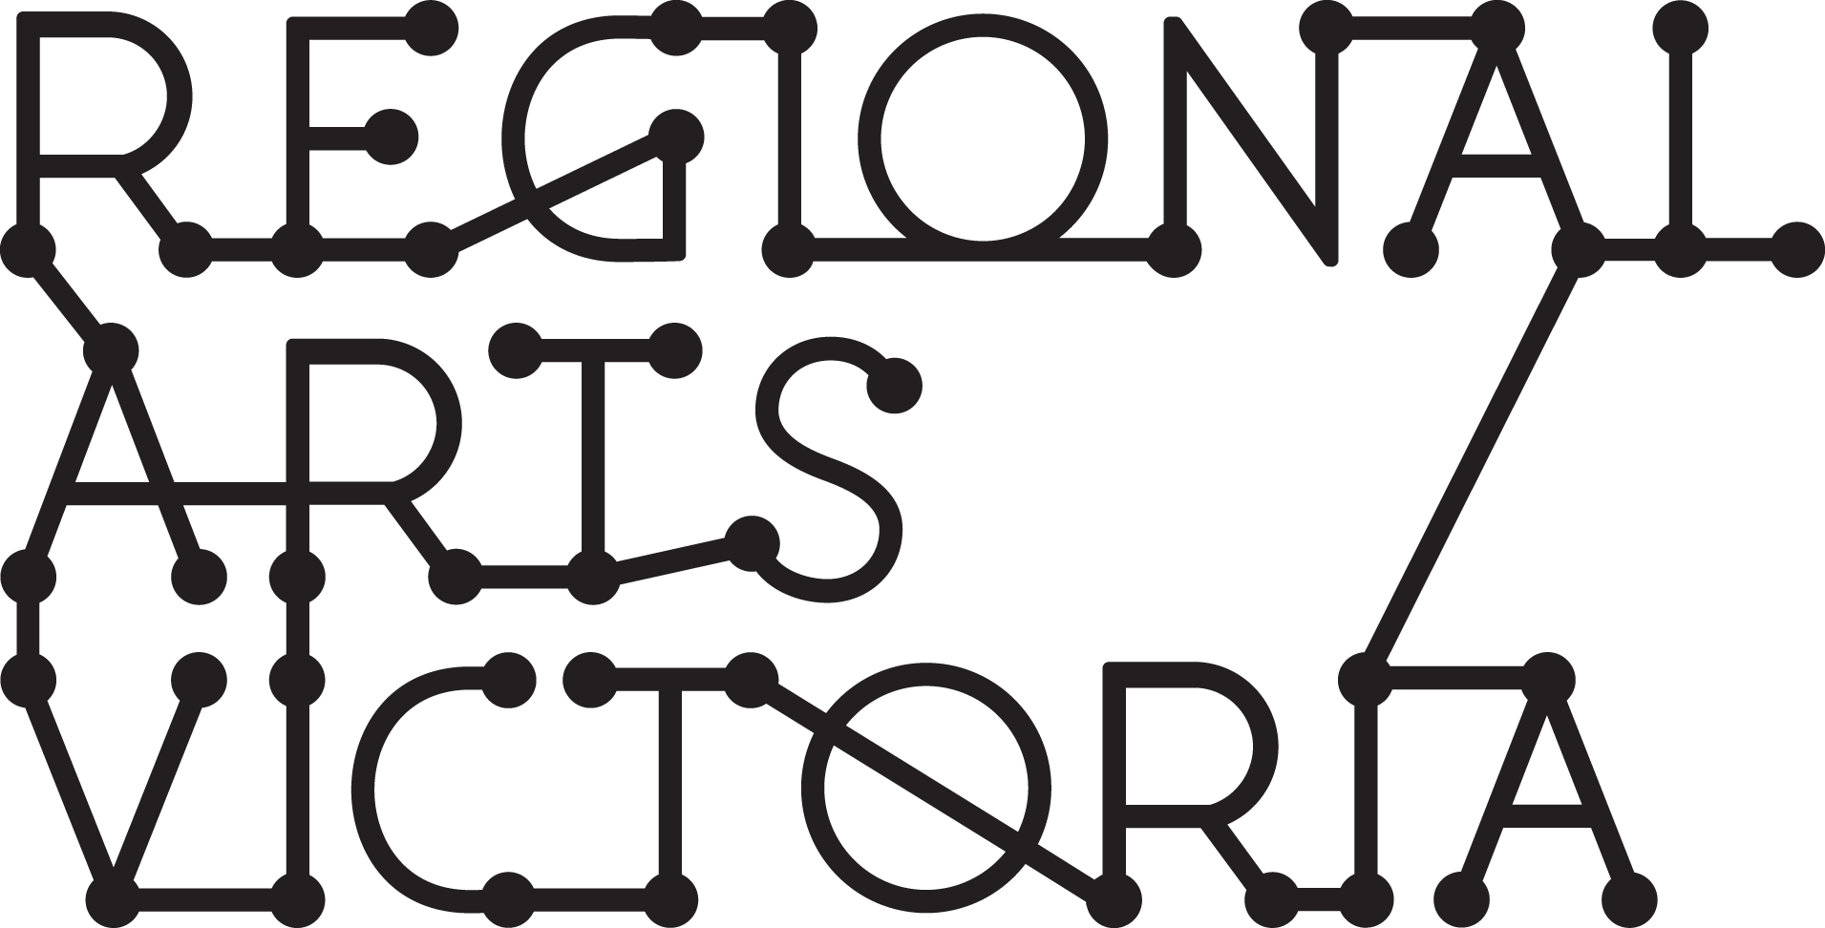

GUIDELINES
Arts & Education Incursion Program
Expressions of Interest for the 2022 Program

Regional Arts Victoria’s Arts & Education program delivers high-quality and educationally relevant arts experiences to young people across Victoria from early years through to VCE. We work to provide accessible arts experiences and encourage students to participate in the arts as both artists and audiences.

The Arts & Education program is seeking a limited number (2-3) of companies to be part of the 2022 program. Expressions of interest for artists/producers to apply to be part of the 2022 program open from Tuesday 27 April 2021 – 12 pm Tuesday 25 May 2021.

Please note: Equity and diversity across our touring programs is a priority of Regional Arts Victoria. , Expressions of Interest from First Nations, CALD and/or regionally based artists/companies will be prioritised. Please contact Regional Arts Victoria for more information.

For almost 50 years Regional Arts Victoria have delivered inspiring arts experiences across Victoria.

The program is designed to be child-centred and interactive with links across the Victorian Curriculum. This program firmly focuses on The Arts - Drama, Music, Dance, Visual Arts, Visual Communication and Design. We are keen to enrich the learnings of young people, and put the A into STE(A)M to give them skills for life.

We aim to assist young people to dream, innovate, think, connect and collaborate. We are interested in finding ways for their education to be relevant and meaningful – to develop the whole child and recognise their lifelong learning. The positive impact of a high-quality arts program is that it is stimulating and uplifting, increasing motivation and concentration, creative thinking, and social skills from shared experiences.

The Arts & Education Program engages young people from early years to VCE, and consists of performances, residencies and workshops which can take place online or in person in schools, community halls, galleries and performing arts centres, or feature in local events such as festivals, school holiday programs or camps.

The program also focuses on professional development opportunities for teachers and artists. Facilitating opportunities for teachers and artists to develop the tools to deliver impactful and sustainable arts experiences to their students and communities.

The following submission process is for artists / producers and companies who wish to present work on a predominantly INCURSION basis, online or directly into schools and community venues which do not always have access to professional theatre facilities.
Here is what we’re looking for to be included in the 2022 program:

- Live performance and/or workshops: led by or significantly involving First Nations, CALD and/or regionally based artists

- Age Ranges (Arts & Education program only): Suitable for Primary and Secondary ages preferred
Preferred Artforms: Music, Dance, Circus, Visual Arts or Visual communication and design program preferred

Arts & Education Selection Criteria:
- The project is innovative, high-quality and entertaining.
- The project is appropriate to a school and/or community context.
- The project demonstrates clear links to the Victorian Curriculum.
- The project stimulates ideas and generates pre and post-program discussion.
- The project has a holistic approach to education, including opportunities for deeper engagement – residencies, workshops, forums etc.
- The project embodies excellent practice in the presentation of the arts for children and young people.
- The project is ‘tour ready’: has already had at least one season and is relatively easy to remount (no remount costs are covered by these programs)
- The project is affordable: per show fee of $1,000-$3,500 (refer to LPA guidelines for artist fees) or per workshop equivalent
- The project is low tech and adaptable to a variety of spaces, consists of a compact touring party (usually 2-3), is tour ready and can generally fit inside a single Toyota Hi-ace van or similar.
- The artist/company are available to tour for two to four weeks between April and November 2022, or availability for workshops or performances (in person and/or online) across 2022 on demand.The company has included strong marketing materials, including video and a framework for teacher resource material.
- Across our program, the range of projects selected reflect Regional Arts Victoria’s equity and diversity goals.
Visit Regional Arts Victoria’s website for the works that have been included in the current Arts & Education program.

The Application process

Applicants are strongly encouraged to contact us prior to commencing the EOI to discuss their project’s suitability to the program.

Pippin Davies
Senior Manager, Arts & Education
pdavies@rav.net.au | 0427 211 123

Expressions of Interest are to be submitted via an online form. In the form you will be asked to provide information outlining your company, your project, fees, technical elements, marketing material and education resources.

If you have access requirements and would like the option to submit your EOI in a different format, please get in touch.

If you feel like your project is relevant to the Connecting Places program as well as Arts & Education, please only submit one application to Arts & Education and indicate in your form that you would like to be considered for both programs.

While eligible applicants are welcome to apply to both programs, selected projects will only be toured via the most appropriate of the two programs. Applicants wishing to be considered for both programs are strongly encouraged to contact the Connecting Places Manager prior to commencing the EOI to discuss their project’s suitability to the program.

Anna Kennedy
Connecting Places Manager
akennedy@rav.net.au | 0431 376 678

Incomplete EOI's will not be eligible and cannot be assessed. The following is a list of information/materials you will be asked to provide as part of your application.

ABOUT YOU
- Title of the work
- Company/Producer Information
- Victoria Child Safe Standards and Working with Children Checks
- Public Liability Insurance
- Current Driver’s License

ABOUT THE PROJECT
- Engagement Type: On The Road, On Call/Online or Residency
- Availability
- Offering Type: Performance, Workshop or Residency
- Project description
- Year Level Appropriate
- Content Warnings
- Additional Offerings

CURRICULUM CONTENT
- Curriculum links and educational content
Our team will work with successful applicants to create a teacher resource, and will provide appropriate curriculum links to relevant learning areas. At this stage you’ll be asked to provide an indication of where you believe your work fits into the Victorian curriculum areas and suggest some complimentary activities which can assist in aligning your work the curriculum. Please consult the Victorian Curriculum website for more information.
victoriancurriculum.vcaa.vic.edu.au

MARKETING INFORMATION
- Show summary and marketing copy
- Images
- Promotional footage

If you would like to discuss the marketing material required, please contact Adam Fawcett, Programing Communications Coordinator at afawcett@rav.net.au to arrange a time to chat.

TECHNICAL SPECIFICATIONS
- Touring Party
- Duration and capacity of Offering
- Venue requirements
- Additional room requirements
- Staging Requirements

YOUR FEE
- Weekly Fee (On the Road)
- Once off Fee (On Call/Online or Residency)

ADDITIONAL INFORMATION
- Can we see your show?
- Other complimentary programs
- Teacher Resources

IMPORTANT DATES
Tuesday 27 April 2021 | Expressions of Interest Open | Link to Expression of Interest form available on the website. Please check the website for the downloadable form including application questions.
Tuesday 25 May 2021, 12pm | Expressions of Interest Close | Late submissions will not be accepted
Tuesday 9 July | Shortlisting Process | All applicants will be notified at the end of the shortlisting process.
Tuesday 10 August | 2022 Program launched | Program launched
Please note: Some dates are subject to change. Contact our Arts & Education team to confirm.

Applicants are strongly encouraged to contact Regional Arts Victoria to discuss your application and its suitability for Arts & Education Program and application process.

For more information, questions or support regarding the application process please contact:

Pippin Davies
Senior Manager, Arts & Education
Phone: 0427 211 123
Email: pdavies@rav.net.au

