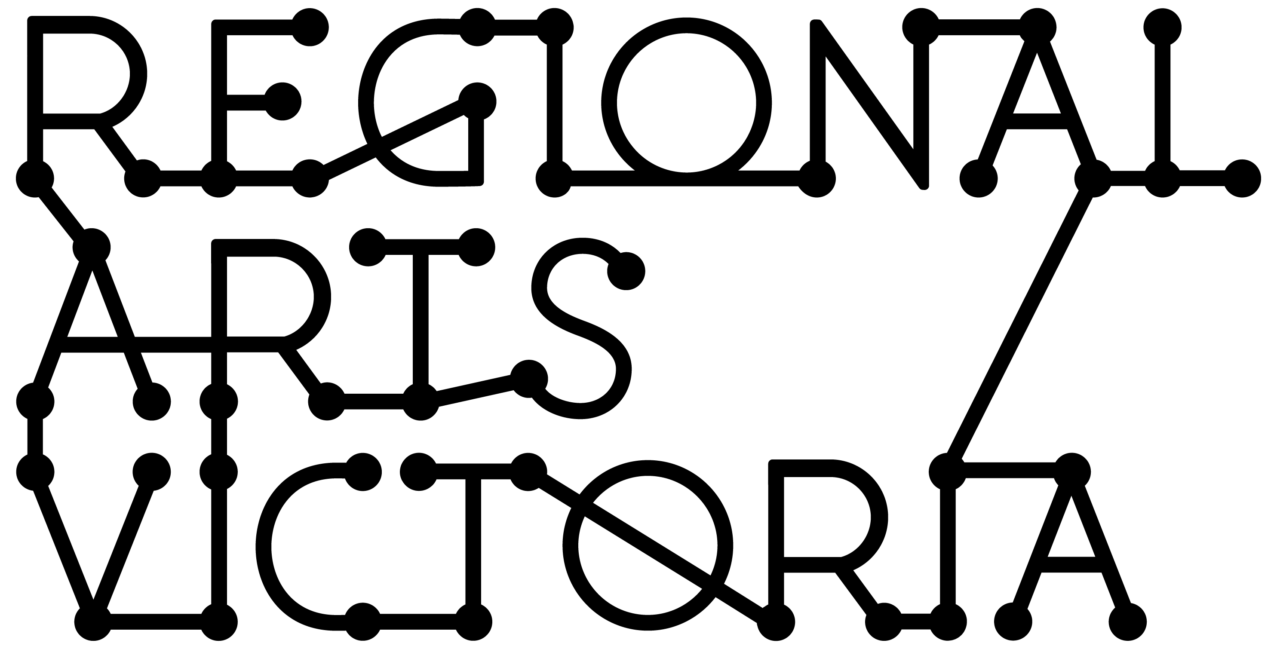
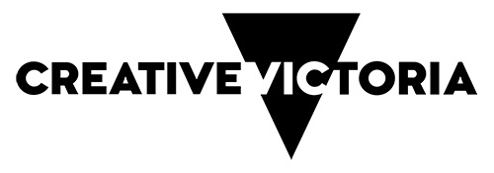

SMALL REGIONAL PRESENTERS
GUIDANCE MATERIAL

2024 Presentations

Contents

You are reading the Small Regional Presenters Guidance Material. These materials have been compiled to assist applicants to complete a submission for the program.

This information is available in a standard PDF version and an accessible word version. If you require further assistance accessing the Guidelines, please contact us by email grants@rav.net.au

What is the Small Regional Presenters program? 2
Important information about the application process 2
Objectives 3
Who can apply? 3
What is on offer? 4
Who is not eligible to apply? 5
Timelines 6
Assessment criteria 7
Equity 8
Support Material 8
Auspicing 9
Privacy 9
Working with young people/working with vulnerable persons 9
Working with First Nations cultural content and communities 10
If you are successful 11

What is the Small Regional Presenters program?
The Small Regional Presenters program supports regional communities to program and present shows in their area. It also supports skills development and capacity building by encouraging presenters to develop long term plans and audience development strategies.

Small Regional Presenters is open to regional community presenters and Local Government Authorities, where the organisation or LGA is in regional Victoria and does not receive organisational or multi-year funding through Creative Victoria programs.
This program is being delivered under the Victorian Government's creative industries strategy, Creative State.

Important information about the application process
The Small Regional Presenters program application process is online. These Guidance Materials have been prepared to assist interested applicants in regional Victoria to prepare their application as follows:

- Read these guidelines carefully before starting your submission.
- Once you have read the guidelines, contact the Small Regional Presenters Program Manager to discuss your application.
- Apply online via SmartyGrants.

Who to talk to?
Small Regional Presenters Project Manager, Regional Arts Victoria
Email: grants@rav.net.au

Note that staff work part-time and there is limited availability. Please ensure you have read all guidelines and the application form before contacting staff.

Apply online via SmartyGrants
All applications are to be submitted online using the SmartyGrants system. Applicants who require support to access the online application process should contact Regional Arts Victoria at grants@rav.net.au
You can access the application form here.
Please note this is the only round of Small Regional Presenters that is open for presentations taking place in 2024.

Objectives
Small Regional Presenters aims to increase the quality, quantity and diversity of professional performing and live arts available to audiences in regional Victoria.

The initiative will seek to support regional presenters to:
- present quality, relevant arts programming to local audiences;
- build their capacity to present and program in their local area and develop long term sustainability and;

Priority is given to shows presented in communities with limited access and opportunities to experience performing and other live arts presentations.

Who can apply?

OPEN FUNDING ROUND – NEW OR EMERGING VOLUNTEER SMALL REGIONAL PRESENTERS
Regional Arts Victoria will deliver an open funding submission process for new or emerging small regional presenters that have had limited experience presenting live arts experiences in their communities or are proposing one-off presentations.
Eligible applicants include,
- New or emerging volunteer small regional presenters who have not yet developed and delivered a consistent annual program in 2021 to 2023.
OPEN FUNDING ROUND – RETURNING VOLUNTEER COMMUNITY PRESENTERS
Regional Arts Victoria will deliver an open funding submission process for returning volunteer community presenters that have built an audience-base and are proposing a strategic annual program and are building on audience development goals from previous years.
Eligible applicants include,
- Returning volunteer community presenters with a history of providing quality programming to their communities. These presenters want to continue presenting live performance in their communities to further grow and develop audiences. These presenters are defined as presenting at least one (1) live performance per year for at least two (2) years.

For both funding streams, presenters must be either:

Regional small presenters that are incorporated not-for-profit organisations and do not receive organisational or multi-year funding through Creative Victoria.

OR

Local Government Authorities that do not receive organisational or multi-year funding through Creative Victoria.

Please note:
- A community presenter is an incorporated association, operating as a not-for-profit organisation, located in regional Victoria. Community presenters should have a policy of reinvesting surplus funds back into performing arts activities and be able to demonstrate an annual program of presenting professional performing arts activities.
- New organisations/presenters are eligible to apply and must be able to demonstrate their capacity to manage presentations of a similar size and scope.
- An applicant’s postcode must reflect their residential or business address in one of the 48 local government areas classified as ‘regional’ by Regional Development Victoria, a department of the Victorian Government. You can find a list of these local government areas here. Please contact Regional Arts Victoria if you are uncertain.
- Groups and organisations must either be legally incorporated and have an ABN or have an auspice organisation manage their grant.
- We strongly encourage all applicants to discuss their proposal with the Project Manager before applying.

What is on offer?
Applications can be for presentations of a single show, a show that is part of a tour, several shows over several months, or for an annual program of shows. Presenters can receive up to $15,000 through this program for presentations taking place between 1 March and 31 December 2024, under the following conditions:
- Community Presenter applicants can apply for up to 100% of presentation costs. Presentation costs requested must not exceed $15,000.
- Applications may include presentation costs associated with booking performances from Regional Arts Victoria or other touring productions. An external panel of assessors will decide which applicants are successful to eliminate conflicts of interest.
- Local Government Authority presenters must match the funding requested on a dollar-for-dollar basis as their applicant’s cash contribution.
- Applicants are not required to be Members of Regional Arts Victoria but must provide a certificate of incorporation and evidence of public liability insurance as part of eligibility. If an applicant is having an auspice apply on their behalf, they must provide a Letter of Support from their Auspice Organisation.

Presentations must be:
- Presented in regional Victoria, for local audiences.
- A professional live Australian show, production, or performance from outside the local government area where the presentation is taking place. This program supports all genres of the performing arts and other live shows, including literary events.
- Ticketed, with box office income.
- Open to the general public.
- A paid presentation, where the presenter pays a fee to bring the show to their community.
Funding through this program can cover costs such as:
- Project / production - show fee, front of house/ushers, technical support, equipment hire, venue costs.
- Marketing and promotion - printing, distribution, advertising (print, radio, social media, other), design.
- Administration - phone, fax, postage, insurance.
- COVIDSafe event delivery - PPE, sanitiser, signage, cleaning costs.
The costs must be for the show(s) applied for, i.e. insurance for the specific show(s), not the entire year. The above list provides examples of the most usual costs. It doesn't cover everything that may come up.
Examples of Supported Activities:
- A community presenter presenting a show that is part of a national tour at the local community hall.
- A Local Government Authority presenting a program of live shows at halls across the shire. The program may include a variety of shows (e.g. contemporary theatre, chamber music, poetry readings and contemporary music), and may take place across several months.
- A community presenter presenting a show with support from a Local Government Authority managed venue (e.g. in-kind assistance with marketing and promotion, ticketing or technical support). This could include newer presenters receiving support from their local professionally managed performing arts centre, or a more experienced community presenter planning to present a show of greater scale or complexity than usual.
- A community presenter or a Local Government Authority presenting one show, such as the headline act, as part of a local festival.

Who is not eligible to apply?
Applications from:
- Applicants outside of regional Victoria.
- A for-profit company; or
- Applicants who receive organisational or multi-year funding through Creative Victoria.
- Applicants who have not satisfactorily acquitted a previous grant, including individuals who have been principal in an organisation that has not acquitted a previous grant.

What will not be funded:
- Shows where the presenter does not pay a fee to bring the show to their community.
- A show from within the same local government area where it is taking place.
- The costs associated with the creative development of a new show.
- Presentation of free shows or shows that do not have box office income.
- Shows that are not open to the general public.
- More than one show in the program of a regional festival.
- Presentations or any costs that fall outside the eligible funding timeframe, including all retrospective costs.
- Applications that do not demonstrate benefit and relevance to the local community.
- Capital purchases or recurrent administrative, infrastructure and other organisational costs not directly associated with the show.
- Applications that do not demonstrate the required level of financial support from the presenter.
- Applications from the producer, creator, manager or tour coordinator of the show. These applications should instead be directed to Creative Victoria's VicArts Grants, Music Works or Touring Victoria programs as best suits the proposed activity. Contact program staff to ensure you are applying to the most appropriate funding program.

Timelines
Round Opens: 9am, Wednesday 13 September 2023 via Regional Arts Victoria’s SmartyGrants portal

Round Closes: 5pm, Monday 30 October 2023 for shows taking place from 1 March 2024.

Applicants will be advised of outcomes from end of January 2024.
Project dates: Presentations taking place between 1 March to 31 December 2024.

Summary Timeline
GRANT TYPE | MAXIMUM AMOUNT AVAILABLE | OPEN DATE | CLOSE DATE AND TIME | APPLICANTS NOTIFIED OF OUTCOME
Small Regional Presenters | Up to $15,000 in presentation costs | 9am, 13 September 2023 | 5pm, 30 October 2023 | From end of January 2024
Once submitted, your application cannot be changed. However, if you receive any confirmations related to your submitted application - including additional funding, partnerships, etc. - you can notify Regional Arts Victoria and staff may provide this new information to peer assessors during assessment at our discretion. To advise on confirmations received after submitting an application, please email grants@rav.net.au, briefly describing the nature of the confirmation and include your application reference number.

Assessment criteria
An External Peer Assessment Panel comprising of artists, arts professionals and community representatives will assess applications against the program aims and assessment criteria.
Applicants will be strongly encouraged to describe how they will work with the creative ecology in or around their locations to address the Creative State principle “For Every Victorian”.
Applications are assessed against the criteria outlined in the table below.
QUALITY AND RELEVANCE
The application demonstrates that the presentation is professional and of benefit and relevance to the local community | - Describe the show(s) to be presented, explaining the benefits and relevance to your local community.
VIABILITY
The application demonstrates the level of planning and organisational capacity required to deliver the proposed activity | - Explain how you plan to deliver and market the show(s) you are presenting.  - Describe learning or development opportunities for you through presenting the show(s).
AUDIENCE DEVELOPMENT
The application demonstrates opportunities for audience development and engagement | - Describe audience development opportunities through presenting the show(s).  - Provide details of community engagement experiences and professional development opportunities such as post-show talks, workshops and masterclasses, artists/curator talks, and skills exchange activities.

Equity
Regional Arts Victoria will consider the reach of the program as part of the assessment process and when making final decisions. This may include designing appropriate support and assessment for applicants including (but not limited to) those who identify as:
- First Nations People;
- Culturally and linguistically diverse;
- Deaf and disabled creatives; and
- Young people.

Support Material
Support material provides the opportunity to communicate the proposal in more than words. Your application can include other support documents and artistic support materials where relevant.
Support documents that may strengthen your application include:
- a link to your website or a one-page history of your organisation, including presentation experience.
- a sample of marketing/promotional material for the show (a link to online material or one page uploaded).
- letters of support regarding services, financial contributions or other assistance that will help with the presentation’s viability. Letters can be from your local performing arts centre (if applicable) or local council, providing information on their support for your organisation and show(s).
- If your organisation is working with First Nations People, please include letters of support from relevant First Nations artists and/or organisations to demonstrate cultural considerations and consent to participate.
Artistic support material could include:
- a link to the show’s website, or the company’s website.
- images/stills from the show to be presented.
- video clips or trailers for the show (no longer than 5 mins in total).
- audio from the show (up to three tracks, no longer than 5 mins in total).
- one page of information on the company/show, including a synopsis.
Artistic support material must adhere to the following requirements:
- Up to 5 files or URLs (external links)
- Files can be no more than 25MB in size each
- Multiple images or letters can be compiled into one document
- When providing URLs, you must link to publicly available (not membership-based) sites. The link must directly open the material you want to submit. If the content is password-protected on a site like Vimeo, you must provide the password details.
- Links to hosting platforms such as Google Drive and Dropbox that require viewers to enter personal information to gain access will not be assessed by the peer advisory panel.

The following file types are accepted:
Documents | Word (.doc .docx); PowerPoint (.ppt .pptx); Acrobat (.pdf)
Images | .jpg .png .tiff
Audio | .mp3 .wma
Video | .mp4 .wma .avi .mov

Auspicing
This program accepts applications from auspice organisations applying on behalf of applicants.
Any legally constituted body may act as an auspice. If the application is successful, the auspice organisation will receive any funds allocated and is responsible for the management of funds and the acquittal of the grant with the applicant.

For more information on auspicing, please refer to this link provided by Creative Victoria.

Privacy
Regional Arts Victoria values applicants’ privacy. For details on how we collect, store and use information, contact Regional Arts Victoria at: grants@rav.net.au

Application details and applicant contact information may be provided to the State Government (including the Minister and the Department), Members of the Victorian Parliament and may be published on the internet by any of them. This will include the applicant’s name/organisation name, funded project description, funded amount, state/territory, location and electorate.

This information may also be used for promotion and reporting purposes. The Directors of Regional Arts Victoria and their representatives may also use this information to conduct research so that we may better understand community needs and can improve service delivery.

When submitting an application to this fund the applicant will be providing permission for this personal information to be used in this way.

Working with young people/working with vulnerable persons
A Working with Children’s Check is compulsory for people who carry out child-related work in Victoria. Ensure that any relevant artists/arts workers have current Working with Children Checks and Police Clearances.
For more information review the Victorian Government’s information on Working with Children.

Grantees also need to comply with applicable state, territory and Commonwealth laws before any project personnel commences an activity that involves vulnerable people.

From 1 July 2019, where funding will support the care, education, services or activities for children (under 18 years), it is a whole of government requirement that the applicant is:
- A separate legal entity that can be sued in its own right in child abuse proceedings and;
- Appropriately insured against child abuse.
The new requirements will improve the ability of child abuse survivors to bring a legal claim for compensation and ensure that successful claims can be paid.
Regional Arts Victoria offers Organisation Membership for not-for-profit, regionally-based Victorian arts organisations with option for insurance.

Working with First Nations cultural content and communities

If your presentation includes any First Nations artists or communities, or if it includes any First Nations content then you will need to show that you have consulted with and have support for the presentation from the local Aboriginal and Torres Strait Islander community.

To protect First Peoples arts practice from misappropriation, moral and copyright infringement, you must submit appropriate documentation if you propose to work with First Peoples stories/cultural material that is not your own, such as letters of confirmation from the First Peoples you’re working with and protocols you’ll put in place to ensure cultural safety.
Please review the Australia Council for the Arts Protocols for using First Nations Cultural and Intellectual Property in the Arts to guide you.
If the applicant’s project contains cultural material or activity and;
- They are a non-Aboriginal or Torres Strait Islander applicant, they must provide appropriate acknowledgement of support for their application to be eligible.
- They are an Aboriginal or Torres Strait Islander applicant and are delivering a project outside their community, they must provide appropriate acknowledgment from that community for their application to be eligible.
Examples of evidence may include:
- A letter of support.
- A video testimonial.
- A PDF of email exchanges shared with permission.
- Meeting minutes detailing confirmation of participation.

If you are successful
If your application is successful, you will be required to:
- Accept a Partnership Agreement with Creative Victoria and Regional Arts Victoria and satisfy any conditions of the partnership, which will be detailed in the Agreement.
- Advise Regional Arts Victoria of any proposed changes to your ability to participate in the partnership. This may include changes to creative personnel, itineraries (dates, venues etc.) and expenditure of approved funding. You will be required to contact program staff to discuss any proposed changes before they occur, where possible.
- Give permission for Creative Victoria and Regional Arts Victoria to access and use relevant samples or images of your project/work in our publicity and marketing activities, reports and other not-for-profit government uses. Creative Victoria and Regional Arts Victoria will consult with the successful applicant in the first instance before publishing any publicity or marketing activities.
- Publicly acknowledge the support of Regional Arts Victoria and the Victorian Government using specific logos and text.
- Acquit your grant by submitting a written report on the outcomes of your funded project within 30 days of project completion.
Please note that these conditions of funding will be detailed in a common funding agreement.

