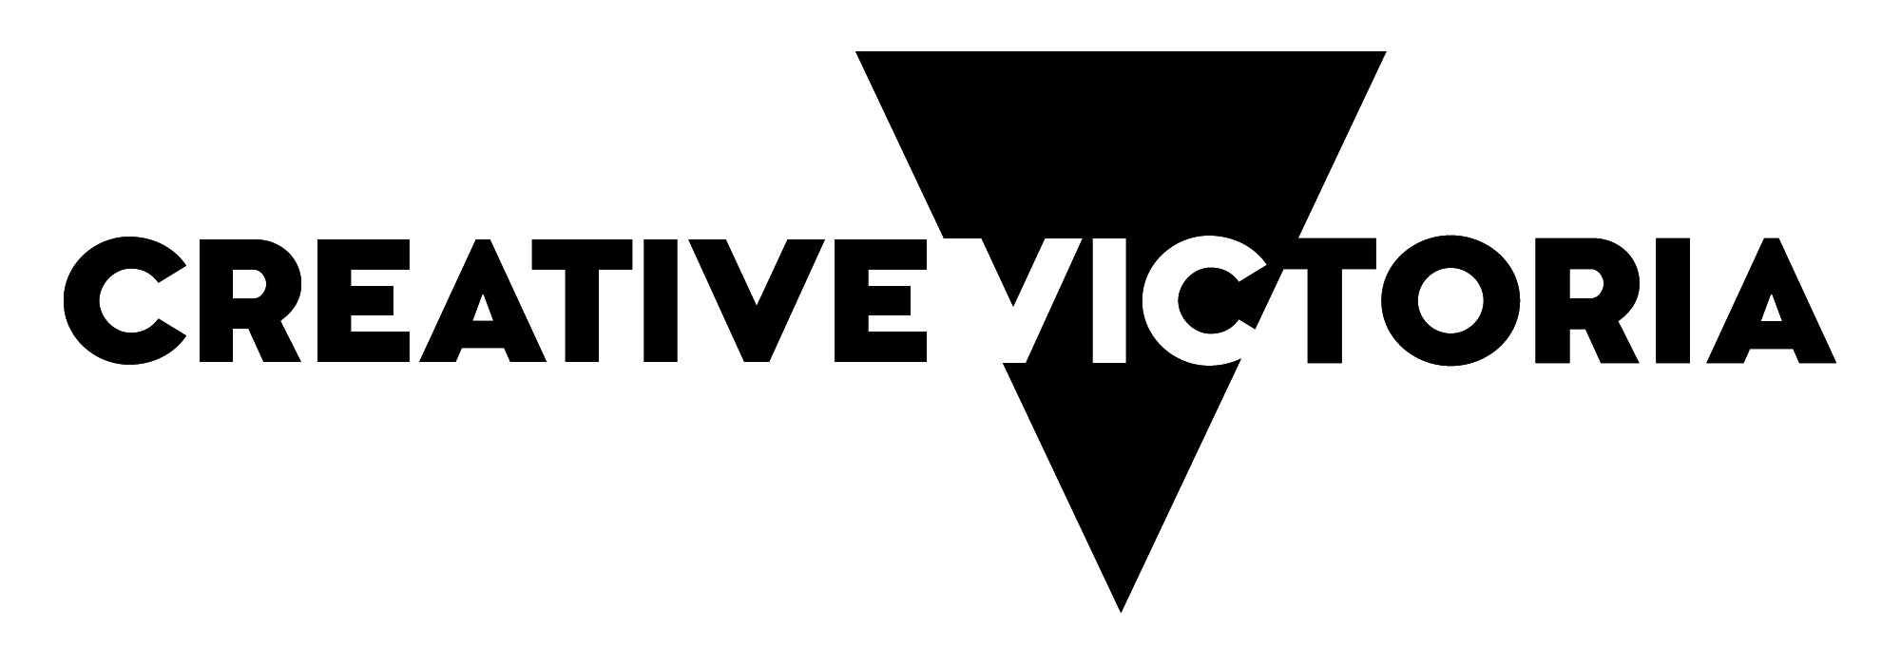
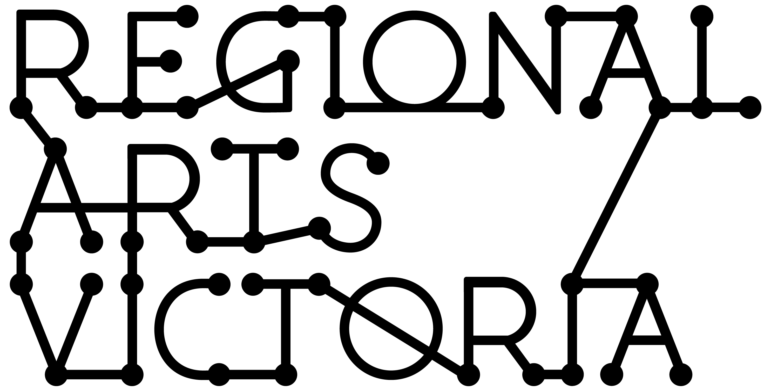

SUSTAINING CREATIVE WORKERS INITIATIVE
REGIONAL STREAM GUIDANCE MATERIAL

APRIL 2020

Contents

This guidance material has been put together to outline the objectives and eligibility criteria for the Sustaining Creative Workers initiative for applicants in regional Victoria.

You can download this version from our website before starting your application.

This information is available in a standard PDF version, an accessible word version, and an audio version. If you require further assistance accessing the Guidelines, please contact us on email grants@rav.net.au.

Introduction: What is the Sustaining Creative Workers initiative? 2
What are the aims of the Sustaining Creative Workers initiative? 2
What can be applied for? 2
Who can apply? 3
What/who is not supported by the Sustaining Creative Workers initiative? 4
Funding available 4
Assessment process 5
Assessment criteria 5
Auspicing 6
How to apply 6
Contact a Partnerships team member 6
Apply Online via SmartyGrants 6
Support material 7
Responsibilities 7
Privacy 8

Introduction: What is the Sustaining Creative Workers initiative?

The Sustaining Creative Workers initiative seeks to support the continued work of Victoria’s independent creative practitioners who have been negatively impacted by coronavirus (COVID-19).

Sustaining Creative Workers will deliver quick-response funding to independent creative practitioners, sole traders, freelancers, collectives and micro-organisations/businesses whose work and livelihoods have been negatively impacted by coronavirus.

It will support creatives, across all creative disciplines, to continue to work in their creative field, adapt to change, research and develop projects, develop their product or skills, and/or connect with new audiences or markets.

Applicants to this program can apply at any time up to 1 June 2020 or until the funding pool is exhausted.

Please note: these guidelines are for regional Victorian applicants. If you are based in metro or outer metro areas, are a First Peoples’ practitioner, or if you identify as a Deaf or Disabled practitioner, Creative Victoria has dedicated funding streams to support you. Head to Creative Victoria’s website to apply.

The regional stream of the program is supported by the Victorian Government through Creative Victoria and administered by Regional Arts Victoria.

What are the aims of the Sustaining Creative Workers initiative?

The Sustaining Creative Workers initiative aims to:
- Deliver quick-response funding to Victorian independent creatives and micro-organisations/businesses negatively impacted by coronavirus (COVID-19);
- Provide stabilisation and improve sustainability of independent creative practice, so that adaptation to the newly emerged environmental context is possible; and,
- Achieve a state-wide reach.

What can be applied for?

Types of activities that the program will support may include, but are not limited to:
- Planning and adaptation to the newly emerged environmental context;
- Research and development;
- Products and/or skills development;
- Exploration of new ways to engage audiences for existing or new work; and,
- Development/exploration of markets for your creative work.

Given the uncertain environment, confirmed outcomes or presentations are not required for this program.

Who can apply?

Sustaining Creative Workers accepts applications from regional Victorian-based independent creative practitioners, sole traders, freelancers and creative micro organisations/businesses, with at least five years of experience, that have been negatively impacted by coronavirus.

Applications are encouraged from a wide range of creative disciplines including, but not limited to, visual arts/craft, literature, contemporary dance/physical performance, community creative practice, circus, cabaret, music, sound art, theatre, fashion, design, screen and digital games, multidisciplinary and experimental work.

Please note, for this regional stream, an applicants’ postcode must reflect their residence in one of the 48 local government area classified as ‘regional’ by the Victorian Government. You can find a list of these local government areas here. Please contact Regional Arts Victoria if you are uncertain.

Applications will be accepted from:
- Creative practitioners/sole traders/freelancers with a minimum track record of 5 years* in public outcomes of their creative practice.
- Arts/creative micro organisation/businesses** that have an Australian Business Number (ABN) with a minimum track record of 5 years in public outcomes of creative practice.
- Groups and organisations must either be legally incorporated and have an ABN or have an auspice organisation manage their grant.
- Individual applicants must have an ABN or have an auspice organisation manage their grant.
- Individuals must be an Australian citizen currently residing in Victoria or a Permanent Resident (holding an appropriate visa) who has resided in Victoria for at least two years immediately prior to the date of your application.
- Individuals who are under 18 at the time of applying must have an auspice organisation manage their grant.

* Creative Victoria is currently working on developing further support for practitioners with less than five years practice. Stay up-to-date here.

** Micro organisations/businesses are those that employ less than 5 Full Time Equivalent staff.

What/who is not supported by the Sustaining Creative Workers initiative?

Applications from:
- Applicants outside of regional Victoria***;
- State-owned cultural agencies or organisations in receipt of multi-year organisation funding from Creative Victoria or the Australia Council for the Arts (except where acting as an auspice body);
- Applicants that are in receipt of a grant in the 2020 rounds of Creative Victoria’s VicArts Grants, Music Works Major Funding programs and Innovation in Marketing Fund;
- Tertiary education qualifications, including projects forming part of a course of study;
- Reimbursement for expenses already incurred, or due to complete before the funding period;
- Competitions, eisteddfods, awards or fundraising activities;
- Screen-related activities (e.g. production costs) that can be supported through Film Victoria;
- Presentation, interstate and international activities that breach current State and Commonwealth Governments’ movement/gathering restrictions to slow the spread of coronavirus (COVID-19);
- Living expenses that can be covered by the Commonwealth Government’s JobSeeker package; and,
- Business support (including ongoing staff salaries or rent) that can go through Victoria’s Business Support Fund or the Commonwealth Government’s JobKeeper package.

Regional Arts Victoria will only accept one application per applicant (including under auspice) at a time. Auspice bodies may apply on behalf of multiple applicants.

*** Please note: these guidelines are for regional Victorian applicants. If you are based in metro or outer metro areas, are a First People’s practitioner, or if you identify as a Deaf or Disabled practitioner, Creative Victoria has dedicated funding streams to support you. Head to Creative Victoria’s website to apply.

Funding available

- Up to $5,000 for individuals, sole traders and freelancers; and,
- Up to $10,000 for collectives, micro-organisations and businesses (micro organisations/businesses are those that employ less than 5 Full Time Equivalent staff).

Applicants can apply anytime up to 1 June 2020 or until the funding pool is exhausted.

If you are in receipt of JobSeeker of JobKeeper support, you may wish to contact Services Australia to determine if any grant payments may affect your JobSeeker or contact your employer/ATO about impacts on your JobKeeper payments.

Assessment process

Applications will be assessed on an ongoing basis. It takes a minimum of 3 weeks from submitting your application until funding results are available.

Due to the large volume of applications we anticipate receiving, application feedback will not be provided for this program. Regional Arts Victoria staff are able to provide advice to applicants prior to their application.

Assessment criteria

All applications will be assessed by one creative industry peer and by senior Regional Arts Victoria staff. Applications will be assessed against the grant program aims and the following two criteria.

1. CREATIVE MERIT | 2. POTENTIAL IMPACT
The applicant’s career stage and type of practice will be taken into consideration when assessing the following:  - An appropriate level of creative merit as demonstrated by the applicant’s biography and/or profile/ curriculum vitae. | The applicant’s career/business stage and type of practice will be taken into consideration when assessing the following;  - Does the proposed activity contribute to the sustainability and/or development of the applicant’s creative practice in 2020?  - Track record of public outcomes/creative outputs in Victoria as demonstrated by their biography and profile/curriculum vitae.  - Where applicable, the applicant’s track record of engaging with Victoria’s diverse communities.

Addressing the assessment criteria

To address the assessment criteria, you are required to:
- Answer One Application Question in the online form using plain English (up to 2,000 characters including spaces):
Tell us what you aim to do during the funded period and how it will assist you to sustain and/or develop your creative practice.
- Upload a CV or organisation/business biography (maximum three pages) or provide a URL to your online CV/biography, to demonstrate your most recent and relevant creative practice and public presentation/outcomes in your field.
- Provide some basic statistical information about your practice.
- No budget is required, but you will need to indicate how you intend to use the funding via a series of tick boxes.

Auspicing

This program accepts applications from auspice organisations applying on behalf of applicants.

Any legally constituted body may act as an auspice. If the application is successful, the auspice organisation will receive any funds allocated and is responsible for the management of the project and the acquittal of grant funds. If you are planning on having your grant managed by an auspice organisation, please ensure your application is submitted by that auspice body on behalf of you.

For more information on auspicing, please refer to this link provided by Creative Victoria.

How to apply

Contact a Partnerships team member

Regional Arts Victoria’s Partnerships team is providing support for applicants to this program. It is recommended that applicants speak to a member of the team prior to commencing your application. Staff can give guidance on eligibility, comment on submissions, and support applicants through the application process. They can be a great sounding board, and have extensive arts and cultural networks across the state and beyond.

Applicants should make the most of this opportunity by allowing plenty of time for discussion and feedback before they wish to submit.

Apply Online via SmartyGrants

All applications are to be submitted online using the SmartyGrants system. Applicants who require additional support to access the online application process, or are unable to access the online form, should contact a member of the Partnerships team.
Links to the forms can be found on our website from 9.00am, 30 April, 2020

To prepare your application, you should:
  - Register for access to the Regional Arts Victoria Smartygrants portal.
  - Read program information and guidelines thoroughly.
  - Contact a Regional Arts Victoria staff member with any questions.
  - In the online Smartygrants Portal, you will need to register as a user, then fill in the details of your application in the Regional Arts Victoria Smartygrants portal.
(Please note: the system will cut text off at 2,000 characters, so it might be best to write your long project description in a system where you can do a word count, then always check your character count before pasting information into the portal).

NOTE: The option to submit responses to the application questions in video or audio format is available for those with access requirements. Please contact Regional Arts Victoria program staff to discuss before submitting via video/audio.
- Upload your CV or organisation/business biography (files or links).
- Submit your completed application via the Regional Arts Victoria Smartygrants portal.
- Once submitted, your application cannot be changed.

Support material

- Applicants only need to supply via upload a 3-page CV or biography and/or one URL to your website that outlines your CV or biography.
- There is a maximum file limit for uploads of 25MB in size. However, it is strongly recommended you try to keep files under 5MB.
- When providing URLs, only use links to publicly available (not membership-based) sites. Link must directly open to the material you want to submit. If you are linking to a private site, you must provide password requirements.
- Do not provide links to Google Drive, Drop Box or other online hosting platforms that require viewers to enter personal identification in order to gain access. Materials provided using these platforms will not be looked at by the assessors.
- The following file types are accepted:
Documents | Word (.doc .docx); PowerPoint (.ppt .pptx); Acrobat (.pdf)
Images | .jpg .png .tiff
Audio | .mp3 .wma
Video | .mp4 .wma .avi .mov

Responsibilities

If your application is successful, please be aware that as a recipient of funding, you will be required to:
- Accept a Funding Agreement with Regional Arts Victoria and satisfy any conditions of funding, which will be detailed in the Agreement.
- Notify Regional Arts Victoria of any proposed changes to your funded project.
- Give permission to Regional Arts Victoria to access and use relevant samples or images of your project/work in our publicity and marketing activities, reports and other not-for-profit government uses. Regional Arts Victoria will consult with you in the first instance before publishing any publicity or marketing activities.
- Publicly acknowledge the support of Regional Arts Victoria and the Victorian Government using specific logos and text.
- Acquit your grant by submitting a written report on the outcomes of your funded project within 30 days of project completion.

Privacy

Regional Arts Victoria values applicants’ privacy. For details on how we collect, store and use information, applicants should review our Privacy Policy at rav.net.au or contact us at enquiry@rav.net.au or call (03) 9644 1800 for a copy.

Application details and applicant contact information may be provided to the State Government (including the Minister and the Department), Members of the Victorian Parliament and may be published on the internet by any of them. This will include the applicant’s name/organisation name, funded project description, funded amount, state/territory, location and electorate.

This information may also be used for promotion and reporting purposes. The Directors of Regional Arts Victoria and their representatives may also use this information to conduct research so that we may better understand community needs and can improve service delivery.
When submitting an application to this fund you will be providing permission for this personal information to be used in this way.

