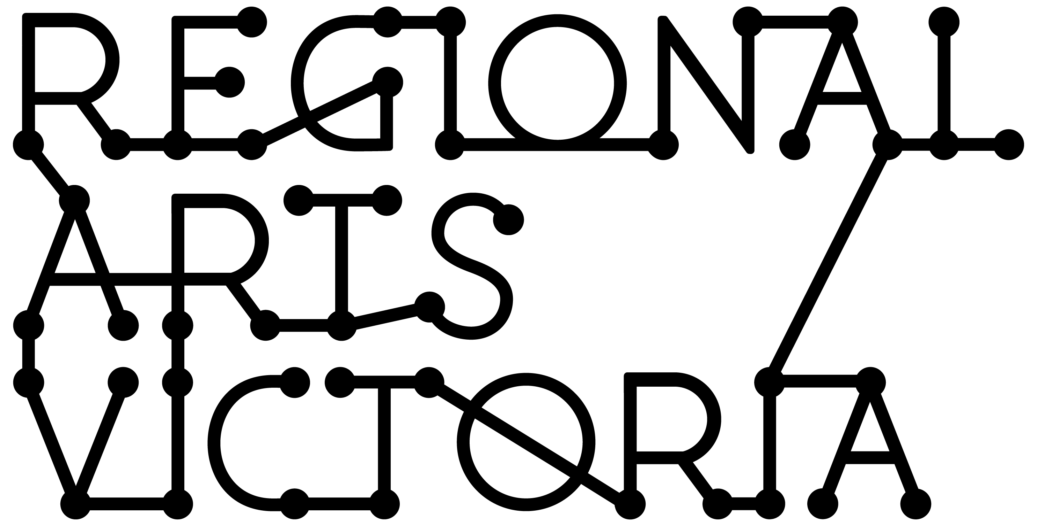
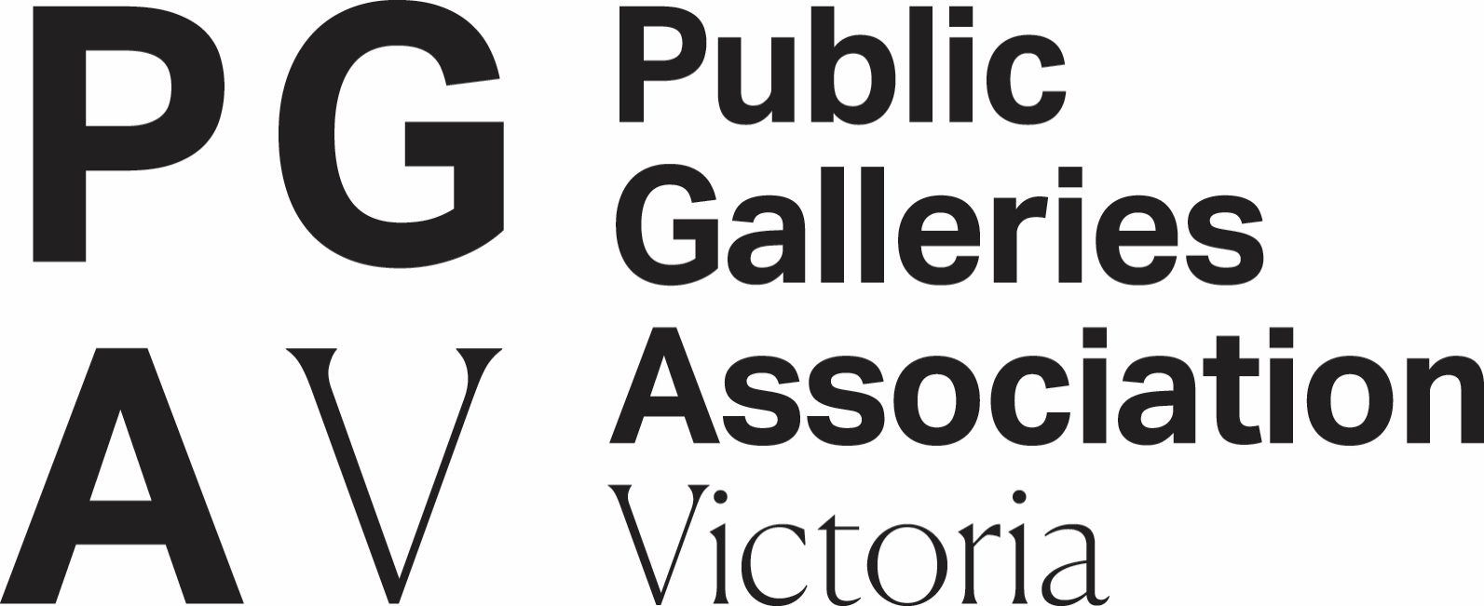
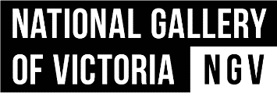
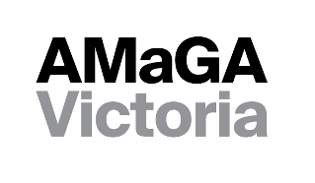

REGIONAL COLLECTIONS ACCESS PROGRAM
GUIDELINES

DECEMBER 2021

Regional Guidelines Access Program
These guidelines have been put together to outline the objectives and eligibility criteria for the Regional Collections Access Program for applicants based in regional Victoria or one of Victoria’s Interface Local Government Areas. You should read these in full before commencing your application.

This information is available in a standard PDF version, an accessible word version, and an audio version. If you require further assistance accessing the Guidelines, please contact us on email grants@rav.net.au.

Contents
Regional Guidelines Access Program 2
The Regional Collections Access Program 4
About the program 4
Objectives of the Program 4
Eligibility 4
Who can apply? 4
Who cannot apply? 5
Funding details 5
Funding Tiers 5
Funding Tier assessment criteria 6
Tier One assessment criteria 6
Funding details 6
Examples of eligible projects 6
Important Dates 6
Assessment Criteria 6
Tier Two assessment criteria 7
Funding details 7
Examples of eligible projects 7
Important Dates 7
Assessment Criteria 7
Tier Three assessment criteria 8
Funding details 8
Examples of eligible projects 8
Important Dates 8
Assessment Criteria 9
Application and assessment process 10
Application guidance 11
Support material 11
SmartyGrants Portal 12
Accessibility 12
Assessment process 12
Assessment panel timelines 12
Program timelines 13
Type of applications that will be funded 13
Types of applications that will not be funded 14
If you are successful 14
Insurance 14
Acknowledgement of Funding 14
Resources and additional information 15
Working with young people/working with vulnerable persons 15
Working with First Peoples cultural content and communities 15
Privacy 16
Payments 16
Auspicing 16

The Regional Collections Access Program

About the program
Galleries and museums across Victoria face challenges in housing and caring for their nationally significant collections, as well as securing artwork and object loans and touring exhibitions due to ageing buildings that may no longer be fit-for-purpose.

The Regional Collections Access Program (RCAP) is a new program to enable equipment and infrastructure upgrades at galleries and museums. The Program will support collections care and storage and facilitate the loaning and touring of collections items from Local, State, National and International lending institutions in regional and Interface Local Government Areas (LGAs). The Program aims to enable more visitors to access more collections in more locations across Victoria.

Applicants to this Program can apply at any time up to the closing date of 5.00pm, 24 February 2022.

The Program is supported by the Victorian Government through Creative Victoria and administered in a partnership between the Australian Museums and Galleries Association Victoria (AMaGA Victoria), the Public Galleries Association of Victoria (PGAV), National Gallery of Victoria (NGV) and Regional Arts Victoria (RAV).

Objectives of the Program
The RCAP program objectives are to:
- Safeguard Collections: support the enhancement of cultural facilities to undertake upgrades through maintenance and small capital works to safeguard collections;
- Exhibit Collections: support eligible facilities to undertake upgrades and capital works that will allow it to exhibit collections of Local, State, National or International significance, resulting in increased tourism and economic stimulus to a facility and region; and,
- Enable Access: enable more visitors to access more Victorian collections in more locations.

Eligibility

Who can apply?
RCAP accepts applications from members of AMaGA Victoria, PGAV or Royal Historical Society of Victoria (RHSV) who are based in one of the 48 Local Government Areas classified as ‘regional’ by the Victorian Government or one of the following 10 Interface LGAs: ]
- Cardinia Shire Council
- Casey City Council
- Hume City Council
- Melton Shire Council
- Mitchell Shire Council
- Mornington Peninsula Shire
- Nillumbik Shire Council
- Whittlesea City Council
- Wyndham City Council
- Yarra Ranges Council

If you are uncertain of your eligibility, contact the relevant program partner listed under “Application guidance”.

Who cannot apply?
Applications will not be accepted from:
- Applicants outside of one of the eligible listed LGAs (see above);
- Applicants who are not members of AMaGA Victoria, PGAV or RHSV;
- Applicants with overdue acquittals for grants from Creative Victoria or Regional Arts Victoria; and/or,
- Organisations that do not own or exhibit collection materials to the public.

If you are uncertain of your eligibility, contact the Program Manager at the relevant partner organisation listed under “Application guidance”.

Funding details

Funding Tiers
Funding from the RCAP is available under the following tiers:
Tier | Funding Available | Examples of Projects Supported | Closing Date | Notification Date
1 | Grants of up to $40,000 | - Equipment purchase and installation  - Project management / specialist expertise in support of project outcomes | 5.00pm 24 February 2022. | 31 May 2022.
2 | Grants of up to $150,000 | - Small-medium scale capital and/or maintenance works including equipment purchase  - First People’s cultural spaces  - Cultural spaces  - Project management / consultants / specialist expertise in support of project outcomes | 5.00pm 24 February 2022. | 31 May 2022.
3 | Grant of $150,000+ | - Medium-large scale capital and/or maintenance works including equipment purchase  - First People’s cultural spaces  - Cultural spaces  - Project management / consultants / specialist expertise in support of project outcomes | 5.00pm on 24 February 2022. All applicants to Tier 3 must meet with a project manager to discuss their submission by 12 February 2022. | 31 May 2022.

Applicants must ensure project start dates are not before the notification date of 31 May 2022.

Funding Tier assessment criteria

All applications will be assessed by an independent panel, comprised of experts from the museum and gallery sectors. Though the criteria are the same across all three Tiers of the Program, the Applications for Tiers 2 and 3 will be required to provide some additional information to address specific criteria.

Tables are provided for each Tier assessment criteria, and include response guidance across each of the Tiers. The assessment criteria will be weighted in accordance with the percentages against each of the headings in the three tables.

Please note that any applications that involve the display of culturally significant collections, including those of First Peoples, must provide evidence of support from the relevant community (see ‘Working with First Peoples cultural content and communities’ for more information).

All applicants to Tier 3 must meet with the relevant Program Manager to discuss their submission by 12 February 2022. Contact details for Program Managers are listed under “Application guidance”.

Tier One assessment criteria

Funding details
One (1) application can be submitted by each eligible organisation requesting up to $40,000. There will be one round of Tier One funding offered.

Examples of eligible projects
- Equipment purchase and installation
- Project management / specialist expertise in support of project outcomes

Important Dates
Application Closing Date: 24 February 2022.
Application Notification Date: 31 May 2022.

Assessment Criteria

CRITERIA | WEIGHTING | QUESTIONS
What is your project? | 20% | Please note: these sub-questions are provided as a prompt only. You don’t need to address each of them if they are not relevant to your particular project.  - What is the problem you are seeking to address through this project?  - What will the funding be used for?  - What will be delivered / achieved?  - Will this project result in increased visitation to your facility and/or region? If so, how?
Why should your project be supported? | 30% | In this section, we want to know why your project should be supported. You must address these sub-questions in providing your response to assist the assessment panel in understanding your initiative.  - Why the project is needed now?  - How will this project enhance your capacity to safeguard your collection?  - Who will benefit from this project, and what evidence is there of their support? For example, visitor numbers or visitor feedback.
Who will deliver your project? | 20% | In this section, we want to know who will deliver your project. You must address these sub-questions in providing your response to assist the assessment panel in understanding your initiative.  - Who is involved in delivering this project, and what are their roles?  - What expertise does the project team/manager have in delivering the project?  - How will this project benefit gallery and museum visitors?
How will your project be delivered? | 30% | In this section, we want to know how your project will be delivered. You must address these sub-questions in providing your response to assist the assessment panel in understanding your initiative.  - What is the timeline for the project to be delivered?  - What evidence exists to demonstrate the feasibility of your project? (For example: quotes for work, feasibility studies, letters of support).

Tier Two assessment criteria

Funding details
One (1) application can be submitted by each eligible organisation requesting up to $150,000. There will be one round of Tier Two funding offered.

Examples of eligible projects
- Small-medium scale capital and/or maintenance works including equipment purchase
- First People’s cultural spaces
- Cultural spaces
- Project management / consultants / specialist expertise in support of project outcomes

Important Dates
Application Closing Date: 24 February 2022.
Application Notification Date: 31 May 2022.

Assessment Criteria

CRITERIA | WEIGHTING | QUESTIONS
What is your project? | 20% | Please note: these sub-questions are provided as a prompt only. You don’t need to address each of them if they are not relevant to your particular project.  - What is the problem you are seeking to address through this project?  - What will the funding be used for?  - What will be delivered / achieved?  - Will this project result in increased visitation to your facility and/or region? If so, how?
Why should your project be supported? | 30% | In this section, we want to know why your project should be supported. You must address these sub-questions in providing your response to assist the assessment panel in understanding your initiative.  - Why the project is needed now?  - How will this project enhance your capacity to safeguard your collection?  - Who will benefit from this project, and what evidence is there of their support? For example, visitor numbers or visitor feedback.  - Please demonstrate how the equipment and/or building infrastructure will allow you to exhibit or loan collections from Local, State, National or International institutions?
Who will deliver your project? | 20% | In this section, we want to know who will deliver your project. You must address these sub-questions in providing your response to assist the assessment panel in understanding your initiative.  - Who is involved in delivering this project, and what are their roles?  - What expertise does the project team/manager have in delivering the project?  - How will this project benefit gallery and museum visitors?
How will your project be delivered? | 30% | In this section, we want to know how your project will be delivered. You must address these sub-questions in providing your response to assist the assessment panel in understanding your initiative.  - What is the timeline for the project to be delivered?  - What evidence exists to demonstrate the feasibility of your project? (For example: quotes for work, feasibility studies, letters of support).  - What other resources (including in-kind) are available to contribute to the project's success?  - If this project has multiple components, what is the order of priority (from highest to lowest) and how do the project components relate to each other?

Tier Three assessment criteria

Funding details
One (1) application can be submitted by each eligible organisation requesting an amount greater than $150,000. There will be one round of Tier Three funding offered.

Examples of eligible projects
- Medium-large scale capital and/or maintenance works including equipment purchase
- First People’s cultural spaces
- Cultural spaces
- Project management / consultants / specialist expertise in support of project outcomes

Important Dates
Application Closing Date: 24 February 2022.
Application Notification Date: 31 May 2022.
All applicants to Tier 3 must meet with a project manager to discuss their submission by 14 February 2022.

Assessment Criteria

CRITERIA | WEIGHTING | QUESTIONS
What is your project? | 20% | Please note: these sub-questions are provided as a prompt only. You don’t need to address each of them if they are not relevant to your particular project.  - What is the problem you are seeking to address through this project?  - What will the funding be used for?  - What will be delivered / achieved?  - Will this project result in increased visitation to your facility and/or region? If so, how?
Why should your project be supported? | 30% | In this section, we want to know why your project should be supported. You must address these sub-questions in providing your response to assist the assessment panel in understanding your initiative.  - Why the project is needed now?  - How will this project enhance your capacity to safeguard your collection?  - Who will benefit from this project, and what evidence is there of their support? For example, visitor numbers or visitor feedback.  - Please demonstrate how the equipment and/or building infrastructure will allow you to exhibit or loan collections from Local, State, National or International institutions?  Applicants to Tier Three must also address at least one of the following in their application:  - How will this project lead to increased economic activity and/or employment during construction?  - How this project will add to increased tourism and/or economic stimulus to your facility and/or region?  - What, if any, support has your organsation received for infrastructure upgrades in the past five years (list by source of funding and amount)?
Who will deliver your project? | 20% | In this section, we want to know who will deliver your project. You must address these sub-questions in providing your response to assist the assessment panel in understanding your initiative.  - Who is involved in delivering this project, and what are their roles?  - What expertise does the project team/manager have in delivering the project?  - How will this project benefit gallery and museum visitors?
How will your project be delivered? | 30% | In this section, we want to know how your project will be delivered. You must address these sub-questions in providing your response to assist the assessment panel in understanding your initiative.  - What is the timeline for the project to be delivered?  - What evidence exists to demonstrate the feasibility of your project? (For example: quotes for work, feasibility studies, letters of support).  - What other resources (including in-kind) are available to contribute to the project's success?  - If this project has multiple components, what is the order of priority (from highest to lowest) and how do the project components relate to each other?  - What is the current capacity of your organisation to deliver the project on time and within budget?  - A high-level implementation plan must be included as support material specifying:  - Key milestones and delivery dates and who is involved in their delivery;  - Key risks and their mitigation strategies and contingencies; and,  - Information on project scope and priorities (if the project has multiple components).

Application and assessment process

Application Process
1 | Prior to applying | - Provide information about you and your organisation, and indicate your membership with AMaGA Victoria, PGAV or RHSV.  - Read program information and guidelines thoroughly.  - Contact the Program Manager at AMaGA Victoria or PGAV with any questions:  - All applicants should contact the Program Manager at the relevant partner organisation before submitting their application. A number of supports are available, depending on your needs:  - Museums and historical societies, should contact AMaGA Victoria to discuss their submission:  - Jackie Fraser, Project Manager, Regional Collections Access Program  Email: jackiefraser@amagavic.org.au  Mobile: 0488 733 562  - Galleries and Art Museums should contact PGAV to discuss their submission:  - Anne Robertson, PGAV Executive Officer (Monday – Friday)  Email: anne.robertson@pgav.ngv.vic.gov.au  Mobile: 0403 268 017
2 | Register via SmartyGrants | - Register for access to the Regional Arts Victoria Smartygrants portal.  - In the online Smartygrants portal, you will need to register as a user, then fill in the details of your application in the Regional Arts Victoria Smartygrants portal.
3 | Apply via SmartyGrants | - Provide some basic statistical information about you and/or your organisation, including contact information.  - Answer the appropriate application questions based on the assessment criteria outlined in these guidelines using 500 words or less to respond to each question.  - Please provide a budget for your project and upload any support material that is relevant to your submission.

Application guidance
All applicants should contact the Program Manager at the relevant partner organisation before submitting their application. A number of supports are available, depending on your needs:
  - Museums and historical societies, should contact AMaGA Victoria to discuss their submission:
  - Jackie Fraser, Project Manager, Regional Collections Access Program
Email: jackiefraser@amagavic.org.au
Mobile: 0488 733 562
- Galleries and Art Museums should contact PGAV to discuss their submission:
  - Anne Robertson, PGAV Executive Officer (Monday – Friday)
Email: anne.robertson@pgav.ngv.vic.gov.au
Mobile: 0403 268 017

Support material
Support material provides the opportunity to communicate your idea in more than words. Effective support material assists the assessment panel to better understand your organisation, your project, and your capacity to deliver it.
Support material you might consider includes:
- Quotes for equipment and infrastructure work to be completed as part of your project;
- Relevant feasibility studies or audience data;
- Confirmation or letters of support from people working on your project or communities you intend to work with (up to a maximum of 10 pages). Effective support letters will tell why the writer wants to be involved, how they are going to be involved and, if they can, provide financial assistance, in-kind assistance, sponsorship or if they just want to come along and participate. If appropriate, they may also state the potential benefits for their community and can provide confidence in the capacity of the applicant to deliver the project.
- Relevant permits (if applicable);
- Biographies of project personnel (up to a maximum of 5 pages); or,
- Images, designs or other creative material (up to a maximum of 10 pages) which might assist the assessors to visualise your project.

If you are applying for Tier 3, a high-level implementation plan (up to a maximum of 10 pages) must be included as support material specifying:
- Key milestones and delivery dates and who is involved in their delivery;
- Key risks and their mitigation strategies and contingencies; and,
- Information on project scope and priorities (if the project has multiple components).

Please note:
- There is a maximum file limit for uploads of 25MB in size. However, it is strongly recommended you try to keep files under 5MB.
- When providing URLs, only use links to publicly available (not membership-based) sites. Link must directly open to the material you want to submit. If you are linking to a private site, you must provide password requirements.
- Do not provide links to Google Drive, Drop Box or other online hosting platforms that require viewers to enter personal identification in order to gain access. Materials provided using these platforms will not be looked at by the assessors.

The following file types are accepted:
Documents | Word (.doc .docx); PowerPoint (.ppt .pptx); Acrobat (.pdf)
Images | .jpg .png .tiff
Audio | .mp3 .wma
Video | .mp4 .wma .avi .mov

SmartyGrants Portal
All applications are to be submitted online using the SmartyGrants system. Applicants who require additional support to access the online application process, or are unable to access the online form, should contact Regional Arts Victoria at grants@rav.net.au.
Links to the forms can be found at this website from 12noon, Thursday 9 December 2021.

Accessibility
The option to submit responses to the application questions in video or audio format is available for those with access requirements. Please contact a support staff member to discuss before submitting via video/audio.

Assessment process
All RCAP program Tiers will be assessed by an independent, external panel of subject matter experts selected by AMaGA Victoria, Creative Victoria, PGAV and RAV.

Applications for First Peoples projects will be assessed via a First Peoples-led process, embedding Aboriginal self-determination into the assessment process.

All panel decisions are final.

Assessment panel timelines

A single competitive funding round closing at 5pm 24 February 2022 will be delivered for all Three Tiers.

Due to the large volume of applications we anticipate receiving, application feedback will not be provided for this program.

Program timelines

Item | Date
Program guidelines released | 9 December 2021
Deadline for Tier 3 meeting requests | 14 February 2022
Applications close | 24 February 2022
Assessment | March 2022
Applicants notified of outcome | 31 May 2022
Projects to be completed. Tier 3 applicants may have other report requirements - please see ‘If you are successful’ for more information. | 30 June 2023

Type of applications that will be funded

The RCAP program supports the purchase of equipment and infrastructure upgrades for collection care and safekeeping, together with the loaning of collection items and the presentation of touring exhibitions from Local, State, National and International lending institutions.

The types of equipment that will be funded through this program include, but are not limited to:
- Climate controls (such as air conditioning, dehumidifiers, data loggers and window treatments);
- Display technology (such as data projectors, VR headsets, HD monitors/screens, and datapoints);
- Lighting and lighting controls;
- Moveable walls;
- Exhibition preparation equipment (such as tables, A Frames, movable tool cabinets)
- Security (such CCTV, alarms, swipe access); and,
- Showcases and other display furniture.

The types of infrastructure upgrades that will be funded through this program include, but are not limited to:
- Additional exhibitions spaces;
- Airlocks;
- Collection stores and storage;
- Crate storage;
- Exhibition Preparation spaces;
- Cultural spaces;
- First Peoples Cultural Spaces;
- Lining / relining of walls; and,
- Loading bay upgrades.

Only one application per applicant (including under auspice) will be accepted across all three Tiers (you cannot apply for more than one Tier). For guidance on the most appropriate Tier for your application, contact the relevant program partner listed under “Application guidance”. Auspice bodies may apply on behalf of multiple applicants. Applications can include sub projects or a number of small projects that make up one application.

Types of applications that will not be funded

The following items are not eligible for support through the RCAP:
- Ongoing staffing costs not related to the delivery of the funded project;
- Operational costs of running a gallery or museum, including ongoing or routine maintenance and archival supplies;
- Repair of equipment or facilities where damage can be covered by insurance;
- Projects that do not align with the outcomes of the program;
- Projects that support private collections or institutions that do not have public outcomes; and/or,
- Projects with a start date before 31 May 2022.

If you are successful

If your application is successful, please be aware that as a recipient of funding, you will be required to:
- Accept a Funding Agreement with Regional Arts Victoria and satisfy any conditions of funding, which will be detailed in the Agreement. After the agreement has been signed, and any other conditions met, the applicant can send an invoice to Regional Arts Victoria.
  - If you receive a Tier 3 funding grant, you may also be asked to provide more detailed information regarding your project implementation before funds are released in full.
- Notify Regional Arts Victoria of any proposed changes to your funded project.
- Give permission to the project partners to access and use relevant samples or images of your project/work in our publicity and marketing activities, reports and other not-for-profit government uses. Regional Arts Victoria will consult with you in the first instance before publishing any publicity or marketing activities.
- Acquit your grant by submitting a written report on the outcomes of your funded project within 30 days of project completion.

Insurance
For any project that involves a public outcome, recipients will be required to provide a copy of their Public Liability Insurance.

Acknowledgement of Funding
All successful applicants must publicly acknowledge the support of Regional Arts Victoria, PGAV, AMaGA Victoria, NGV, and the Victorian Government using specific logos and text.

“Supported by the Victorian Government through Creative Victoria. The Regional Collections Access Program is delivered in partnership with AMaGA Victoria, PGAV, NGV and Regional Arts Victoria.”
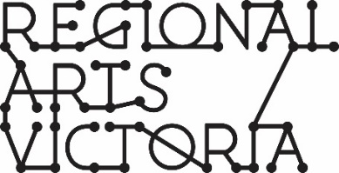
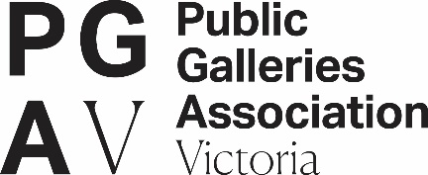

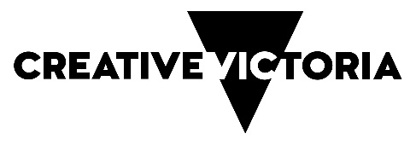

Further information about what will be required should an application be successful is available on our website.

Non-compliance with acquittal conditions may result in the recipient being ineligible for future funding rounds until their acquittal has been submitted and accepted.

Resources and additional information

Working with young people/working with vulnerable persons

A Working with Children’s Check is compulsory for people who carry out child-related work in Victoria. Ensure that your artists/arts workers have current Working with Children Checks and Police Clearances. For more information: dhhs.vic.gov.au/children-and-families

Grantees also need to comply with applicable state, territory and Commonwealth laws before any project personnel commences an activity that involves vulnerable people.

Working with First Peoples cultural content and communities

RCAP requires that any project reflecting or working with Aboriginal and Torres Strait Islander people and/or community should be endorsed by the relevant authority from that community.

It is a requirement that applicants show how they will acknowledge any Aboriginal and Torres Strait Islander cultural knowledge and intellectual property.

If your project contains cultural material or activity and;
- You are an Aboriginal or Torres Strait Islander applicant and are delivering a project outside your community, you must provide appropriate letter/s of support from that community for your application to be eligible.
- You are a non-Aboriginal or Torres Strait Islander applicant, you must demonstrate you are working in partnership and provide appropriate letter/s of support for your application to be eligible.

Further details on the protocols and appropriate acknowledgements of Aboriginal and Torres Strait Islander people and their culture, are available from the Australia Council for the Arts Protocols for working with Indigenous Artists.

Privacy
Regional Arts Victoria values applicants’ privacy. For details on how we collect, store and use information, applicants should review our Privacy Policy at rav.net.au or contact us at enquiry@rav.net.au or call (03) 9644 1800 for a copy.

Application details and applicant contact information may be provided to the State Government (including the Minister and the Department), Members of the Victorian Parliament and may be published on the internet by any of them. This will include the applicant’s name/organisation name, funded project description, funded amount, state/territory, location and electorate.

This information may also be used for promotion and reporting purposes. The Directors of Regional Arts Victoria and their representatives may also use this information to conduct research so that we may better understand community needs and can improve service delivery.
When submitting an application to this fund you will be providing permission for this personal information to be used in this way.

Payments
Payments will be structured with up to 90% paid upon an executed funding agreement and 10% upon final acquittal for grants up to $150,000.

Grants over $150,000 will include payments of up to 60% upon an executed funding agreement, 30% on construction commencing and 10% on financial acquittal.

Payments will be made conditional upon:
- The Funding Agreement having been executed by both parties.
- Milestones having been achieved to the department’s satisfaction including provision of required/requested information and reports to the satisfaction of the department.
- Other terms and conditions of funding continue to be met.

Auspicing
This program accepts applications from auspice organisations applying on behalf of applicants. Any legally constituted body may act as an auspice. If the application is successful, the auspice organisation will receive any funds allocated and is responsible for the management of the project and the acquittal of grant funds. If you are planning on having your grant managed by an auspice organisation, please ensure your application is submitted by that auspice body on behalf of you.
For more information on auspicing, please refer to this link provided by Creative Victoria.

