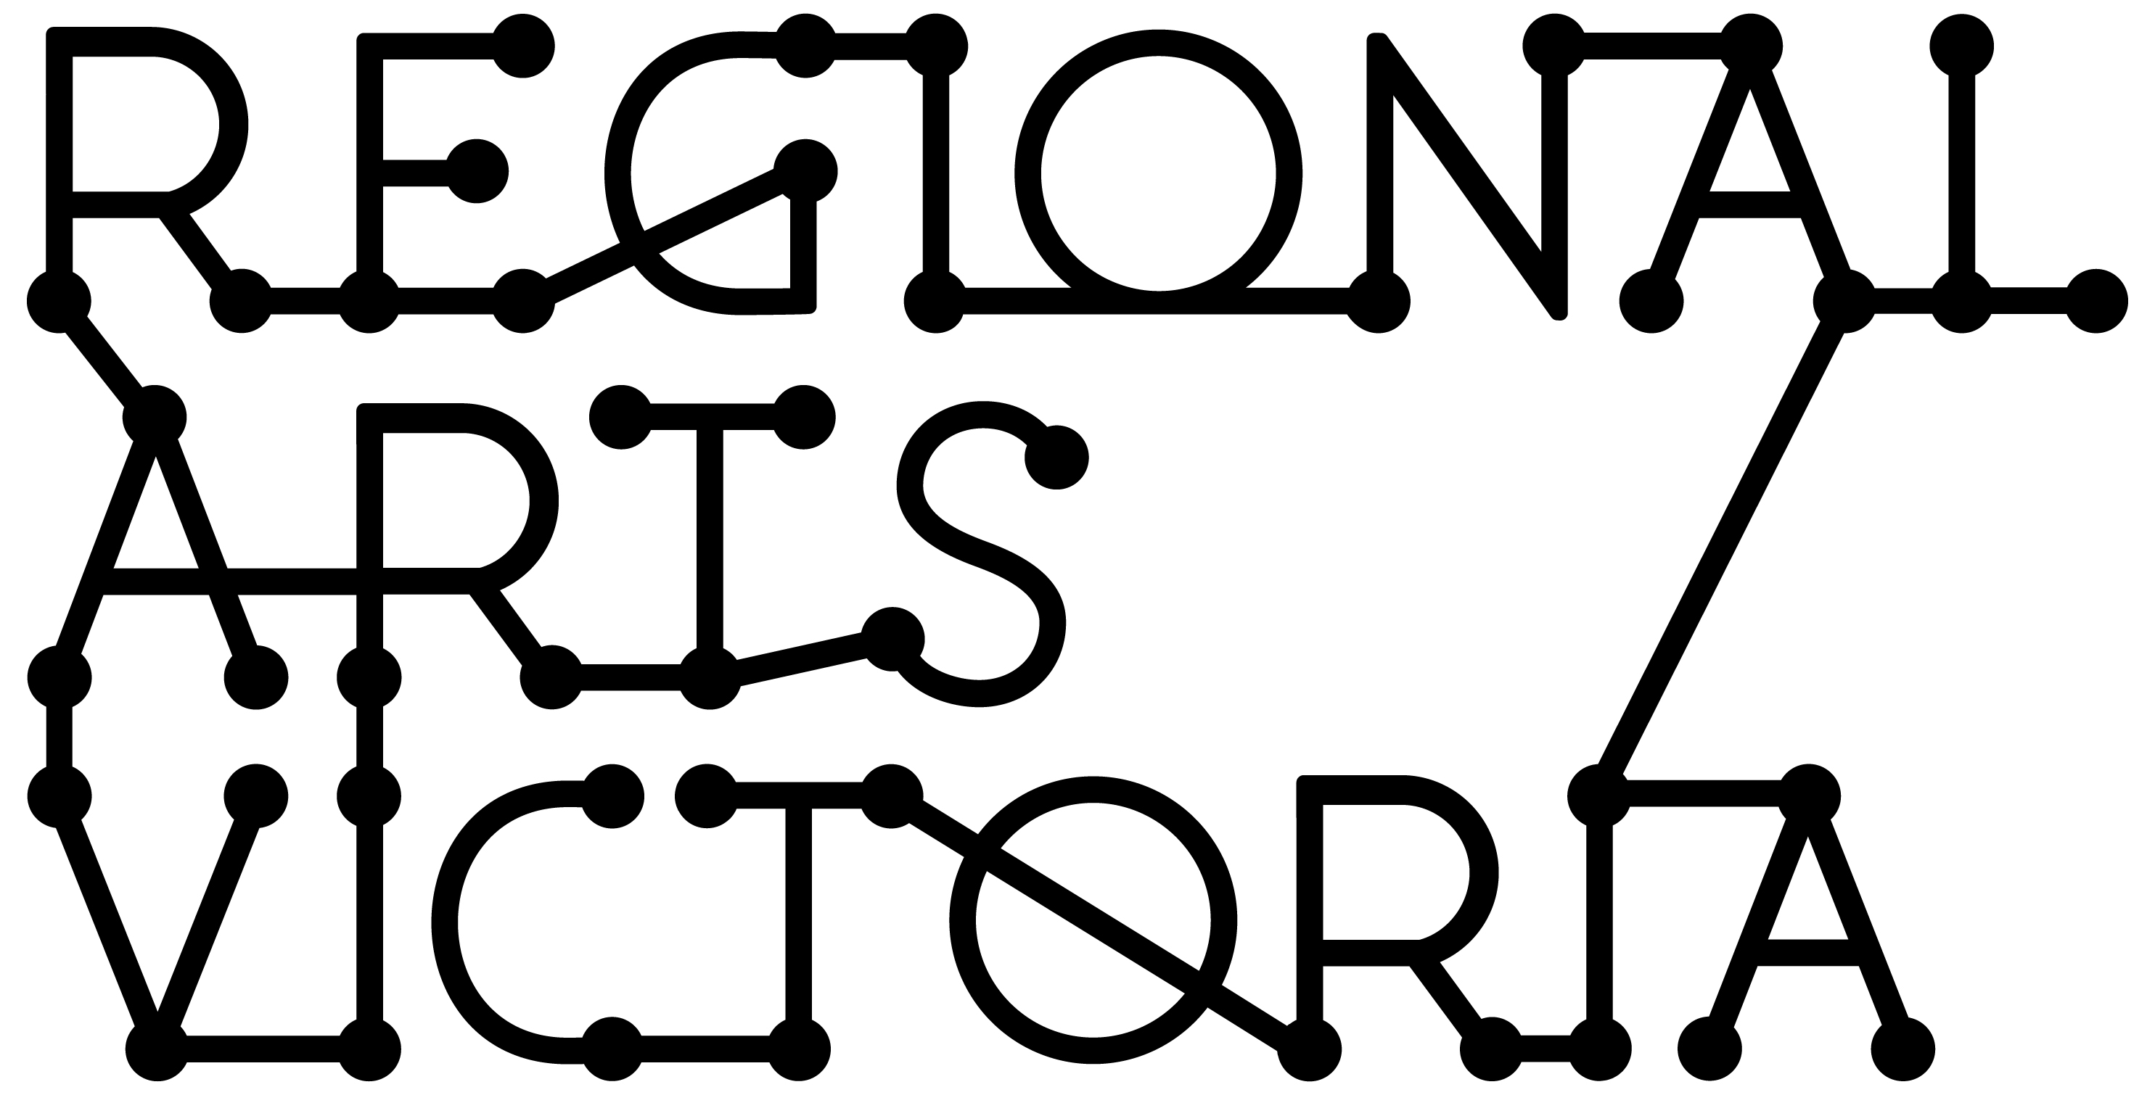

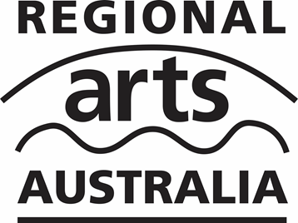
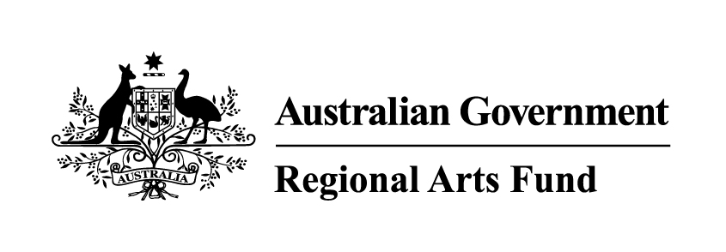
REGIONAL ARTS FUND
GUIDANCE MATERIAL

2016 – 2020
Updated July 2019
Contents

This guidance material has been put together to outline the objectives and eligibility criteria for the Regional Arts Fund in Victoria. It covers each funding category: Community Grants, Quick Response Grants and Fellowships.

This guidance material covers the period 2016 – 2020. Please note that this material is subject to change between grant rounds, so make sure you download the most up to date version from our website before starting your application.

We have also put together some hints and tips to support you in developing your application, which you can find here.

This information is available in a standard PDF version, an accessible word version, and an audio version. If you require
further assistance accessing the Guidelines, please contact us on (03) 9644 1800 or email grants@rav.net.au.

Introduction: What is the Regional Arts Fund? 2
What are the objectives of the Regional Arts Fund? 2
Who Can Apply? 2
What will the Regional Arts Fund not support? 3
Funding Categories. 3
1. Community Grants. 3
2. Quick Response Grants. 4
3. Fellowships. 5
How to apply. 5
Contact a Partnerships team member. 5
Apply Online via SmartyGrants. 5
Assessment process and criteria. 5
Support Material: Letters, CVs and examples of previous work 7
Privacy. 7
If you are successful. 8

Introduction: What is the Regional Arts Fund?

The Regional Arts Fund is an Australian Government Program that supports sustainable cultural development in regional and remote communities in Australia. The program is managed nationally by Regional Arts Australia and is delivered in Victoria by Regional Arts Victoria. The Regional Arts Fund is designed to benefit regional and remote arts practitioners, arts workers, audiences and communities.

There are two Community Grant rounds and one Fellowship round per year.
Quick Response Grants are available throughout the year for exceptional opportunities for artists and their communities.

What are the objectives of the Regional Arts Fund?

The Regional Arts Fund is designed to benefit regional and remote arts practitioners, arts workers, audiences and communities across Australia.

The objectives of the Fund are to support and promote participation in, and access to, arts and culture in regional and remote Australia by:

- Increasing employment and professional development opportunities for, and raising the profile of, regional and remote artists.
- Encouraging and supporting sustainable economic, social and cultural development in regional communities.
- Developing partnerships and networks that leverage financial and/or in-kind support for specific projects and encourage ongoing collaboration.
- Developing audiences and broadening community engagement with the arts.

Who Can Apply?

- Individuals, groups and incorporated not-for-profit organisations.

- Applicants must reside in postcodes classified as regional using the Modified Monash Model Map. The postcode must be MMM classification 2 or above.

To check how your town/district is classified visit the Doctor Connect Locator Map:

https://beta.health.gov.au/resources/apps-and-tools/health-workforce-locator/health-workforce-locator#hwc-map

- Groups and organisations must either be legally incorporated and have an ABN or have an auspice organisation manage their grant.

- Individual applicants must have an ABN or have an auspice organisation manage their grant.

- Individuals who are under 18 at the time of applying must have an auspice organisation manage their grant.

What will the Regional Arts Fund not support?

- Applications from applicants outside of regional Victoria.
- Projects principally benefitting a major city or metropolitan location.
- Components of projects that are also funded by other programs administered by the Australian Government.
- Projects that do not substantially align with the objectives of the Regional Arts Fund.
- Ongoing administration costs of an organisation (with the exception of Small Festivals grants).
- Projects that commence before funding is approved. Projects will be ineligible for funding if they have already been advertised by the applicant, including any online marketing on websites or via social media, until notified of the decision.
- The costs of organising and running competitions, prizes, awards, or fundraising events.
- Curriculum based activities in schools, or courses of ongoing education and training in government or private institutions in Australia or overseas.
- Academic activity, including wages or course work that is required as part of any tertiary academic program.
- Touring projects that involve touring from major urban centres to regional communities.
- Infrastructure projects and projects involving the purchase of assets.
- Applicants who have not acquitted overdue grants from the Regional Arts Fund, or any other Australian Government funding program administered by the Department of Communications and the Arts.
- Recurrent or ongoing funding for projects or programs.
- Requests solely for exhibition, publication, printing, performance or presentation costs.

Funding Categories.

Regional Arts Victoria administers three funding programs within the Regional Arts Fund: Community Grants, Quick Response Grants and Fellowships.

1. Community Grants.

Community Grants are intended to assist cultural development projects that meet the objectives and eligibility criteria of the Regional Arts Fund.

- Project and Skills Development Grants (amounts up to $15,000) are for projects involving regional artists that have a public outcome, and significantly engage the community in which they are based. They can also be used for skills development opportunities for regional artists, arts groups or community organisations.
- Small Festivals Grants (amounts up to $6,000) are available for small, volunteer run arts festivals to employ a professional (regionally based) arts worker to assist to program or coordinate the event, or provide skills development and mentoring for the volunteer committee. Applicants must demonstrate that they have no paid administrative staff and provide evidence of audience growth and community support for the festival. The application should explain how the role will impact on the festivals processes and strategies going forward.
Applicants are limited to one Community Grant application per round and one successful Community Grant application in a 12-month period. Funding is offered on an annual basis only, and no multi-year funding is offered.

Closing Dates:

Round 2 2019 for projects commencing after 1 January 2020
Opening date: Monday 1 July 2019
Closing date: 5.00pm, Monday 19 August 2019

Round 1 2020 for projects commencing after 1 July 2020
Opening date: Monday 13 January 2020
Closing date: 5.00pm, Monday 2 March 2020

Please note: All projects must be completed by 30 June 2021.

2. Quick Response Grants.

Quick Response Grants are intended to assist regional artists, arts organisations and communities to take up mentoring, professional or skills development or small project opportunities.

The Quick Response Grant program is open to applications on an ongoing basis throughout the year. The start date of your project must be between 3 to 12 weeks after the date you submit your application. In 2019, applications will close on Friday 6 December or once funds are expended, whichever is sooner. For 2020, applications will be open from Monday 13 January 2020 to Tuesday 30 June 2020 or until funds are expended.

- Individuals and unincorporated groups may apply for amounts up to $1,500. They are limited to $1,500 per financial year, with a maximum of $2,500 over the four-year funding period (2016 – 2020).

- Organisations may apply for amounts up to $3,000. They are limited to $3,000 per financial year, with a maximum of $6,000 over the four-year funding period (2016 – 2020). To apply for the full $3,000, organisations or groups must be incorporated and have an ABN, otherwise they will only be able to apply for up to $1,500.

This program has been set up to be responsive to projects that fall outside the scope of other funding opportunities. Applicants must clearly explain why there is no other suitable funding program for their project. Please discuss this point with Regional Arts Victoria staff before you begin your application.
Please note: All projects must be completed by 30 June 2021.

3. Fellowships.

The Regional Arts Fund Fellowship Program is intended to assist artists to undertake a self-directed program that builds their capacity to sustain a career in regional Victoria. This fellowship offers the opportunity for an artist or group to undertake a range of activities including residency opportunities, the creation of new work, research and development, skills development and experimentation.

One $20,000 fellowship is available per round for an individual artist living and working in regional Victoria. Groups must have a demonstrated history of ongoing collaborative practice. Applicants must provide evidence of past work and demonstrate how the proposed activity will extend the boundaries of their practice. While no public outcome is required, applicants must document their experience and share their findings in their acquittal.

Applicants are limited to one successful application over the four-year funding period (2016 – 2020).

Closing Dates:

Round 2 2019
Opening date: Monday 1 July 2019
Closing date: 5.00pm, Monday 19 August 2019
Applicants must be available to fulfill the fellowship between January and December 2020

Round 1 2020
Opening date: Monday 13 January 2020
Closing date: 5.00pm, Monday 2 March 2020
Applicants must be available to fulfill the fellowship between July 2020 and June 2021

Additional Opportunity: Successful applicants have the option to request a mentor from the Regional Arts Victoria team for the duration of their fellowship.

How to apply.

Contact a Partnerships team member.

It is essential that applicants speak to a member of the Partnerships team prior to applying. It is preferred that this occurs prior to starting an application. The team can give guidance on eligibility, comment on the development of concepts and support applicants through the application process. They can be a great sounding board, and have extensive arts and cultural networks across the state and beyond!

Applicants should make the most of this opportunity by allowing plenty of time for discussion and feedback before applications close.

Apply Online via SmartyGrants.

All applications are to be submitted online using the SmartyGrants system. Applicants who require support to access the online application process should contact a member of the Partnerships team.
Links to the forms can be found on our website: rav.net.au

We have written an application guide that refers directly to the application form which answers some of our frequently asked questions.

Assessment process and criteria.

Community Grants and Fellowships are assessed by an independent, external panel of artists and cultural workers from across the state. The Australian Government Minister for the Arts has the option to announce the Regional Arts Fund Community Grant recipients,
after which Regional Arts Victoria staff notify all applicants. Notification of the outcome can take around three months after the Grant round closing date. Please be aware this is an indicative time frame only.

Quick Response Grant applications are processed and assessed internally in our Melbourne office. You will be notified of the outcome within 10 working days of receipt of your application.

All applications are assessed against the following six criteria. The questions below each criterion are prompts for the assessors; however in some cases it is understood that not all projects are able to meet every criteria.
Employment/Professional Development for Regional Artists.

- Does the project provide employment opportunities for, and raise the profile of, regional artists?

- Does the project allow an artist access to an exceptional or rare opportunity?

- Does the project help develop the artist’s skills?
Artistic Merit.

- Has the applicant considered the calibre of the artists involved? Is this evidenced through appropriate and high quality support material?

- Has the applicant considered the cultural context in which the project will be placed?

- Does the project involve an original or innovative concept?

Sustainable Cultural, Social and Economic Development.

  - What are the long term outcomes of the project?

  - Does it create opportunities for future cultural activity?

  - Are there any sustainable economic benefits to the project (e.g. increased activity for local tourism and business, paid opportunities for artists, etc.)?

  - Are there any sustainable social benefits to the project (e.g. health, social cohesion, access, etc.)?

Project Viability.

- How realistic is the timeframe and budget?

- Does the applicant have the capacity to deliver? How is this evidenced?

- Is there appropriate community, council or other support for this project?

- Have appropriate risks been taken into consideration and addressed?
Developing Audiences and Broadening Community Engagement.

- How is the project providing opportunities for community members or groups to participate in the arts?

- Does the project develop audiences by attracting new attendees or participants?

- Does the project develop audiences by extending their experience of the arts?

Partnerships, Collaborations and Networks.

- Is community support for this project evidenced through partnerships and collaborations? Do these leverage financial and/or in-kind support for the project?

- Does the project assist the development of networks, collaborations and partnerships that could support future cultural activity?

Support Material: Letters, CVs and examples of previous work

Applicants must supply CVs for artists and arts workers in the relevant areas of the online application. CVs cannot exceed more than two pages per artist. CVs included should relate to the work that will be required of the artist. Other support material can be uploaded to online applications. You will only be able to upload:

- One support letter from each of the strategic partners
- Seven written material documents (must not exceed more than five pages each)
- Five photographs and images such as art works or examples of past projects
- Three direct links of audio, images or video (no greater than three minutes in length per video)
- Two audio files (mp3 format preferred)

Support material gives the opportunity to sell us an idea in more than words. This is an opportunity for applicants to show us some great examples of previous projects and artwork relevant to their submission.

Effective support letters will tell why the writer wants to be involved, how they are going to be involved and, if they can, provide financial assistance, in-kind assistance, sponsorship or if they just want to come along and participate. If appropriate, they may also state the potential benefits for their community and can provide confidence in the capacity of the applicant to deliver the project. Support letters may vary depending on the type of category you are applying to. Fellowships will require support material and letters that provide evidence of experience, commitment to your work and significance of your practice as an artist or group in the community.

Privacy.

Regional Arts Victoria values applicants’ privacy. For details on how we collect, store and use information, applicants should review our Privacy Policy at rav.net.au or contact us at enquiry@rav.net.au or call (03) 9644 1800 for a copy.
The Australian Government stipulates that application details and applicant contact information may be provided to the Australian Government (including the Minister and the Department), Members of Parliament, Regional Arts Australia, and other Regional Program Administrators (such as Regional Arts Victoria) and may be published on the internet by any of them. This will include the applicant’s name/organisation name, funded project description, funded amount, state/territory, location and electorate.
This information may also be used for promotion and reporting purposes. The Directors of Regional Arts Victoria and their representatives may also use this information to conduct research so that we may better understand community needs and can improve service delivery.
When submitting an application to the Regional Arts Fund you will be providing permission for this personal information to be used in this way.

If you are successful.
Successful applicants will be sent a contract and information about invoicing and reporting on the project.

Funds will be provided once Regional Arts Victoria receives an invoice with a valid ABN.

After the project an acquittal will need to be submitted.
- For Quick Response Grants: 6 weeks after the project’s end date
- For Community Grants: 13 weeks after the project’s end date
- For Fellowships: 13 weeks after the project’s end date

Information about what will be required should an application be successful is available on our website: rav.net.au/funding-opportunities/regional-arts-fund/info/

Regional Victoria is defined as a postcode that is MMM Classification 2 or above. Check how your town/district is classified here: https://beta.health.gov.au/resources/apps-and-tools/health-workforce-locator/health-workforce-locator#hwc-map

