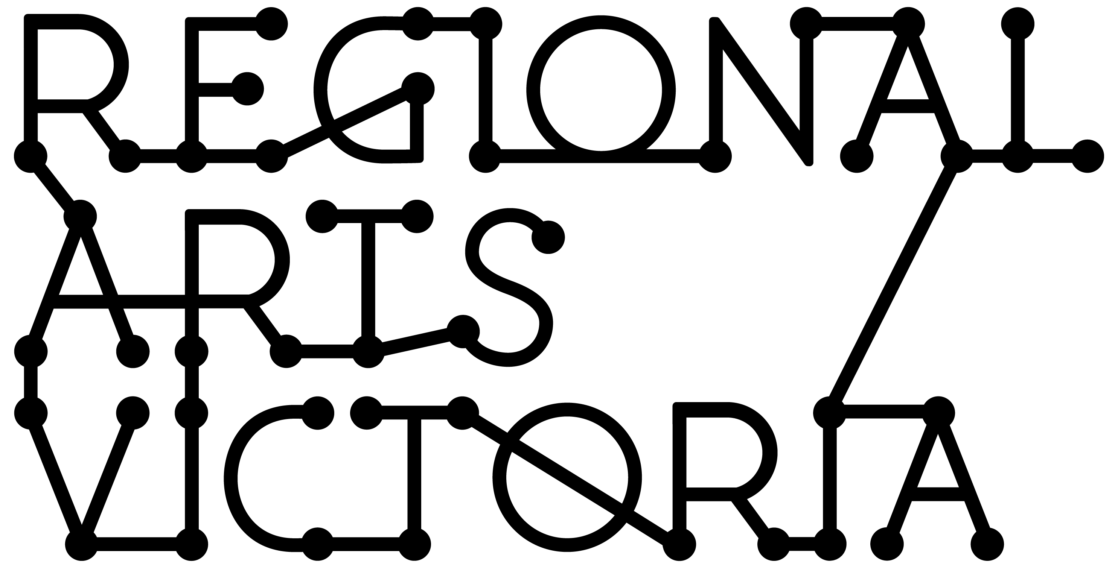

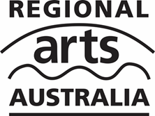
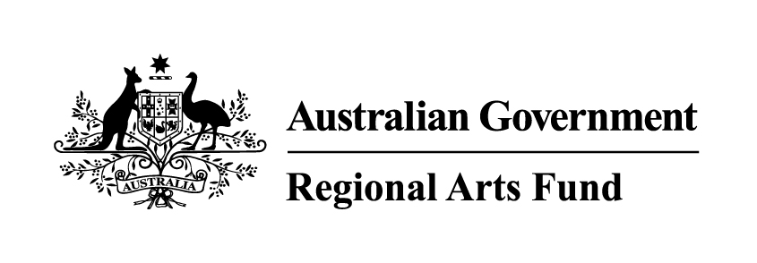
REGIONAL ARTS FUND
APPLICATION GUIDE

2016 – 2020
Updated December 2018
Contents.

These hints and tips have been compiled to support you as you work through an application form for the Regional Arts Fund. Each section relates to a different pages of the application form on SmartyGrants.

Before working through this document, you must read the guidance material and talk to a member of the Partnerships Team to make sure your project is eligible and appropriate for the Fund.

Before You Begin. 2
Page 1: Contact Regional Arts Victoria. 2
Page 2: Applicant Details. 2
Page 3: Auspice Organisation. 3
Page 4: Project Details. 3
Page 5: Aboriginal & Torres Strait Islander Cultural Material. 3
Page 6: Working with Children. 4
Page 7: Project Description. 4
Page 8: Project Timeline. 5
Page 9: Artists and Arts Workers. 6
Page 10: Strategic Partnerships. 6
Page 11: Project Budget. 7
Page 12: Support Material. 8
Page 13: Privacy Statement & Declaration. 9
Page 14: Feedback. 9

Before You Begin.
- The SmartyGrants application form has a Form Navigation contents box, this links directly to every page of the application. Click the link to jump directly to the page you want.
- You may begin anywhere in this application form. Please ensure you save as you go.
- You can save a partially completed application, press 'save' and log out. When you log back in and click on the 'My Submissions' link at the top of the screen, you will find a list of any applications you have started or submitted.
- You can download any application, whether draft or completed, as a PDF. Click on the 'Download' button located at the bottom of the last page of the application form.
- If you need more help using this form, SmartyGrants have developed a help guide: https://applicanthelp.smartygrants.com.au/help-guide-for-applicants/

Page 1: Contact Regional Arts Victoria.
Applicants must contact a Creative Arts Facilitator or a member of the Partnerships Department before completing an application to the Regional Arts Fund. Assistance and advice can be given if sufficient time is allowed prior to application closing dates.
Find your local Creative Arts Facilitator or member of the team here.
The Creative Arts Facilitators are part of the Partnerships Department. They are Regional Arts Victoria's key arts catalysts. Based in pivotal regional locations across the state, they work closely with artists, communities and local government. This passionate team facilitates new work, keeps communities informed of key arts opportunities and development as well as supporting arts policy development. Our Facilitators form part of the national Regional Arts Development Officer network.

Page 2: Applicant Details.
Applicant.
The applicant is the person or organisation applying to receive the funding. In this section you will need to tell us who the applicant is, provide details such as the street address and, if applicable, ABN.

Insurance.
We ask you to consider whether you have appropriate insurances for your project. If your project involves the public in any way as creative participants, workshop participants or audience members, you are liable for any claims of personal injury or property damage that a third party may make as a result of these activities. In order to protect yourself and/or your organisation, you MUST have Public Liability Insurance (PLI). The level of insurance you require will be dictated by the size of your event. Sometimes, funding or project delivery partners will require you to have a certain level. You may also need other forms of insurance to cover you and your members. If you are unsure, your auspice organisation may also be able to help you with insurance. Regional Arts Victoria also provides access to some insurance through membership.

Organisation Details.
If you are applying on behalf of an organisation, we ask you what type of organisation you belong to and give details about the organisation’s President or Chair.

Contact Details.
If you are applying on behalf of an organisation, we ask for the details of the contact person. This is the person we will contact about the application.

Auspice Organisation.
An auspice is a legally constituted organisation that will take financial responsibility for a grant if awarded. The auspice body is responsible for accepting the grant monies on behalf of the grant recipient, paying the grant monies to the grant recipient and ensuring, to the best of its ability, that the funds are used for the purpose for which the grant is intended.

It is recommended that grant recipients enter into a written agreement with their nominated auspice body highlighting respective rights and responsibilities.
To be able to auspice your project, the auspice organisation must be an incorporated association or a company limited by guarantee and hold an ABN. An example of an incorporated association is a local council, a local arts council or local sports club. You may be able to find a suitable auspice organisation at www.acnc.gov.au .

Page 3: Auspice Organisation.
If you have said that you need an auspice organisation, here we ask for the details, including ABN and contact details, of that organisation. If your application is successful we will be in touch with the contact person to arrange contracts and invoicing.

Page 4: Project Details.
Tell us some basic details of your project, such as its title.

Here we also ask for a short summary of no more than 100 words. While you will have space on the next page to talk more about the project, the summary is the first thing that assessors will read about your project, so make sure it is clear. This summary will also be used to develop a short paragraph about your project should your project be successful. To see an example of a project summary please look at the list of Successful Quick Response Grant or Successful Community Grant Applications.

Page 5: Aboriginal & Torres Strait Islander Cultural Material.
Aboriginal and Torres Strait Islander cultural material refers to Aboriginal and Torres Strait Islander cultural heritage and may include, but is not limited to, objects, knowledge, artistic, literary, musical and performance works.
Protocols are appropriate ways of using Aboriginal and Torres Strait Islander cultural material and working with Aboriginal and Torres Strait Islander artists and communities. They encourage ethical conduct and promote interaction based on good faith and mutual respect. Responsible use of Aboriginal and Torres Strait Islander cultural knowledge and expression will ensure that Aboriginal and Torres Strait Islander cultures are maintained and protected so that they can be passed on to future generations.
If your project uses Aboriginal and Torres Strait Islander Cultural Material, you must show how you will acknowledge the cultural and intellectual property and how you have consulted with community and gained permissions to proceed.
Further details on the protocols and the appropriate acknowledgements of local community authority, communal rights over cultural heritage material, engagement of Aboriginal and Torres Strait Islander people through consultation and prior informed consent mechanisms are available from the Australia Council for the Arts.

Page 6: Working with Children.

If your activity at any stage involves working with children under 18, you must comply with Working With Children protocols and state that you have read them in this section. You can find out more about obtaining Working With Children checks here.

Page 7: Project Description.
In this section of the application form we ask you to describe your project in more detail.

It’s important to describe your concept clearly. Panel members have commented that they sometimes have difficulty getting a clear sense of the project despite repeatedly reading the application. Describing ideas in an engaging way is encouraged, and using dot points can be useful. Make sure that you spell out acronyms and do not assume that panel members have the same knowledge as you. Always consider that no-one on the panel will know anything about you or your project. A good idea is to get someone not at all connected with the project to read a draft and give you feedback.
Assessment criteria
All applications are assessed against the following six criteria. The questions below each criteria are prompts for the assessors. You do not need to answer each of the prompts, but strong applications will explain how their project addresses one or more of these prompts across the selection criteria
Employment/Professional Development for Regional Artists.

- Does the project provide employment opportunities for, and raise the profile of, regional artists?

- Does the project allow an artist access to an exceptional or rare opportunity?

- Does the project help develop the artist’s skills?
Artistic Merit.

- Has the applicant considered the calibre of the artists involved? Is this evidenced through appropriate and high quality support material?

- Has the applicant considered the cultural context in which the project will be placed?

- Does the project involve an original or innovative concept?

Sustainable Cultural, Social and Economic Development.

  - What are the long term outcomes of the project?

  - Does it create opportunities for future cultural activity?

  - Are there any sustainable economic benefits to the project (e.g. increased activity for local tourism and business, paid opportunities for artists, etc.)?

  - Are there any sustainable social benefits to the project (e.g. health, social cohesion, access, etc.)?

Project Viability.

- How realistic is the timeframe and budget?

- Does the applicant have the capacity to deliver? How is this evidenced?

- Is there appropriate community, council or other support for this project?

- Have appropriate risks been taken into consideration and addressed?

Developing Audiences and Broadening Community Engagement.

- How is the project providing opportunities for community members or groups to participate in the arts?

- Does the project develop audiences by attracting new attendees or participants?

- Does the project develop audiences by extending their experience of the arts?

Partnerships, Collaborations and Networks.

- Is community support for this project evidenced through partnerships and collaborations?

- Do these leverage financial and/or in-kind support for the project?

- Does the project assist the development of networks, collaborations and partnerships that could support future cultural activity?

Page 8: Project Timeline.

In this section we ask for your project start and end dates, as well as a more detailed timeline. For Community Grants, your project may not start before the nominated start date. For Quick Response Grants, your start date must be between 3 to 12 weeks from the date of your application.

Timelines help show how your project will be achieved and managed. A timeline can include but is not limited to things like when you will contract artists or do your marketing, as well as other milestones.

Remember that projects cannot commence before funding is approved. Projects cannot have been advertised by the applicant, including any online marketing on websites or via social media. Make sure everyone connected to your project is aware of this.

Page 9: Artists and Arts Workers.

This section asks you to provide information about the artists and arts workers that will be involved in the project.

- Artist is the person who is responsible for developing, the making of, and delivering the creative outcomes of the project
- Arts Worker is someone who provides administrative or operational support to the artist/s, community, participants or the project as a whole
You will need to name and provide CVs for all artists and arts workers working on the project. They should reflect the skills required for the artist's or arts worker’s role in the project.
- CVs must not exceed 2 standard pages. They should be uploaded as a PDF and named using the following format:
- Application number_Type of support material (e.g "CV")_Description (e.g. "Artist Name").
You need to say whether the artist is regionally based. The Regional Arts Fund in Victoria is designed to support Victorian regional artists and arts communities. It may be, however, that your particular regional project would benefit from an artist with skills not found in your area. In this instance, you may employ an artist from a city or from interstate. If this is the case, you will need to clearly articulate your reasons for including them. In your project description (under “Who will be involved in your project?”) you will need to clearly define the benefit or skill that will be transferred to the host community from this particular artist that can’t be achieved through the employment/engagement of an artist from regional Victoria.

Page 10: Strategic Partnerships.
Strong applications will make strategic partnerships with organisations, businesses and individuals who can support the project, either through co-funding arrangements or in-kind support. This will help to make sure that projects and programs will be sustainable

You should upload a support letter from each partner. Please do not upload more than two documents per strategic partner. Written documents should be uploaded as a PDF and named using the following format:
Application number_Type of support material (e.g "Support Letter")_Description (e.g. "Partner Name").
You are also able to upload video support statements. Either provide the URL link to the video or upload the video making sure the file size is small (recommended size no more than 5mb) and each individual video is no longer than 2 minutes.
The best support letters are:
- Clear
- Show who the writer is and/or represents and their contact information
- Show what the writer’s relationship is to you and/or the project
- Show an understanding of the project – how it is relevant and its potential impact
- Include any permissions, funding or in-kind support offered

Page 11: Project Budget.
In this section of the form, you will need to provide a budget. This includes an in-kind budget, cash income and cash expenditure. A well-constructed budget is vital to the success of your application. It provides evidence of what you have showed us in your application so far and also demonstrates the viability of the project to the assessors.
This budget should only cover the project for which you are seeking funds. For example, if you are applying for a workshop which makes up one component of a larger festival, please only provide a budget that focuses on the workshop and not the festival itself.
Before completing the budget section we strongly advise all applicants to create a draft budget to ensure the income and expenditure balances and all in-kind contributions are identified and correctly allocated.
A sample budget and a budget template that can be used as a draft can be downloaded from the Regional Arts Victoria website here.
In-Kind Budget.
Sometimes an organisation or group might offer to help you by providing something you require for your project at no cost (e.g. venue hire, volunteer hours, donations of materials). This is referred to as an ‘in kind contribution’ and has a value or cost that can be shown in your project budget.

It is really important that you include a monetary value associated with support provided to your project. If an organisation is supporting you with venue hire, give this a dollar value and include it in the budget.

When an artist is taking a cut in fees to do the project, show the balance of their contribution as ‘in-kind’ so that the value of their input is properly represented. If you expect the project administration to take 50 hours but only request payment for 20 of these – show the remaining 30 hours as an in-kind contribution.

This is also an opportunity to provide further evidence of how your partners will be supporting you with in-kind support.

Cash Income.
As well as putting in the amount requested from the Regional Arts Fund, applicants are expected to seek support from other sources. These should be indicated in the budget as confirmed or not confirmed.

Cash Expenditure.
In this section, you can show us any cash expenses that your project will incur. Please itemise each item. Expenditure totaling the amount of the Regional Arts Fund grant request must be noted in the Regional Arts Fund Amount column..
The Regional Arts Fund has strict criteria about what items it can fund. It cannot fund ongoing administration costs, the purchasing of assets, or elements of a project that are receiving funding from another fund provided by the Department of Communications and the Arts.
Budget Totals.
Here you will need to enter your total Regional Arts Fund requested amount. The other totals calculate automatically.
Please note that all budgets must break even. This means that the Cash Balance should be $0. If it is not you need to go back and check your budget.

Page 12: Support Material.
In this section of the application we invite you to upload support material for your application. Please do not upload information that you have already uploaded throughout the application and please upload only information that is relevant to this application.
You will only be able to upload:
- Up to seven written material documents.
- Up to five Photographs/images such as art works or examples of past projects.
- Up to three Direct web links of audio, images or video (no greater than 3 minutes in length each)
- Up to two audio files (mp3 format preferred)
- Optional video summary of the project (no greater than 2 minutes in length)
Written Material.
Written Material includes, but is not limited to documents such as reviews, media coverage, synopses or pages of manuscript (max. five pages each).
If applicable, please upload your Aboriginal and Torres Strait Islander Agreements and Working with Children evidence here.
You could also include support letters from potential audience members and participants.
This written material should not include CVs or support letters from strategic partners as this information should be uploaded in the relevant section throughout the application form.
Photographs or Images.
These images could include the artist’s previous work, examples of the location of the project, or anything else that will help demonstrate to the panel what you have outlined in your application. Please explain what the image is.
URLs.
URLS could be links to short clips of work you have on YouTube, examples of images on Tumblr, Flickr or Instagram. It could also be a direct link to a webpage you have designed, or someone else's website that displays your work.
Audio, images or video shown must each be no longer than three minutes in length each.
Give the direct link and briefly annotate in ‘Description’ what you want viewed as support material.
Audio Files.
You can upload sounds files here, but each must not be more than 3 minutes in length.
Video Summary.
In addition to the written project description applicants have the option to submit a short (no greater than 2 minutes) video describing their project.

Page 13: Privacy Statement & Declaration.
In this section you must agree to the privacy statement and make a declaration, including that you are authorised to submit the form.

Page 14: Feedback.
This is an optional section where we ask for feedback on your application process. It will not be used to assess your application.

Please also take a moment to review your application before clicking submit.

