Sustaining Creative Workers Initiative

Funding Conditions
The Sustaining Creative Workers initiative seeks to support the continued work of Victoria’s independent creative practitioners who have been negatively impacted by coronavirus (COVID-19).

Regional Arts Victoria will administer Sustaining Creative Workers on behalf of the Creative Victoria to deliver quick-response funding to independent creative practitioners, sole traders, freelancers, collectives and micro-organisations/businesses based in regional Victoria whose work and livelihoods have been negatively impacted by coronavirus.

It is essential to the continuation of Government support for the arts that funding recipients are, and are seen to be, fully accountable for the money they receive. For this reason, the following terms and conditions have been established. These conditions need to be formally accepted before the grant can be paid. If you anticipate problems in complying with any of the conditions placed on this grant you should discuss this with the nominated contact officer as soon as possible.

Use of Grant 1
Special conditions applying to this Grant 1
Consultation and Monitoring 1
Reporting Requirements/Acquittal Reports 1
Intellectual Property and use of Activity Material 1
Indemnity and Compliance 2
Notice of Project Events 2
Acknowledgement of Support 2

Use of Grant
This grant can only be used for the purpose specified in the offer of grant. Recipients must seek approval in writing from Regional Arts Victoria before any variation is made to the funded activity. A variation occurs when aspects of a project change. This could include artists becoming unavailable or changes to the dates on which the activity is to take place.

Special conditions applying to this Grant
Any special conditions applying to this grant are explained in the attached Offer of Grant, which forms part of this agreement.

Consultation and Monitoring
Regional Arts Victoria staff shall have access to any relevant material, documentation or records relating to the funded projects. Grant recipients must respond within 14 days to any written request for information about the funded project.

Reporting Requirements/Acquittal Reports
Recipients of funding through the Sustaining Creative Workers initiative must provide Regional Arts Victoria with an acquittal report by completing an online acquittal form. Information to be provided will include:

- A financial statement detailing project income and expenditure, including a reconciliation of the grant funds received.
- A written evaluation of the project.
- Statistics relating to actual audience and participant numbers.
- Documentation of proof of acknowledgement of the Creative Victoria and Regional Arts Victoria is required. This could include copies of all publicity materials produced for the project and copies of all media coverage about the project including a listing of appearances on radio and TV and websites.
- Support material/documentation (if applicable) that may include photographs and testimonials. When people are present in your images, a photographic subject release form must be attached with your acquittal. You can download a copy of this form from the Regional Arts Victoria website: rav.net.au/funding-opportunities/sustaining-creative-workers/info

Acquittal reports are due 30 days after the nominated completion of the project OR by 31 December 2021, whichever is sooner. If an acquittal report is not satisfactorily submitted by the due date, the grant may need to be returned.

Intellectual Property and use of Activity Material
Activity Material means any material created through use of the Sustaining Creative Workers initiative.
Intellectual Property Rights in Activity Material rests in the artist or community as specified in submissions and reports.

Moral rights are the personal rights of the artist and includes the artist’s right:
- To be named the author or creator of their work (the right to attribution)
- Not to have their work falsely attributed to another (the right against false attribution)
- To protect their work from unauthorised alteration, distortion or other derogatory treatment that prejudices their honour and reputation (the right of integrity)

You will observe the moral rights of the artist/s, regardless of who holds the Intellectual Property Rights.

You will grant to the Creative Victoria, through Regional Arts Victoria, the right to use, reproduce, adapt and exploit the Intellectual Property Rights in Reports for any purpose. Regional Arts Victoria will also have the right to use activity material for promotion of the program.

Indemnity and Compliance
You will indemnify (and keep indemnified) Regional Arts Victoria and the Creative Victoria against any costs, losses, and damage arising from this grant. This means that you will also take out the requisite insurance, including Public Liability Insurance.

If you are working with children you will be expected to have the requisite Working with Children check: workingwithchildren.vic.gov.au

You will ensure that you and everybody involved in your project abide by current state government social distancing rules in operation for the period of your project or activity.

Notice of Project Events
Recipients are required to send invitations to Regional Arts Victoria for performances, exhibitions, launches or similar events where relevant.

Acknowledgement of Support
All recipients of Sustaining Creative Workers initiative acknowledge the funding by using both the Creative Victoria logo and Regional Arts Victoria logo in all advertising and promotion material.

The logo below is at the minimum allowable size and should be on all promotion material including brochures, invitations, flyers and all other documentation. You can download the digital version of the logo from the Regional Arts Victoria website: rav.net.au/funding-opportunities/sustaining-creative-workers/info

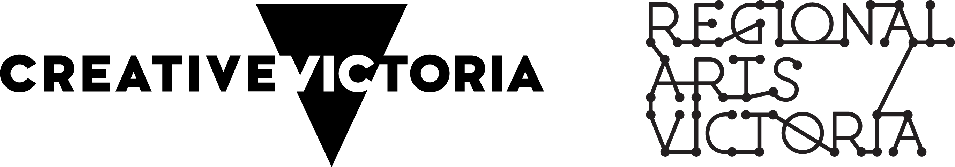

The Creative Victoria logo must be used on all public materials relating to your funded project or activity. Its size and placement should be commensurate with the level of support provided by Creative Victoria and relative to other supporters or sponsors. Minimum size, clear space and other requirements are outlined below.

Additional information regarding Creative Victoria acknowledgement can be found on their website:
creative.vic.gov.au/grants-and-support/information-for-current-recipients/logos-and-acknowledgements/creative-victoria-logo-and-guidelines

