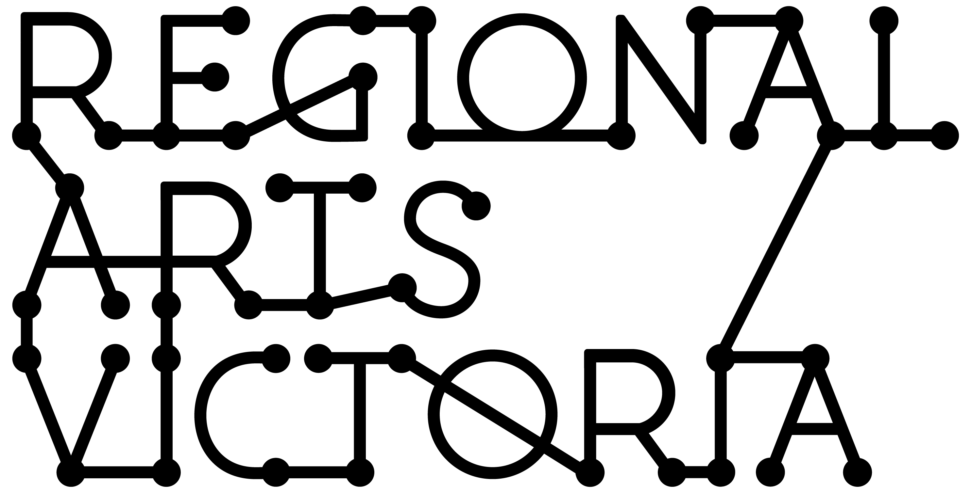

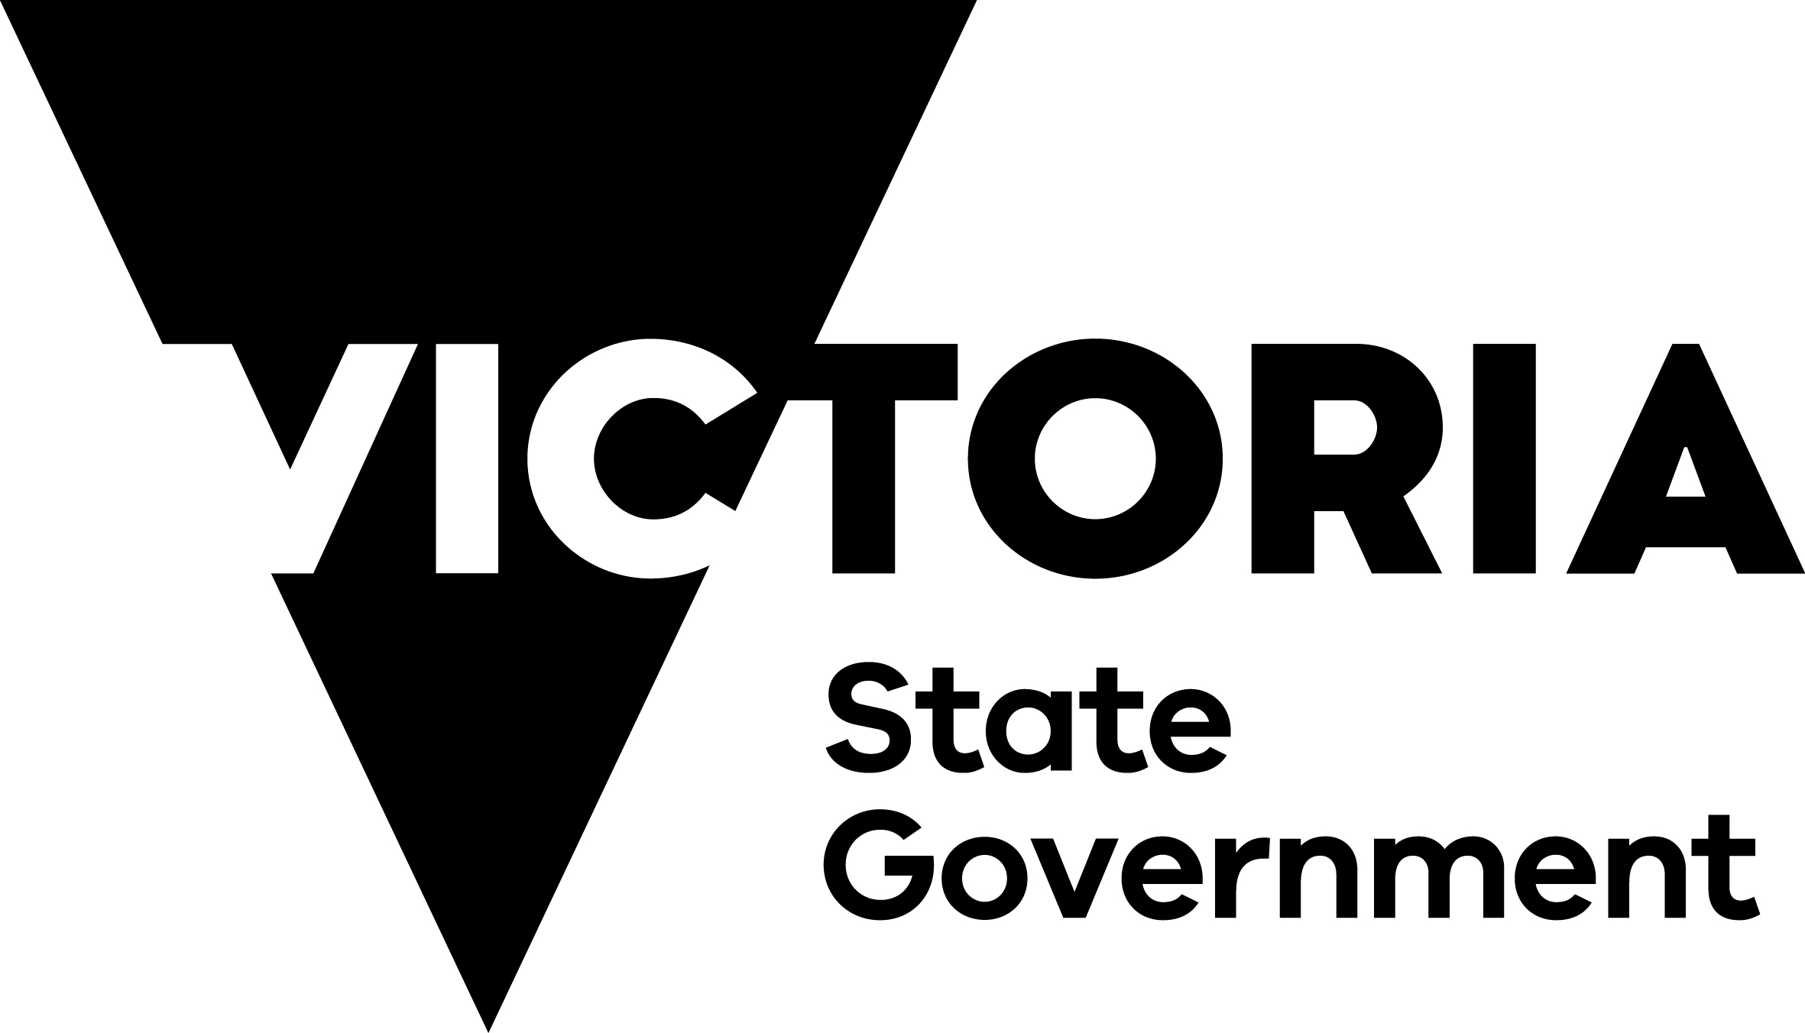
Anniversary of the 2009 Bushfires
COMMUNITY ARTS GRANTS PROGRAM
GUIDELINES

2018-19
Contents

This guidance material has been put together to outline the objectives and eligibility criteria for the Community Arts Grants Program as part of the Victorian Government’s commemorative activities for the 10 Year Anniversary of the 2009 Victorian Bushfires.

This information is available in a standard PDF version, and an accessible word version. If you require further assistance accessing the Guidelines please contact us on
(03) 9644 1800 or email agibson@rav.net.au.

What are the Community Arts Grants? 2
Who Can Apply? 2
What will the Community Arts Grants support? 2
What will the Community Arts Grants not support? 3
Key Dates. 3
How to apply. 4
Contact Regional Arts Victoria’s Grants Project Manager. 4
Apply Online via SmartyGrants. 4
Assessment Process and Criteria 4
Addressing the Assessment Criteria. 4
Support Material. 5
Privacy. 5
If you are successful. 5

What are the Community Arts Grants?

The Community Arts Grants program will provide funding for creative arts projects that reflect the experiences of local communities directly affected by the 2009 Victorian bushfires. Regional Arts Victoria will administer funding for communities and individuals from the 21 local government areas directly affected.

Who Can Apply?

- The Community Arts Grants program accepts applications from individuals, community organisations, and incorporated not-for-profit organisations including arts, non-arts, community and local government.

- Applicants must reside in one of the 21 local government areas directly affected by the 2009 bushfires. These are:

Alpine Shire Council
Baw Baw Shire Council
Cardinia Shire Council
City of Casey
Corangamite Shire
City of Greater Bendigo
Hepburn Shire Council
Horsham Rural City Council
Indigo Shire Council
Latrobe City Council
Macedon Ranges Shire Council
Mitchell Shire Council
Mount Alexander Shire Council
Murrindindi Shire Council
Nillumbik Shire Council
Shire of South Gippsland
Southern Grampians Shire Council
Rural City of Wangaratta
Wellington Shire Council
Whittlesea City Council
Yarra Ranges Council

- Any individual or organisation directly affected by the 2009 bushfires who resides outside of the nominated local government areas may be eligible if their project outcome occurs within, or directly benefits, one or more of the areas. Applicants in this instance must contact the Grants Project Manager prior to commencing an application.

- Groups and organisations must either be legally incorporated and have an ABN or have an auspice organisation manage their grant.

- Individual applicants must have an ABN or have an auspice organisation manage their grant.

- Individuals who are under 18 at the time of applying must have an auspice organisation manage their grant.

What will the Community Arts Grants support?

- Creative projects which reflect the experience of local communities impacted by the 2009 bushfires.
- Projects that will occur in one of the local government areas eligible for funding.
- Creative arts projects that are community led.

What will the Community Arts Grants not support?

- Activities that do not specifically target residents from one of the 21 eligible local Government areas
- Activities which are of an individual, private, political or commercial nature
- Personal memoirs
- Projects and programs that do not follow correct protocols when working with Aboriginal artists and/or communities
- Applicants that have an overdue Regional Arts Victoria acquittal
- Competitions, eisteddfods, awards or fundraising activities
- Private tuition, training, study or course work. This includes work that will be used for the purposes of academic assessment
- Ongoing administration costs of an organisation
- Overseas or domestic travel
- Projects that commence before funding is approved
- Infrastructure projects and projects involving the purchase of assets
- Recurrent or ongoing funding for projects or programs.

Key Dates.

Applications Open: 22 October 2018.
Applications Close: 31 January 2019.
There will be four assessments with applicants notified of outcome within 10 working days of receipt of applications.
Projects can commence no sooner that 14 days from notification of outcome.
All projects must be completed by 31 March 2019.
Applications Due | Assessment commences | Notification Date | Project start dates
5 November 2018 | 7 November 2018 | 19 November 2018 | 4 December 2018
29 November 2018 | 30 November 2018 | 12 December 2018 | 31 December 2018
7 January 2019 | 8 January 2019 | 18 January 2019 | 6 February 2019
31 January 2019 | 1 February 2019 | 13 February 2019 | 4 March 2019

Should all funding be expended prior to the final closing date of 31 January, the Community Arts Grants will close early.

How to apply.

Contact Regional Arts Victoria’s Grants Project Manager.

Applicants are invited to work closely with Regional Arts Victoria’s Grants Project Manager for guidance and support in developing their application.
Contact Amanda Gibson: agibson@rav.net.au
Applicants in: Wellington Shire Contact Creative Arts Facilitator Tim Dakin, tdakin@rav.net.au
Corangamite Shire & Southern Grampians Shire Contact Creative Arts Facilitator Jo Grant, jgrant@rav.net.au
Applicants should make the most of this opportunity by allowing plenty of time for discussion and feedback before applications close.

Apply Online via SmartyGrants.

All applications are to be submitted online using the SmartyGrants system. Applicants who require support to access the online application process should contact Regional Arts Victoria’s Grants Project Manager or a member of the Partnerships team.
Application forms will be available on Regional Arts Victoria’s website.

Assessment Process and Criteria.

Applications will be checked for eligibility. Eligible applications will then be assessed using the criteria listed below.
- The extent to which projects’ artistic concept reflects the experience of local communities impacted by the 2009 bushfires
- The extent to which the activity will strengthen and assist the community affected by the 2009 bushfires
- The ability of the applicant to deliver the project

Each application will be processed and assessed internally in our Melbourne office.
We are unable to give feedback to any applicants regarding their applications.
Applicants are not required to make a co-contribution toward the cost of the project.

Addressing the Assessment Criteria.

To address the program assessment criteria, you are required to:
- Provide a very short description (up to 100 characters max) of the project
- Answer the three Application Questions (see Assessment Criteria above) in the online form using plain English (up to 600 characters for each question, including spaces).
- Provide a balanced Budget.
- Provide Support Material (see below)

Support Material.

Applicants should provide appropriate artistic support material and supporting documents.
CVs for artists and arts workers must be included in this section of the application form.
Other support material is not compulsory but can give you the opportunity to tell us about your idea in more than words. This allows applicants to provide evidence of community support, or to show us some great examples of previous projects and artwork relevant to their submission.

Support material can be uploaded to online applications.

Privacy.

Any personal information about you or a third party in your application will be collected by Regional Arts Victoria for the purposes of administering grants and informing Members of Parliament of successful applications. Application details may be published on the internet by Regional Arts Victoria and the State Government. This will include the applicant’s name/organisation name, funded project description, funded amount, and electorate.
This information may also be used for promotion and reporting purposes. The Directors of Regional Arts Victoria, State Government, and their representatives may also use this information to conduct research so that we may better understand community needs and can improve service delivery.
Regional Arts Victoria values applicants’ privacy. For details on how we collect, store and use information, applicants should review our Privacy Policy at http://www.rav.net.au/ or contact us at enquiry@rav.net.au or call (03) 9644 1800 for a copy.
When submitting an application to the Community Arts Grants you will be providing permission for this personal information to be used in this way.

If you are successful.
Successful applicants will be sent a contract and information about invoicing and reporting on the project. Funds will be provided once Regional Arts Victoria receives an invoice with a valid ABN.
Grant recipients must comply with the requirements outlined in the funding agreement with Regional Arts Victoria. Please be aware that as a recipient of State Government funding, you will be required to:
- Notify Regional Arts Victoria of any proposed changes to your funded project. This may include changes to creative personnel, itineraries (dates, venues etc.) and expenditure of approved funding.
- Publicly acknowledge the support of the Victorian Government using specific logos and text,
- Acquit your grant by submitting a written report on the outcomes of your funded project. All acquittals must be submitted to Regional Arts Victoria by 31 May 2019.

