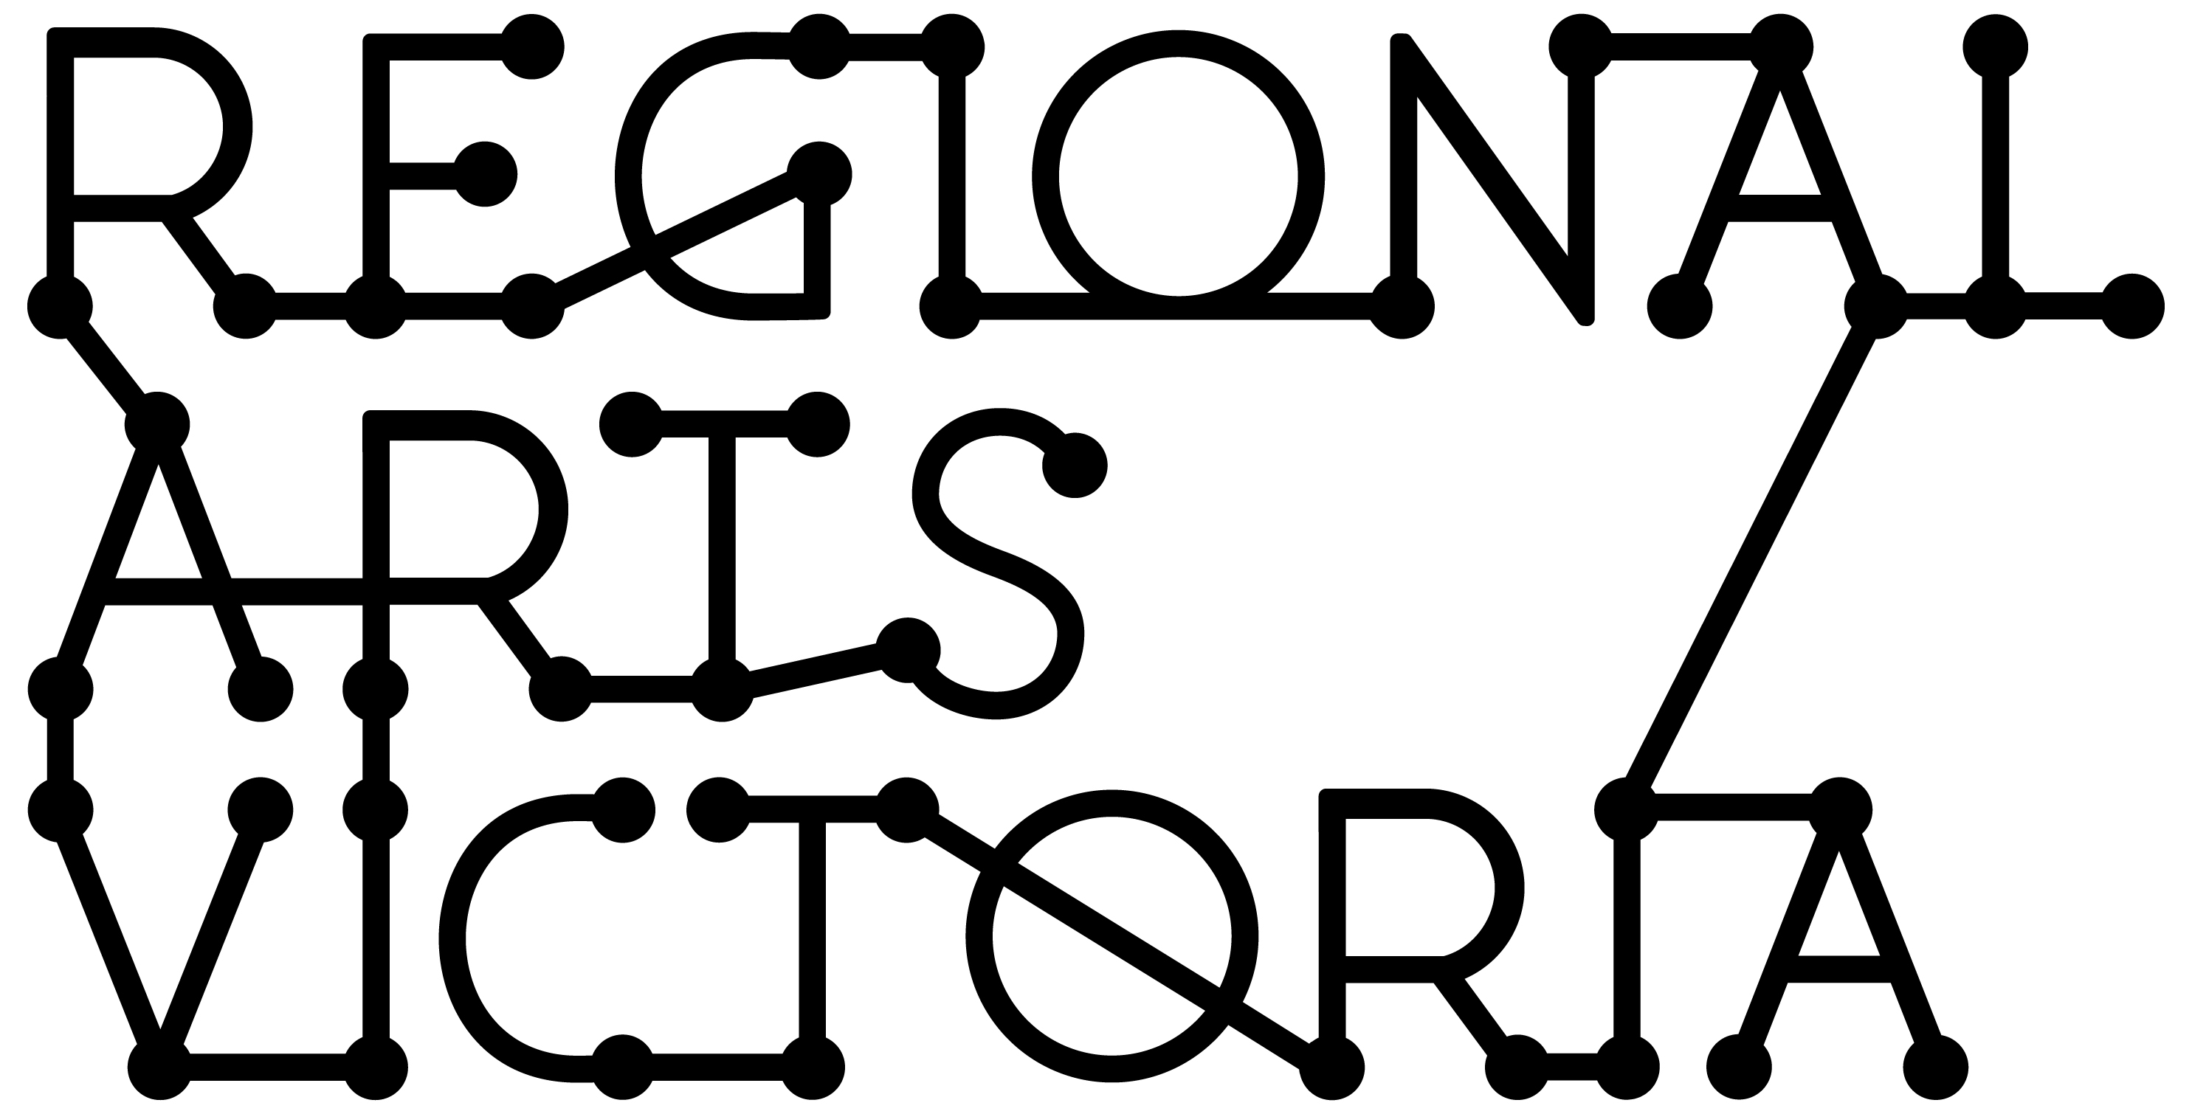
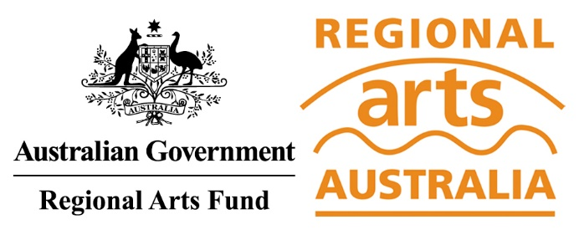

RECOVERY BOOST: RENEWAL
REGIONAL ARTS FUND 2020-2021 ADDITIONAL GUIDANCE MATERIALS
VICTORIA
NOVEMBER 2020

Contents

You are reading the Regional Arts Fund Recovery BOOST Additional Guidance Materials for Victoria. These materials have been compiled to assist applicants in applying for support under the Renewal stream of the program, and must be read in addition to the existing Regional Arts Fund Recovery BOOST Guidance Materials.

Even if you have applied for the Regional Arts Fund in the past, please read these new Guidance Materials as changes have been made from previous years.

We have also put together some hints and tips to support you in developing your application, which you can find here.

This information is available in a standard PDF version, an accessible word version, and an audio version. If you require further assistance accessing the Guidelines, please contact us on email grants@rav.net.au.

CONTENTS
About this document 2
About the Regional Arts Fund Renewal program 2
What kind of initiatives will the RAF Renewal program support? 2
Application process 3
How many projects will be supported? 5
Assessment criteria 5
Support material 5

About this document

This document outlines additional information for applicants interested in seeking support through the Renewal stream of the Regional Arts Fund Recovery BOOST. You must read the Regional Arts Fund Recovery BOOST Guidance Material available at http://www.rav.net.au/funding-opportunities/raf-recovery-boost/ as well as these materials if you are interested in applying to the Renewal stream.

Information about eligibility, Assessment Criteria, the Objectives of the Regional Arts Fund, timelines and other important details are available in Regional Arts Fund Recovery BOOST Guidance Materials.

About the Regional Arts Fund Renewal program

RAF Renewal grants will provide up to $125,000 over three years to support projects that have strong partnerships and demonstrated long term outcomes, with sustainable future-positioning focus.

These projects will be strategic in nature. Collaborations across State and Territory borders will be encouraged. The projects may be about processes and not just outcomes, providing an opportunity to think beyond ‘snap back’ and to consider renewed arts practice and learning processes.

Projects must begin after July 1, 2021, and conclude no later than June 30, 2024. Applicants are eligible for one successful RAF Renewal grant.

What kind of initiatives will the RAF Renewal program support?

The RAF Renewal program will focus on supporting applicants to aid communities and artists in their region* with recovery. It is not intended to operate as a multi-year operational funding program for an organisation or individual artist to support their recovery alone. Though it is understood there may be crossover between the two, applicants must focus their application on how their initiative will drive wider creative and/or community recovery.

Competitive RAF Renewal initiatives in Victoria will be able to demonstrate benefits at a regional level. Applicants will be required to show how this initiative will support creatives and communities in the region to rebuild (or build anew) following the impacts of COVID-19. Submissions will be expected to reflect the circumstances, strengths and challenges of the region from which they are based.

Examples of the kinds of submissions that might be supported include:
- Wages for creative recovery positions (First Nations worker positions are encouraged);
- Partnership projects between arts and non-arts organisations (including local government); and
- A multi-year program of community events or initiatives across a region, including residencies or festivals.

This list is not intended to be exhaustive. You will be required in your submission to outline why a particular approach is the right one for your region.

Consistent with the Regional Arts Fund Recovery BOOST Guidance Material, RAF Renewal funds are targeted at supporting regional artists, arts organisations and communities who have been heavily impacted by COVID-19.

* For the purposes of the RAF Renewal program, ‘region’ refers to the geographic area you are based and/or working within. Regional Arts Victoria understands that the way people live, work and create in Victoria does not always align with state or municipal boundaries, and for this reason applicants will have the opportunity to define the region in which they work that makes sense for their particular initiative. Note, however that whilst it is not essential, it is expected that competitive applications will have an impact beyond an applicant’s immediate township and/or local government area.

Application process

The RAF Renewal program will follow a three-stage application process.

Stage 1: From 30 November 2020, any interested party will be able to register their interest in the Renewal program. This will be a simple, online process, which will close 4pm January 28, 2021.

Registrants will be required to provide basic contact details and answer three questions in brief (250 words per question):
- How have artists, arts organisations and communities in your region been impacted by COVID-19?
- What is your proposal to address this impact?
- What is your capacity to deliver on your proposal? Please tell us a bit about you/your organisation, your expertise and anything that will helps us understand your ability to delivery on the proposed three year time period.

Stage 2: Invitations to shortlisted candidates will be sent in February 2021. Regional Arts Victoria will work closely with those invited to submit a more detailed Expression of Interest.

The number of invitations will be small, but receiving an invitation does not guarantee you success. Regional Arts Victoria may also extend invitations beyond the list of registered applicants if, for example, it is deemed necessary to broaden the geographic spread of the shortlist or to encourage partnerships between applicants.

Expressions of Interest must be submitted by 11.59pm March 31, 2021.

Stage 3: Following assessment of the shortlist, Regional Arts Victoria will submit a formal application with any accompanying notes for the final five projects to Regional Arts Australia. This will include any additional support Regional Arts Victoria intends to provide, and how the program will align with other strategic initiatives currently underway,

Following this submission, Regional Arts Australia will assess these applications, in consultation with the Department.

Summary Timeline
STAGE | OPEN DATE | CLOSE DATE AND TIME | APPLICANTS NOTIFIED OF OUTCOME
RAF Renewal
- Submit your idea | 30 November 2020 | 4.00pm 28 January 2021 | 22 February 2021
- Submit your Expression of Interest | 22 Feb 2021 (by invitation only) | 11.59pm 31 March 2021 | 1 July 2021
- Final decision published by Regional Arts Australia | - | - | 1 July 2021

Contact a staff member
As for all Regional Arts Fund applications, it is essential that applicants speak to a Regional Arts Victoria staff member prior to applying. It is preferred that this occurs prior to starting an application. The team can give guidance on eligibility, comment on the development of concepts and support applicants through the application process. They can be a great sounding board, and have extensive arts and cultural networks across the state and beyond.

Applicants should make the most of this opportunity by allowing plenty of time for discussion and feedback before applications close.

For contact details, head to: rav.net.au/your-artistic-development/develop-your-practice/meet-your-creative-arts-facilitator

Apply online via SmartyGrants
All applications are to be submitted online using the SmartyGrants system. Applicants who require support to access the online application process should contact Regional Arts Victoria at rav.net.au/your-artistic-development/develop-your-practice/meet-your-creative-arts-facilitator
Links to the forms can be found on the Regional Arts Victoria website: rav.net.au/funding-opportunities/regional-arts-fund

Assessment processes

Regional Arts Victoria will appoint an independent panel to review and provide advice on submissions to Stage 1 and Stage 2 of the Assessment process. The final decision on Stage 3 will be made by Regional Arts Australia, in consultation with the Department.

How many projects will be supported?

The RAF Renewal program is expected to be highly competitive. A total of five initiatives will be supported for delivery.

Anyone can submit their idea at the first stage of program applications. Following shortlisting, Regional Arts Victoria will invite a smaller number of applicants to submit a more detailed Expression of Interest.

Assessment criteria

All projects will be assessed against the Assessment Criteria outlined in the Regional Arts Fund Recovery BOOST Guidance Material. This includes guidance on Equity across the program, to ensure it is representative of the regional Victorian community.

Support material

Applicants may provide support material at Stage 1 and Stage 2 of the submission process in accordance with the Regional Arts Fund Recovery BOOST Guidance Material.

