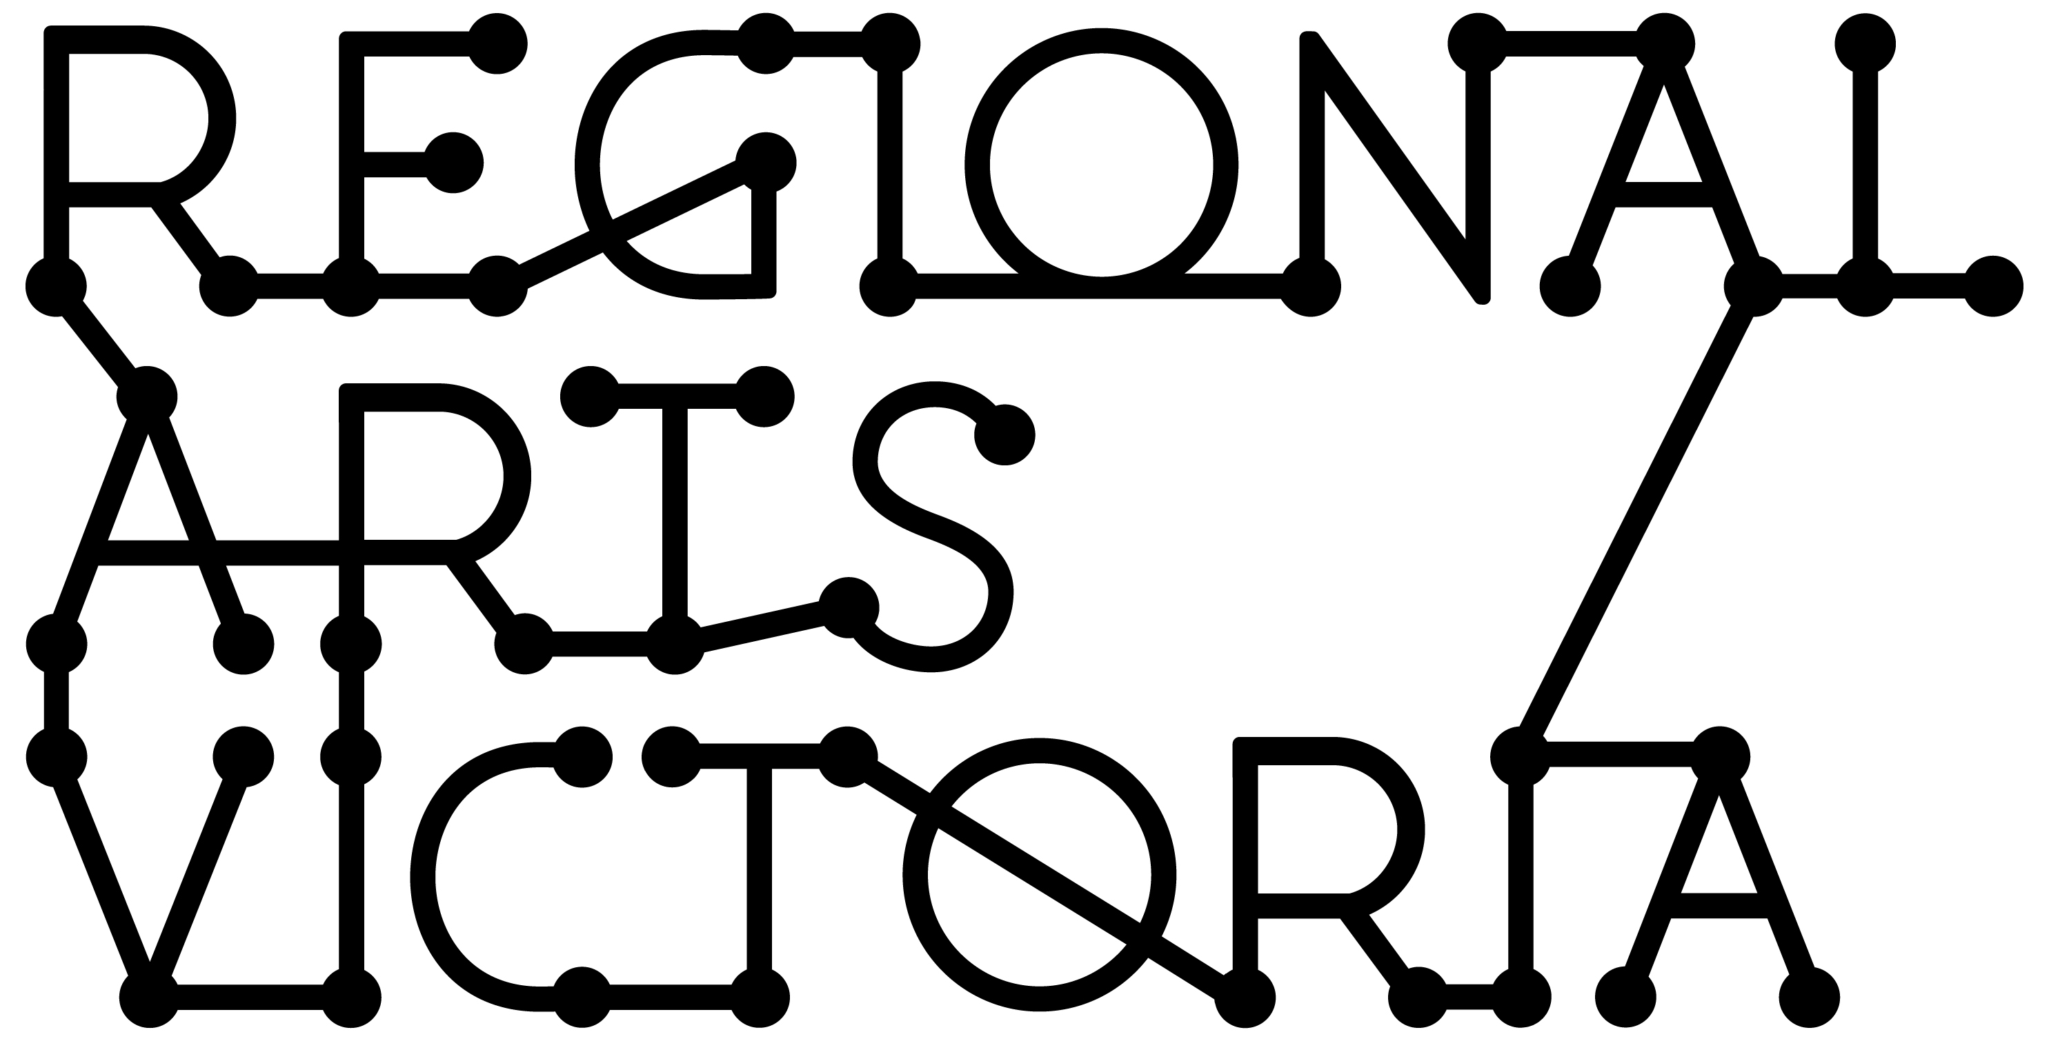
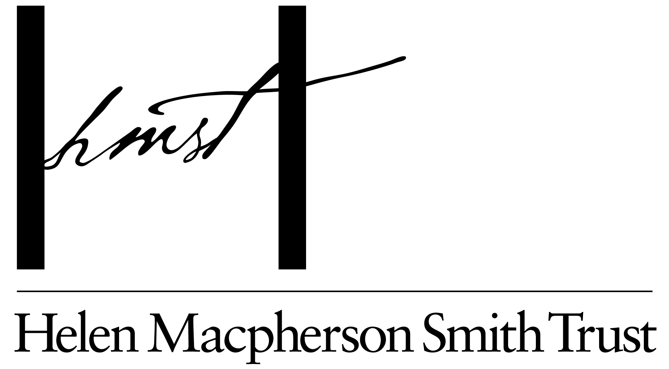

CREATIVE RECOVERY SMALL GRANTS PROGRAM
June 2021 Storms
GUIDANCE MATERIAL

September 2021

Contents

You are reading the Creative Recovery Small Grants Program Guidance Material. These materials have been compiled to assist applicants to complete a submission for the program.

This information is available in a standard PDF version, an accessible word version, and an audio version. If you require further assistance accessing the Guidelines, please contact us on email grants@rav.net.au

What is the Creative Recovery Small Grants Program? 2
Important information about the application process 2
Objectives 2
Who can apply? 2
What is on offer? 3
Who is not eligible to apply? 3
What is not supported by the Creative Recovery Small Grants Program? 3
Timelines 4
Assessment criteria 4
Equity 5
Support material 5
Auspicing 6
Privacy 6
Working with young people/working with vulnerable persons 6
Working with First Nations cultural content and communities 6
If you are successful 7

What is the Creative Recovery Small Grants Program?

This round of the Creative Recovery Small Grants Program will support creatives and creative communities in Victorian regions significantly impacted by storms and subsequent flooding in June 2021. This program is delivered by Regional Arts Victoria and supported by the Helen Macpherson Smith Trust.

Important information about the application process

Applicants to this fund will need to submit one response outlining the impact of the disaster on their creative practice or community, what they plan to use the funds for and how the funds will benefit their creative practice or their community’s recovery.

Objectives

This program is designed to assist creatives and creative communities impacted by the 2021 storms and floods.

Applications could come from individuals or not for profit organisations who have had experienced damage or loss of equipment or working spaces, or from creatives who wish to get a small boost to restart a creative practice that has been interrupted by the crisis.

Small projects would also be eligible if they provide employment for creatives and benefit the community in their recovery.

Funding could cover the cost of:
- Replacement of tools lost or damaged
- Rental of temporary work spaces
- Cleaning or repair of damaged work spaces (if not covered by insurance)
- Payment of artists to work on projects

Small projects that would benefit a community could:
- Tell a community story creatively
- Bring community together for a creative outcome
- Encourage tourists to a region

Who can apply?

- Individuals, groups and incorporated not-for-profit organisations
- Groups and organisations must either be legally incorporated and have an ABN or have an auspice organisation manage their grant
- Individual applicants must have an ABN or have an auspice organisation manage their grant
- Applicants must indicate significant impact from the storm incident
- Applicants can apply if they reside in the following impacted Local Government Areas,

Eligible Local Government Areas*:

Bass Coast | Baw Baw | Cardinia | Hepburn
La Trobe | Macedon Ranges | Moorabool | Murrindindi
South Gippsland | Wellington | Yarra Ranges
*Please note, an applicants’ postcode must reflect their residence in one of the above local government areas.

What is on offer?

Successful applicants can receive up to $1,500 in funding.

Given the uncertain environment, confirmed outcomes or presentations are not required for this program.

Applicants will need to abide by funding conditions and complete a final acquittal report on their project or activity.

Who is not eligible to apply?

Applications from:
- Applicants outside of the designated Local Government Areas
- A for-profit company
- Local Government Authorities
- Schools

What is not supported by the Creative Recovery Small Grants Program?

- Tertiary education qualifications, including projects forming part of a course of study
- Artistic program activities that commenced before 26 October 2021
- Competitions, eisteddfods, awards or fundraising activities
- Activities that have already been supported through other government programs, including the Regional Arts Fund
- Presentation, interstate and international activities that breach current State and Commonwealth Governments’ movement/gathering restrictions to combat COVID-19.

Regional Arts Victoria will only accept one application per applicant (including under auspice) at a time. Auspice bodies may apply on behalf of multiple applicants.

Timelines

Applications to this fund will open at 9am, Tuesday 7 September 2021 and will close 5pm, Friday 1 October 2021.

Successful applicants will be notified on Monday 25 October, 2021
Activities are to commence no earlier than 26 October 2021 and must be completed by 31 January 2022.

Summary Timeline
STAGE | OPEN OR START DATE | CLOSE OR FINISH DATE AND TIME | APPLICANTS NOTIFIED OF OUTCOME
- Submit your application | Tuesday 7 September 2021 | Friday 1 October 2021 | Monday 25 October 2021

Contact a staff member
Whilst it is not compulsory, you can contact the following Regional Arts Victoria staff member if you require assistance regarding eligibility once you have read the guidelines.

Tim Dakin – tdakin@rav.net.au

Please note Regional Arts Victoria is not able to provide tailored advice to applicants or read draft applications.

Due to the number of submissions we expect to receive, Regional Arts Victoria is not able to provide feedback on unsuccessful applications.

Apply online via SmartyGrants
All applications are to be submitted online using the SmartyGrants system. Applicants who require support to access the online application process should contact Regional Arts Victoria at grants@rav.net.au
Links to the application form can be found via Smarty Grants.

Assessment criteria

Alongside basic contact information and statistics, applicants will be asked to provide a response to the following in 300 words or less:
- How has your creative practice or your community been impacted by the storm incident?
- What do you intend to do with the funding and how will your practice or community/region benefit from this funding?
Applicants can either respond to this question in writing using the text field in the application form or upload a video response no longer than 2 minutes in length addressing the two points above.

All applications will be assessed by the external assessors convened by Regional Arts Victoria. Applications will be assessed against the program objectives and the following two criteria, with questions in the application form for you to respond to.

1. IMPACT | 2. BENEFIT
The impact of the storm on your creative practice or your community  - The degree to which you, your practice or your community was impacted | The benefit of the funds to you or your community:  - How will the funds assist you to return to your creative practice?  - If relevant, how will the funds benefit your community?

Equity

Regional Arts Victoria will consider the reach of the program as part of the assessment process and when making final decisions. This may include designing appropriate support and assessment for applicants including (but not limited to) those who identify as:
- First Peoples;
- Culturally and linguistically diverse;
- Deaf and disabled creatives; and,
- Young people.

Support material

Support material is not compulsory. However, you may wish to provide documents or weblinks that may assist in the assessors in understanding your work or proposal.

Support material can be uploaded to online applications but is not compulsory. Applicants may consider providing photos/images, CV’s or weblinks.

The following file types are accepted:
Documents | Word (.doc .docx); PowerPoint (.ppt .pptx); Acrobat (.pdf)
Images | .jpg .png .tiff
Audio | .mp3 .wma
Video | .mp4 .wma .avi .mov

Auspicing

This program accepts applications from auspice organisations applying on behalf of applicants.

Any legally constituted body may act as an auspice. If the application is successful, the auspice organisation will receive any funds allocated and is responsible for the management of the project and the acquittal of grant funds. If the applicant is planning to have their grant managed by an auspice organisation, please ensure the application is submitted by that auspice body on the applicants’ behalf.

For more information on auspicing, please refer to this link provided by Creative Victoria.

Privacy

Regional Arts Victoria values applicants’ privacy. For details on how we collect, store, and use information, contact Regional Arts Victoria at: enquiry@rav.net.au

Application details and applicant contact information may be provided to the Helen Macpherson Smith Trust. This will include the applicant’s name/organisation name, funded project description, funded amount, state/territory, location and electorate.

This information may also be used for promotion and reporting purposes. The Directors of Regional Arts Victoria and their representatives may also use this information to conduct research so that we may better understand community needs and can improve service delivery.

When submitting an application to this fund the applicant will be providing permission for this personal information to be used in this way.

Working with young people/working with vulnerable persons

A Working with Children’s Check is compulsory for people who carry out child-related work in Victoria. Ensure that any relevant artists/arts workers have current Working with Children Checks and Police Clearances. For more information: dhhs.vic.gov.au/children-and-families

Grantees also need to comply with applicable state, territory and Commonwealth laws before any project personnel commences an activity that involves vulnerable people.

Working with First Nations cultural content and communities

Regional Arts Victoria requires that any project reflecting or working with Aboriginal and Torres Strait Islander people and/or community should be endorsed by the relevant authority from that community.

It is a requirement that applicants show how they will acknowledge any Aboriginal and Torres Strait Islander cultural knowledge and intellectual property.

If the applicant’s project contains cultural material or activity and;
- They are a non-Aboriginal or Torres Strait Islander applicant; they must provide appropriate letter/s of support for their application to be eligible.
- They are an Aboriginal or Torres Strait Islander applicant and are delivering a project outside their community, they must provide appropriate letter/s of support from that community for their application to be eligible.

Further details on the protocols and appropriate acknowledgements of Aboriginal and Torres Strait Islander people and their culture, are available from the Australia Council for the Arts Protocols for working with Indigenous Artists

If you are successful

If the application is successful, the applicant will be required to:
- Accept a Partnership Agreement with Regional Arts Victoria and satisfy any conditions of the agreement.
- Notify Regional Arts Victoria of any proposed changes to their ability to complete the objectives.
- Give permission to Regional Arts Victoria to access and use relevant samples or images of their project/work in our publicity and marketing activities, reports and other not-for-profit government uses. Regional Arts Victoria will consult with the successful applicant in the first instance before publishing any publicity or marketing activities.
- Publicly acknowledge the support of Regional Arts Victoria and the Helen Macpherson Smith Trust using specific logos and text.
- Complete an acquittal that will include some basic evaluation questions.

