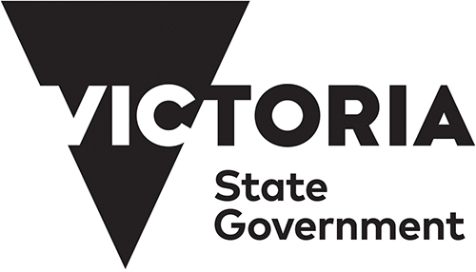
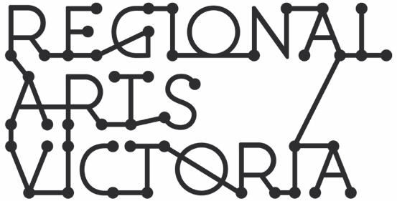

CREATIVE WORKERS IN SCHOOLS:
FREQUENTLY ASKED QUESTIONS
FOR SCHOOLS
OCTOBER 2020

- Do I need to have a project/activity idea?
No, but a loose idea of your school’s priority curriculum area/s to be addressed through the project or set of activities, the student cohort/s (year level and number of students) and artforms of interest will help the Creative Workers in Schools (CWS) Assessment Panel to match you with an appropriate creative worker or team. An artistic concept or project idea may be helpful in the assessment process, however it is not essential at Expression of Interest (EOI) stage as project development will take place with the partnered creative worker as part of the residency timeline. The project coordinator and creative worker will be supported Regional Arts Victoria (RAV) staff to develop the project idea

- Can government schools in Melbourne apply?
Yes, it’s a State-wide program. All schools will need to follow government advice regarding COVID for the relevant region. All schools must comply with Department of Education and Training (DET) and the Victorian Chief Health Officer’s directives related to minimising the spread and impact of the coronavirus (COVID-19) and any associated operational guidelines issued by DET to schools.

- Can government schools from regional Victoria apply?
Yes, it’s a State-wide program. All schools will need to follow government advice regarding COVID for the relevant region. All schools must comply with Department of Education and Training (DET) and the Victorian Chief Health Officer’s directives related to minimising the spread and impact of the coronavirus (COVID-19) and any associated operational guidelines issued by DET to schools.

- Are government special schools and language schools able to put in an EoI?
Yes, all Victorian government schools are eligible and encouraged to apply.

- What are the eligibility criteria?
All Victorian Government Schools, including special schools, are eligible to submit an EOI for the CWS program. See the program guidelines for detailed information.

- How will the EOIs be assessed?
The EOIs from schools and creative workers will be assessed simultaneously, and creative workers will be ‘matched’ with schools. Assessment will consider; proximity to the school, matching of interest in creative projects or project ideas with creative worker skills and experience, background check on the creative worker. The CWS program assessment panel will include the Regional Arts Victoria (RAV) project management team and invited advisors (including DET and/or VCAA representatives, experienced alumni of Creative Victoria’s education programs, and students where appropriate and only via correspondence through the school).

- How many schools will be selected?
The program will provide placements for 150 creative workers. Creative Workers may be matched with a school as an independent worker or part of a collective of creative workers, therefore the number of schools selected to participate will depend on the number of artists allocated per project.

- Will schools be able to select which artist they are matched to?
A School may indicate a preference to be matched with a specific creative worker intending to lodge an EOI, however this does not guarantee the CWS Assessment Panel will make this match. Assessment will consider: proximity to the school, matching of interest in creative projects or project ideas with creative worker skills and experience, and background check on the creative worker.

- Will schools be the employer of the creative worker?
No, RAV will be the employer of all participating creative workers.

- How will creative workers be selected?
Interested creative workers will have to submit an EOI to RAV for assessment. All creative workers will be required to hold a valid Working with Children Check and will be subject to other relevant checks. Selection criteria details are available in the CWS guidelines.

- What is the timeline?
A detailed timeline for the program is available on the RAV website. The EOI process will commence in November for projects that would begin in Term 1 2021.

- Can we start in Term 2 2021, instead of Term 1?
Yes. The CWS program will run across two Streams. Stream One will take place across Terms One and Two 2021, and Stream Two will take place across Terms 2 and 3 2021.

- What is the expected time commitment of the project coordinator? Will the program increase their workload?
The schools nominated project coordinator is expected to commit sufficient time to co-design and develop the project plan with the creative worker. However, the program is not expected to increase the workload of the project coordinator or other school staff. Planning time will occur during school hours; contact with students and associated supervision is to take place in the course of normal class time; and up to $3,500 is available for each project to cover casual relief teachers (CRT), to free up the project coordinator for this work. Planning time will vary from project to project and this will be supported by RAV staff.

- Will there be funds to support CRT costs to allow the Project Coordinator time to work on the project?
Yes. A budget of $3500 towards relief teacher costs per creative worker will be provided to support the Project Coordinator’s role in the program.

- How much time will the project take out of the school timetable?
Project lengths and number of contact hours will vary from project to project and will determined by the school project coordinator and creative worker during the project planning and development process.

- Does the project or set of activities need to have an outcome (such as a physical performance or piece of artwork)?
No, the residency can focus on addressing learning areas within the Victorian F-10 Curriculum - The Arts framework through creative approaches without having a physical outcome.

- What happens if schools are required to switch to online learning again?
Project planning to include scenario of full shift to virtual delivery. Creative workers will undertake professional development training focused on adapting and delivering projects via virtual and other alternative platforms.

- How will teachers be supported?
Schools and creative workers will meet to develop their project plan and will be supported by RAV program staff for the project duration. The schools nominated project coordinator and the creative worker/s will be supported in preparing a partnership project plan including a timeline, roles and responsibilities and a budget.

- What will it cost the school to participate?
The salary and costs of the creative worker and funding for broad project costs and CRT will be covered by the CWS program. A budget of $4000 will be provided for each creative worker towards project costs. However, there may be incidental additional project costs depending on the size and scale of the project the school wishes to undertake. Such costs would only be at the discretion of schools.

- How many students can be involved?
This will vary from project to project and will depend on the schools available resources. The school and creative worker must always ensure that a school teacher is present during student contact time and the number of students working with the creative worker does not exceed the schools class sizes unless agreed previously by both parties.

- How does the training/professional development component work for teachers?
The project coordinator will have opportunity for professional development over the duration of the residency through working directly with the creative worker, enhancing areas and skills in creative practice and alternative approaches to curriculum delivery. As project/activity plans develop, areas of focus for professional development will be identified and appropriate training will be offered where possible.

- What about coronavirus (COVID-19)?
All projects and project personnel will comply with Department of Education and Training and the Victorian Chief Health Officer’s directives related to minimising the spread and impact of the coronavirus (COVID-19). Creative workers and CWS program personnel are also expected to abide by RAV’s COVID Safe Management plan which will provided to the school project coordinator and Principle upon commencement of the residency.

