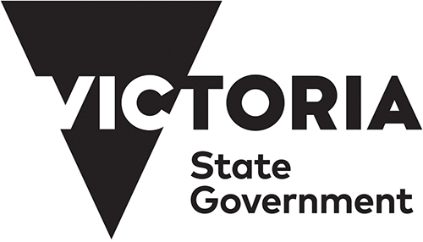
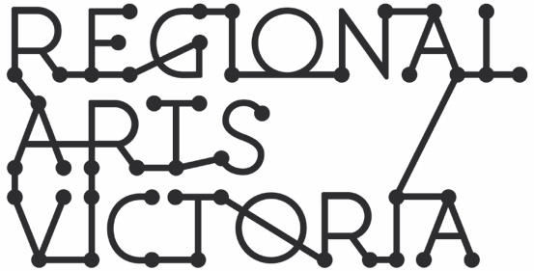

CREATIVE WORKERS IN SCHOOLS:
FREQUENTLY ASKED QUESTIONS
FOR CREATIVE WORKERS
OCTOBER 2020

- Do I need to have a project or activity idea?
No, but a loose idea of the student cohort/s (year level and number of students) and artforms of interest will help the Creative Workers in Schools (CWS) Assessment Panel to match you with an appropriate school. An artistic concept or project idea may be helpful in the assessment process, however it is not essential at Expression of Interest (EOI) stage as project/activity development will take place with the partnered school as part of the residency timeline. A school’s nominated project coordinator and matched creative worker will be supported Regional Arts Victoria (RAV) staff to develop the project idea.

- What kinds of creative skills is the program seeking? What are the eligibility criteria?
Creatives with experience in any artform are eligible and encouraged to apply. Some experience in your chosen field of artistic practice is required, as well as an interest in working within your chosen artform area in a school setting. Artforms can vary from poetry to landscape design, music composure to carpentry and design. Eligible creative skills can also come in the form of facilitation or working across multiple disciplines. Whatever your specialised form of artistic practice, we encourage you to apply.

- What is the timeline?
A detailed timeline for the program is available on the RAV website. The EOI process will commence in November for projects that would begin in Term 1 2021.

- What if I can’t start in Term 1 2021?
The CWS program will run across two Streams. Stream One will take place across Terms One and Two 2021, and Stream Two will take place across Terms 2 and 3 2021. The EOI will offer the opportunity to give your preference of participating in Stream One or Two, and will also ask if you are able to begin in Term 2 should your EOI for Stream One be unsuccessful.

- I’ve already been speaking with a school about a project/activity, can I apply with a school already confirmed?
A Creative Worker may indicate a preference to be matched with a specific school intending to lodge an EOI, however this does not guarantee the CWS Assessment Panel will make this match. Assessment will consider: proximity to the school, matching of interest in creative projects or project/activity ideas with creative worker skills and experience, background check on the creative worker.

- Who RAV own the intellectual property in the work I create?
Creatives will not be required to assign intellectual property rights to RAV as part of this program. Further details about licensing and schools requirements may be discussed at the project development stage.

- Can I apply as a group?
This program is open to individuals and groups of up to five creatives based in Victoria. Organisations are not able to apply for this program (please note employment arrangements below).

- Do I need to do an interview for the role?
Creative workers meeting assessment criteria will be required to attend an interview via Zoom as part of the matching and recruitment process.

- Will I have a choice of what school I am placed in?
A creative worker may indicate a preference to be matched with a specific school intending to lodge an EOI, however this does not guarantee the CWS Assessment Panel will make this match. If not matched with the school of choice, the CWS Assessment Panel will refer to your nominated preferences such as region and student cohort/s (year level and number of students) you would be most comfortable working with to determine a suitable placement.

- Will I be working alone?
No. The school and creative worker must always ensure that a member of staff is present during student contact time. The role of the creative worker is a facilitator of the creative process, not a teacher. Student sessions will require collaboration from school staff and creative worker/s.

- How many students can be involved?
This will vary from project to project and will depend on the schools available resources. The school and creative worker must always ensure that a school teacher is present during student contact time and the number of students working with the creative worker must not exceed the schools class sizes unless agreed previously by both parties.

- Can I choose what age I work with?
Creative workers can nominate a preferred age group to work with in their EOI and this will be considered by the assessment panel.

- Will I be required to purchase all equipment for the project or set of activities?
A budget of $4000 will be provided for each creative worker towards project/activity costs. In the project planning stage, you will develop this budget with the support of Regional Arts Victoria; you do not need to submit it now.

- Do I need experience in teaching?
No. While experience in working with young people and community groups is beneficial, it is not mandatory as the school will fulfill the role of teaching students. The role of the creative worker is a facilitator of the creative process.

- I am based in Melbourne, can I apply?
Yes, it’s a State-wide program. Creatives will be matched with local schools in the first instance.

- I am based in regional Victoria, can I apply?
Yes, it’s a State-wide program. Creatives will be matched with local schools in the first instance.

- Will I be required to move/travel for the role?
Creatives will be matched with local schools in the first instance. Dependant on the number of schools and creative workers in a geographical area, it may be necessary matching more distant partners. Creative workers will be asked in their EOI to nominate whether or not they are able and prepared to travel for the contact hours of the project.

- How many creatives will be selected?
150 creative workers will be selected.

- How will the EOIs be assessed?
The EOIs will be assessed simultaneously, and creative workers will be ‘matched’ with schools. Assessment will consider: proximity to the school, matching of interest in creative projects or project ideas with creative worker skills and experience, background check on the creative worker. Assessment panel will include the RAV project management team and invited advisors (including DET and/or VCAA representatives, experienced alumni of Creative Victoria’s education programs, and students where appropriate and only via correspondence through the school).
.
- When will I be notified if I have been selected?
Stream One creative workers (for projects/activities running across Terms 1 and 2, 2021) will be notified between 14-18 December 2020.

- When will the role start?
Creative workers will be required to attend a project induction and planning session between 25 January – 5 February with project planning and commencement beginning from 28 January. Ongoing project planning, commencement and delivery will vary from project to project across Terms 1 and 2 2021.

- How long will the contract be?
Six months.

- How much will I get paid? What wage is on offer?
All creatives will be paid a full time pre-tax fee of $33,592 for the six month appointment, paid in fortnightly instalments. This does not include superannuation or other allowances, which are paid in addition to this amount.

- Is it a full-time role? What hours?
Whilst this is a full time role, it is understood that time commitments, project planning and contact hours will vary from project to project. Planning time is expected to be included within these hours and undertaking full-time contact hours in the school is not expected.

- Will I get school holidays off?
Creatives will plan leave as part of their project development, which may fall in school holidays as required.

- What training will be provided?
A suite of training and induction for all participating creatives will be complemented by additional professional development relevant to your specific project or set of activities.

- Will I receive support throughout the process?
Creative workers will be supported throughout the duration of the project or set of activities by experienced RAV program personnel. This will include support in project planning and development and specialised roles designed to respond to identified areas where support and professional development is required.

- Who will my employer be?
Creative workers will be employed by RAV.

- What happens if schools are required to switch to online learning again?
Project planning to include scenario of full shift to virtual delivery. Creative workers will undertake professional development training focused on adapting and delivering projects via virtual and other alternative platforms.

- What about COVID?
Creative workers and program personnel will be expected to abide by RAV’s COVID Safe Management plan which will provided to the school project coordinator and Principle upon confirmation of the residency. All projects and project personnel will comply with DET and the Victorian Chief Health Officer’s directives related to minimising the spread and impact of the coronavirus (COVID-19).

