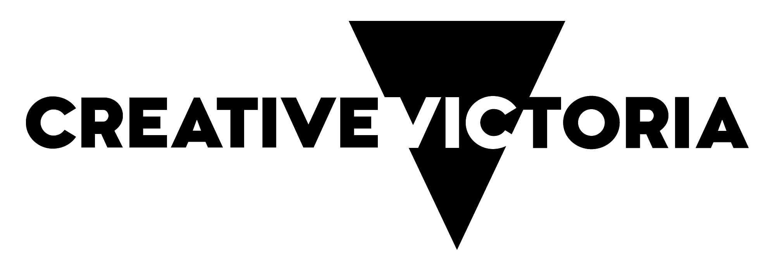
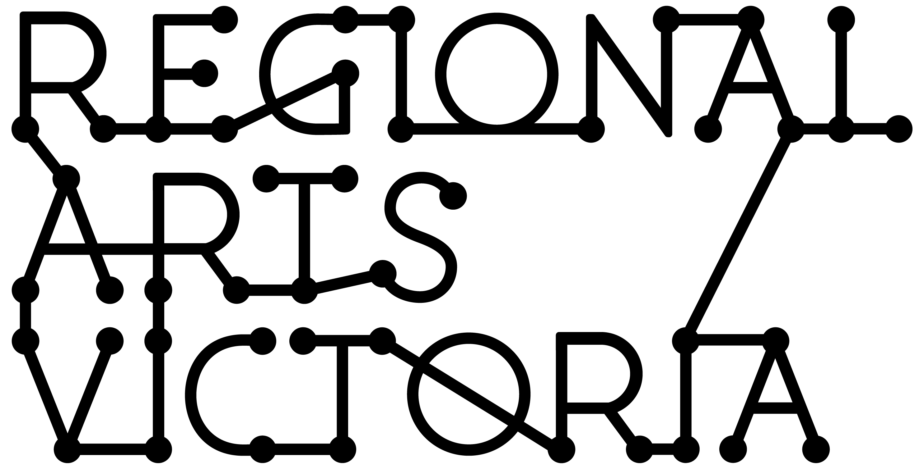

CREATIVE RECOVERY
SMALL GRANTS PROGRAM
GUIDANCE MATERIAL

JUNE 2020

Contents

This guidance material has been put together to support you with your application and ensure you meet the objectives and eligibility criteria for the Creative Recovery Small Grants Program.

You can download this version from our website before starting your application.

This information is available in a standard PDF version, an accessible word version, and an audio version. If you require further assistance accessing the Guidelines, please contact us on email grants@rav.net.au.

Introduction: what is the Creative Recovery Small Grants Program? 2
What are the aims of the Creative Recovery Small Grants Program? 2
What can be applied for? 2
Who can apply? 2
What/who is not supported by the Creative Recovery Small Grants Program? 3
Funding available 3
Assessment process 4
Assessment criteria 4
Auspicing 5
How to apply 5
Support material 6
Responsibilities 7
Privacy 7

Introduction: what is the Creative Recovery Small Grants Program?

The Creative Recovery Small Grants Program supports community connection, engagement and resilience for communities impacted by the 2019-20 bushfires in regional Victoria. The program will focus on the creative activity that assists these communities with short and long term recovery.

Applicants to this program can apply at any time up to 31 October 2020.

This program is a partnership between Regional Development Victoria, Bushfire Recovery Victoria and Creative Victoria, delivered by Regional Arts Victoria.

What are the aims of the Creative Recovery Small Grants Program?

The Creative Recovery Small Grants Program aims to:
- Deliver small grant funding to Victorian creatives and organisations impacted by the 2019-2020 bushfires;
- Provide a means for creatives to return to their practice;
- Strengthen community connection, engagement and resilience through the arts;
- Ensure all six impacted local government areas are supported;
- Support projects that assist communities with short and/or long-term recovery; Encourage visitors to return to impacted regions by supporting arts programs.

What can be applied for?

Types of activities that may sustain or support your creative practice may include, but are not limited to:
- Creative projects;
- Replacement of lost small artist tools and equipment;
- Rental of premises to continue to work on creative practice;
- Planning for future programs or re-opening events;
- Presentation or touring costs;
- Technology and equipment to enable online/digital content to be delivered; and,
- Professional development.

Given the uncertain environment, confirmed outcomes or presentations are not required for this program.

Who can apply?

The Creative Recovery Small Grants Program accepts applications from Victorian individuals and organisations based in six local government authority areas:
- Alpine;
- East Gippsland;
- Indigo;
- Mansfield;
- Towong; or
- Wangaratta.

Please note, an applicants’ postcode must reflect their residence in one of the above local government areas.

Applications will be accepted from:
- Groups and organisations that are either legally incorporated or have an ABN. If they don’t have either one of these they will need to have an auspice organisation manage their grant.
- Individual applicants must have an ABN or have an auspice organisation manage their grant.
- Individuals must be an Australian citizen currently residing in Victoria or a Permanent Resident (holding an appropriate visa) who has resided in Victoria for at least two years immediately prior to the date of your application.
- Individuals who are under 18 at the time of applying must have an auspice organisation manage their grant.

What/who is not supported by the Creative Recovery Small Grants Program?

Applications from:
- Applicants who are not located in local government authority areas of Alpine, East Gippsland, Indigo, Mansfield, Towong or Wangaratta.
- Tertiary education qualifications, including projects forming part of a course of study.
- Reimbursement for expenses already incurred, or due to complete before the funding period.
- Competitions, eisteddfods, awards or fundraising activities.
- Activities that have already been supported through other government programs, including the Regional Arts Fund or Sustaining Creative Workers Initiative.
- Presentation, interstate and international activities that breach current State and Commonwealth Governments’ movement/gathering restrictions to combat COVID-19.

Regional Arts Victoria will only accept one application per applicant (including under auspice) at a time. Auspice bodies may apply on behalf of multiple applicants.

Funding available

Up to $5,000 is available for individuals and organisations. In limited circumstances, applicants may be invited to apply for funding above this threshold after consulting with Regional Arts Victoria (see contact details below).

Applicants can apply anytime up to 31 October 2020. Regional Arts Victoria will assess submissions monthly.

Assessment process

Applications will be assessed monthly against the program aims and assessment criteria.

Applicants must contact a Regional Arts Victoria staff member prior to applying to the fund.

Assessment criteria

Applications will be assessed against the grant program aims and should address the following two criteria:

1. CREATIVE IMPACT | 2. COMMUNITY AND/OR RECIPIENT BENEFIT
The applicant’s previous experience and type of practice will be taken into consideration when assessing the following:  - An appropriate level of creative impact as demonstrated by the applicant’s biography and/or profile/ curriculum vitae.  - The potential of the project to support creative activities that aid community recovery. | Proposals will be assessed against their likelihood of supporting one or more of the following aims:  - Strengthening of community connections and engagement.  - Impact on short term or long term recovery.  - Contribution to community resilience.  When considering applications for replacing lost tools or equipment, assessment will consider:  - The nature and type of equipment lost.  - How funds will assist a return to creative practice.

Regional Arts Victoria will also consider the equity of the program when making final decisions, including support for people who identify as First Peoples; culturally and linguistically diverse; Deaf and disabled; and young people. Please see contact details below for support with your submission.

Addressing the assessment criteria

To address the assessment criteria, you are required to:
- Answer One Application Question in the online form using plain English (up to 2000 characters including spaces, or a video/audio submission if you have access requirements – see ‘Apply Online’ below): Tell us what you aim to do and how it will address the aims of the fund. Upload support material relevant to your application
- Upload a CV or organisation or business biography (maximum three pages) or provide a URL to an online CV/ biography, if relevant to your application.
- Provide up to five photographs and images such as art works or examples of past projects
- Provide up to two direct links of audio, images or video (no greater than three minutes in length per video)
- Provide some basic statistical information about your application.
- No budget is required but you will need to indicate how you intend to use the funding via a series of tick boxes.

Auspicing

This program accepts applications from auspice organisations applying on behalf of applicants.

Any legally constituted body may act as an auspice. If the application is successful, the auspice organisation will receive any funds allocated and is responsible for the management of the project and the acquittal of grant funds. If you are planning on having your grant managed by an auspice organisation, please ensure your application is submitted by that auspice body on behalf of you.

For more information on auspicing, please refer to this link provided by Creative Victoria.

How to apply

Contact a Partnerships team member

Regional Arts Victoria’s Partnerships team is providing support for applicants to this program. Applicants must speak to a member of the team prior to commencing their application. Staff will give guidance on eligibility, comment on submissions, and support applicants through the application process. They can be a great sounding board, and have extensive arts and cultural networks across the state and beyond.

Applicants should make the most of this opportunity by allowing plenty of time for discussion and feedback before they wish to submit.

Apply Online via SmartyGrants

All applications are to be submitted online using the SmartyGrants system. Applicants who require additional support to access the online application process, or are unable to access the online form, should contact a member of the Partnerships team.
Links to the forms can be found on our website from 9.00am, 1 July 2020.

To prepare your application, you should:
  - Register for access to the Regional Arts Victoria Smartygrants portal.
  - Read program information and guidelines thoroughly.
  - You must speak with a Regional Arts Victoria staff member before applying.
  - In the online Smartygrants Portal, you will need to register as a user, then fill in the details of your application in the Regional Arts Victoria Smartygrants portal.
(Please note: the system will cut text off at 2,000 characters, so it might be best to write your long project description in a system where you can do a word count, then always check your character count before pasting information into the portal).

NOTE: The option to submit responses to the application questions in video or audio format is available for those with access requirements. Please contact Regional Arts Victoria program staff to discuss before submitting via video/audio.
- Upload any support material (files or links).
- Submit your completed application via the Regional Arts Victoria Smartygrants portal.
- Once submitted, your application cannot be changed.

Support material

Support material gives the opportunity to sell us an idea in more than words. This is an opportunity for applicants to show us some great examples of previous projects and artwork relevant to their submission.
- Applicants applying to do a project should add CV’s for any artists managing their projects
- CV’s or biographies should be up to three pages long. Applicants could also add a URL to a website that outlines a CV or biography.
- Applicants who are applying for replacements costs of tools or equipment should add a CV that demonstrates their creative practice, and a list of tools or equipment lost.

You are also able to upload:
- Up to five photographs and images such as art works or examples of past projects.
- Up to two direct links of audio (or up to two audio files), images or video (no greater than three minutes in length per video)

Please:
- Do not provide links to Google Drive, Drop Box or other online hosting platforms that require viewers to enter personal identification in order to gain access. Materials provided using these platforms will not be assessed by the assessors,
- It is the responsibility of applicants to ensure that all weblinks and uploaded material can be viewed, and appropriate passwords are provided. Regional Arts Victoria will not be contacting applicants if support material cannot be accessed after submission.

- The following file types are accepted:
Documents | Word (.doc .docx); PowerPoint (.ppt .pptx); Acrobat (.pdf)
Images | .jpg .png .tiff
Audio | .mp3 .wma
Video | .mp4 .wma .avi .mov

Responsibilities

If your application is successful, please be aware that as a recipient of funding, you will be required to:
- Accept a Funding Agreement with Regional Arts Victoria and satisfy any conditions of funding, which will be detailed in the Agreement.
- Notify Regional Arts Victoria of any proposed changes to your funded project.
- Give permission to Regional Arts Victoria to access and use relevant samples or images of your project/work in our publicity and marketing activities, reports and other not-for-profit government uses. Regional Arts Victoria will consult with you in the first instance before publishing any publicity or marketing activities.
- Publicly acknowledge the support of Regional Arts Victoria and the Victorian Government using specific logos and text
- Acquit your grant by submitting a written report on the outcomes of your funded project within 30 days of project completion.

Privacy

Regional Arts Victoria values applicants’ privacy. For details on how we collect, store and use information, applicants should review our Privacy Policy at rav.net.au or contact us at enquiry@rav.net.au or call (03) 9644 1800 for a copy.

Application details and applicant contact information may be provided to the State Government (including the Minister and the Department), Members of Parliament and may be published on the internet by any of them. This will include the applicant’s name/organisation name, funded project description, funded amount, state/territory, location and electorate.

This information may also be used for promotion and reporting purposes. The Directors of Regional Arts Victoria and their representatives may also use this information to conduct research so that we may better understand community needs and can improve service delivery.
When submitting an application to this fund you will be providing permission for this personal information to be used in this way.

