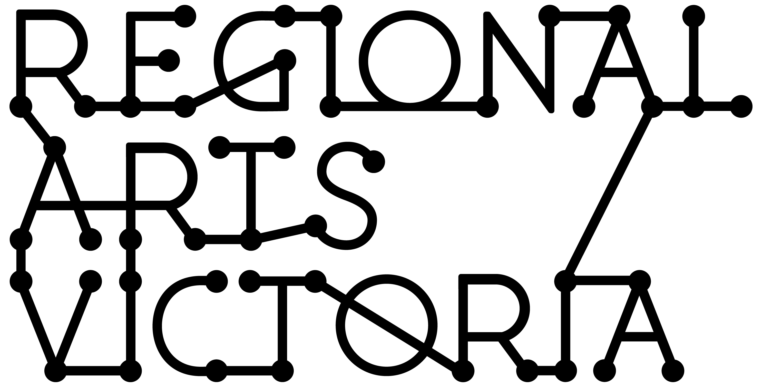
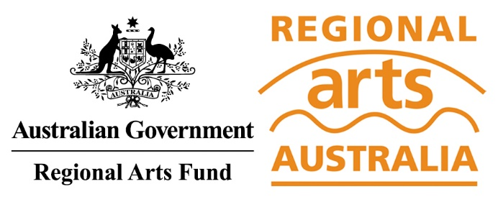

RECOVERY BOOST: REGIONAL ARTS FUND
2020-2021 GUIDANCE MATERIALS
VICTORIA
JUNE 2020

Contents

You are reading the Regional Arts Fund Recovery Boost Guidance Materials for Victoria. These materials have been compiled to assist applicants in applying for support under the program.

This document includes Regional Arts Fund grants available in the 2020-2021 financial year.

Even if you have applied for the Regional Arts Fund in the past, please read these new Guidance Materials as changes have been made from previous years.

We have also put together some hints and tips to support you in developing your application, which you can find here.

This information is available in a standard PDF version, an accessible word version, and an audio version. If you require further assistance accessing the Guidelines, please contact us on email grants@rav.net.au.

CONTENTS
What is the Regional Arts Fund? 2
What is the Recovery Boost? 2
Objectives 2
Who can apply? 2
What can the funding be used for? 3
Who is not eligible to apply? 3
What will the Regional Arts Fund not support? 4
Recovery Boost funding categories 4
How to apply 6
Assessment criteria 8
Additional assessment criteria – Recovery Boost 9
Equity 9
Support material 10
Privacy 10
Working with young people/working with vulnerable persons 11
Working with First Nations cultural content and communities 11
If you are successful 11

What is the Regional Arts Fund?

The Regional Arts Fund is an Australian Government Program that supports sustainable cultural development in regional and remote communities in Australia. It meets the strategic priorities of supporting participation in, and access to, the arts; and encouraging greater private sector support for the arts.

The Regional Arts Fund is designed to benefit regional and remote arts practitioners, arts workers, audiences and communities. The program is managed nationally by Regional Arts Australia and is delivered in Victoria by Regional Arts Victoria.

What is the Recovery Boost?

The Recovery Boost is a $10 million targeted measure announced by the Australian Government in 2020 as part of the Relief and Recovery Fund. It responds to the difficulties experienced by regional artists, arts organisations and communities who have been heavily impacted by COVID-19. The Recovery Boost is one-off funding and will be delivered through the Regional Arts Fund and seeks to offer short (Relief), medium (Recovery) and long-term (Renewal) support.
This document refers to Regional Arts Fund grants available in the 2020-2021 financial year.
RAF Project Grants, (formally known as RAF Community Grants) are outlined in separate Guidance Materials that are located here. Rounds will open from 18 January 2021.

Objectives

The objectives of the Regional Arts Fund are to support and promote participation in, and access to, arts and culture in regional and remote Australia by:
- Encouraging and supporting sustainable economic, social and cultural development in regional communities;
- Developing partnerships and networks which leverage financial and/or in-kind support for specific projects and encourage ongoing collaboration;
- Developing audiences and broadening community engagement with the arts; and
- Increasing employment and professional development opportunities for, and raise the profile of, regional and remote artists.

Who can apply?

- Individuals, groups and incorporated not-for-profit organisations.
- Local government authorities
- Applicants must reside in postcodes classified as regional using the Modified Monash Model Map. The applicant's physical address must be MMM Classification 2 or above. To check how your address is classified visit the Doctor Connect Locator Map:
- health.gov.au/resources/apps-and-tools/health-workforce-locator/health-workforce-locator
- Groups and organisations must either be legally incorporated and have an ABN, or have an auspice organisation manage their grant.
- Individual applicants must have an ABN or have an auspice organisation manage their grant.
- Individuals who are under 18 at the time of applying must have an auspice organisation manage their grant.
- Schools, provided funding is not used for curriculum based activities or courses of ongoing education and training in government or private institutions in Australia or overseas.

What can the funding be used for?

The Regional Arts Fund will only fund arts or cultural development projects that are directed at achieving the objectives of the Program, as outlined above.

The Regional Arts Fund may be used toward the cost of the project including but not limited to:
- Artist and arts worker fees (artists should be paid appropriately, see RAF Resources for reference).
- Access costs for applications from Deaf and Disabled creatives, artists, arts workers and disability-led organisations/businesses.
- Travel costs (including international travel).
- Materials and small assets (up to $5000).
- Venue hire.
- Equipment hire.
- Insurance (a portion of organisations insurance appropriate to the project).
- Project administrative costs (up to 15%).
- Costs of running an organisation, including wages (Recovery & Renewal Projects only).

Who is not eligible to apply?

Applications from:
- Applicants outside of regional Victoria.
- A for profit company.
- Applicants who have not acquitted overdue grants from the Regional Arts Fund, any other Australian Government funding program, or any other program administered by Regional Arts Victoria.

What will the Regional Arts Fund not support?

- A project principally benefitting a major city or metropolitan location (MMM Classification 1).
- Projects that will commence before funding is approved. Projects will be ineligible for funding if they have already been advertised by the applicant, including any online marketing on websites or via social media, until notified of the decision.
- Components of projects that are also funded by other programs administered by the Australian Government or other state and local government agencies.
- Projects which do not substantially align to and further the objectives of the Regional Arts Fund.
- Touring projects from major urban centres
- Competitions, prizes or awards
- Ongoing activities of collecting institutions
- Ongoing core administration costs of the applicant organisation
- Infrastructure costs including building or fitting out permanent structures
- Curriculum based activities in schools, or courses of ongoing education and training in government or private institutions in Australia or overseas.
- Academic activity, including wages or course work that is required as part of any tertiary academic program.
- Recurrent or ongoing funding for projects or programs.

Recovery Boost funding categories

RAF Relief – up to $5,000
Relief grants are designed to assist regional artists, arts organisations and communities to meet their immediate needs. This could include asset replacement or purchase, support for arts practice (including self-directed residency/research and development), small projects and professional development opportunities.

The RAF Relief program will be open from 1 July 2020, and close 30 September 2020.
All RAF Relief projects must be completed by 30 June 2021. Project start date must be at least 30 business days from submission date.

RAF Recovery – up to $30,000
Recovery grants are designed to meet the medium-term recovery needs of artists, organisations and communities. Projects in this program should focus on activities that assist in recovery from the impacts of COVID-19.

Project activities could include creative recovery projects, training programs, operational recovery plans, asset purchase or replacement (up to $5,000) and the development of risk plans and emergency operating procedures and responses.

The RAF Recovery Program will operate as a single competitive funding round.

All RAF Recovery projects must be complete by 30 June 2024, and must not commence before January 1, 2021.

RAF Renewal – up to $125,000 over 3 years
Renewal grants will provide up to three years of funding to support projects that have strong partnerships and demonstrated long term outcomes, with sustainable future-positioning focus.

These projects will be strategic in nature. Collaborations across State and Territory borders will be encouraged. The projects can be process-driven and provide an opportunity to think beyond ‘snap back’ and to consider renewed arts practice and learning processes.

Project activities could include partnership projects, community events or programs, First Nations-led renewal and wages for workers (First Nations worker positions will be encouraged).

Applications to this program will be by Expression of Interest, by invitation only.

Regional Arts Australia will assess these applications, in consultation with the Department.

All RAF Renewal projects must be complete by 30 June 2024.

Applicants are eligible for one successful grant in each category, per financial year* (and one RAF Renewal grant over the life of the program).

*financial year – dates are based on when the funds are allocated, not when project happens.

GRANT TYPE | MAXIMUM AMOUNT AVAILABLE | OPEN DATE | CLOSE DATE AND TIME
RAF Recovery Boost
RAF Relief | $5,000 | 1 July 2020 | 11.59pm AEST 30 September 2020
RAF Recovery | $30,000 | 1 July 2020 | 11.59pm AEST 1 Nov 2020
RAF Renewal | $125,000  (over three years) | 1 Feb 2021 (by invitation only) | 11.59pm AEST 31 March 2021

How to apply

Contact a staff member
It is essential that applicants speak to a Regional Arts Victoria staff member prior to applying. It is preferred that this occurs prior to starting an application. The team can give guidance on eligibility, comment on the development of concepts and support applicants through the application process. They can be a great sounding board, and have extensive arts and cultural networks across the state and beyond.

Applicants should make the most of this opportunity by allowing plenty of time for discussion and feedback before applications close.

For contact details, head to: rav.net.au/your-artistic-development/develop-your-practice/meet-your-creative-arts-facilitator

Apply online via SmartyGrants
All applications are to be submitted online using the SmartyGrants system. Applicants who require support to access the online application process should contact Regional Arts Victoria at rav.net.au/your-artistic-development/develop-your-practice/meet-your-creative-arts-facilitator
Links to the forms can be found on the Regional Arts Victoria website: rav.net.au/funding-opportunities/regional-arts-fund

Assessment processes

RAF Relief
Applications are processed and assessed internally by Regional Arts Victoria staff, with the aid of independent advisors selected by Regional Arts Victoria. Applicants will be notified of the outcome within 15 working days of receipt of their application.

The Australian Government Minister for the Arts has the option to announce recipients of these grants retrospectively.

RAF Recovery
All RAF Recovery Grants are assessed by an independent, external panel of artists and cultural workers from across Victoria selected by Regional Arts Victoria. The panel’s decisions are final.

The Australian Government Minister for the Arts has the option to announce the Regional Arts Fund Recovery Grant recipients, after which Regional Arts Victoria staff notify all applicants. Notification of the outcome can take around three months after the Grant round closing date. Please be aware this is an indicative time frame only.

RAF Renewal
Applications are by Expression of Interest, by invitation only.

These will be assessed by Regional Arts Australia, in consultation with the Department.

Assessment criteria

All projects must include clearly defined arts and cultural activity. All applications are assessed against the following six criteria. The questions below each criterion are prompts for the assessors; however in some cases it is understood that not all projects are able to meet every criteria.

IMPACT
Encouraging and supporting sustainable economic, social and cultural development in regional communities
- Are there long term outcomes for the project?
- Does it create opportunities for future cultural activity?
- Are there any sustainable economic benefits to the project (e.g. increased activity for local tourism and business, paid opportunities for artists, etc.)?
- Are there any sustainable social benefits to the project (e.g. health, social cohesion, access, etc.)?

PARTNERSHIP
Developing partnerships and networks that leverage financial and/or in-kind support for specific projects and encourage ongoing collaboration
- Is community support for this project evidenced through partnerships and collaborations?
- Do these leverage financial and/or in-kind support for the project?
- Does the project assist the development of networks, collaborations and partnerships that could support future cultural activity?
- Is there appropriate community, council or other support for this project?

REACH
Developing audiences and broadening community engagement with the arts
- Does the project provide access to social and cultural development opportunities for diverse communities, practitioners, participants and/or audiences?
- How is the project providing opportunities for community members or groups to participate in the arts?
- Does the project develop audiences by attracting new attendees or participants?
- Does the project develop audiences by extending their experience of the arts?

OPPORTUNITY
Increasing employment and professional development opportunities for, and raising the profile of, regional and remote artists and/or arts workers
- Does the project provide employment opportunities for regional artists or arts workers?
- Does the project raise the profile of regional artists or arts workers?
- Does the project allow an artist access to an exceptional or rare opportunity?
- Does the project help develop the artist’s skills?

QUALITY
Proven capacity to deliver high-quality arts and cultural initiatives in regional communities in response to identified need or demand
- Has the applicant considered the calibre of the artists involved? Is this evidenced through appropriate and high quality support material?
- Has the applicant considered the cultural context in which the project will be placed?
- Does the project involve an original or innovative concept?

VIABILITY
Demonstrates good planning, management and realistic budget and timeframes
- How realistic is the timeframe and budget?
- Does the applicant have the capacity to deliver? How is this evidenced?
- Have appropriate risks been taken into consideration and addressed?

Additional assessment criteria – Recovery Boost

The Recovery Boost will be assessed against the criteria listed above. In addition, the following principles will be applied to the assessment of the RAF Recovery and RAF Renewal Streams:
- Community confidence (evidenced by connectivity) “increased or renewed community confidence”
- Creative confidence (evidenced by arts practice)
- Business confidence (evidenced by partnerships)

The RAF Renewal Program in particular needs to respond to:
- Lasting benefits
- Local supply
- Job incentives

Specific questions in application forms will allow for applicants to address these additional criteria.

Equity

Regional Arts Victoria will consider the reach of the program as part of the assessment process and when making final decisions. This may include designing appropriate support and assessment for applicants including (but not limited to) those who identify as:
- First Peoples;
- Culturally and linguistically diverse;
- Deaf and disabled creatives; and,
- young people.

Support material

Applicants must supply CVs for artists and arts workers in the relevant areas of the online application. CVs cannot exceed more than two pages per person. CVs included should relate to the work that will be required for the project.

Other support material can be uploaded to online applications. You will only be able to upload a maximum of:
- One support letter from each of the strategic partners/
- Seven written material documents (must not exceed more than five pages each).
- Five photographs and images such as art works or examples of past projects.
- Three direct links of audio, images or video (no greater than three minutes in length per video).
- Two audio files (mp3 format preferred).

Support material provides the opportunity to communicate your idea in more than words. This is an opportunity for applicants to show examples of previous projects and/or artwork relevant to their submission.

Effective support letters will tell why the writer wants to be involved, how they are going to be involved and, if they can, provide financial assistance, in-kind assistance, sponsorship or if they just want to come along and participate. If appropriate, they may also state the potential benefits for their community and can provide confidence in the capacity of the applicant to deliver the project. Support letters may vary depending on the type of category you are applying to.

Privacy

Regional Arts Victoria values applicants’ privacy. For details on how we collect, store and use information, applicants can review our Privacy Policy at rav.net.au/assets/2.-regionalartsvictoria-privacy-policy22.pd for contact us at enquiry@rav.net.au or call (03) 9644 1800 for a copy.
The Australian Government stipulates that application details and applicant contact information may be provided to the Australian Government (including the Minister and the Department), Members of Parliament, Regional Arts Australia, and other Regional Program Administrators (such as Regional Arts Victoria) and may be published on the internet by any of them. This will include the applicant’s name/organisation name, funded project description, funded amount, state/territory, location and electorate.

This information may also be used for promotion and reporting purposes. The Directors of Regional Arts Australia, Regional Arts Victoria, the Department and their representatives may also use this information to conduct research so that we may better understand community needs and can improve service delivery.

When submitting an application to the Regional Arts Fund you will be providing permission for this personal information to be used in this way.

The following file types are accepted:
Documents | Word (.doc .docx); PowerPoint (.ppt .pptx); Acrobat (.pdf)
Images | .jpg .png .tiff
Audio | .mp3 .wma
Video | .mp4 .wma .avi .mov

Working with young people/working with vulnerable persons

A Working with Children’s Check is compulsory for people who carry out child-related work in Victoria. Ensure that your artists/arts workers have current Working with Children Checks and Police Clearances. For more information: dhhs.vic.gov.au/children-and-families

Grantees also need to comply with applicable state, territory and Commonwealth laws before any project personnel commences an activity that involves vulnerable people.

Working with First Nations cultural content and communities

Regional Arts Victoria requires that any project reflecting or working with Aboriginal and Torres Strait Islander people and/or community should be endorsed by the relevant authority from that community.

It is a requirement that applicants show how they will acknowledge any Aboriginal and Torres Strait Islander cultural knowledge and intellectual property.

If your project contains cultural material or activity and;
- You are a non-Aboriginal or Torres Strait Islander applicant, you must provide appropriate letter/s of support for your application to be eligible.
- You are an Aboriginal or Torres Strait Islander applicant and are delivering a project outside your community, you must provide appropriate letter/s of support from that community for your application to be eligible.

Further details on the protocols and appropriate acknowledgements of Aboriginal and Torres Strait Islander people and their culture, are available from the Australia Council for the Arts Protocols for working with Indigenous Artists

If you are successful

All applicants will be notified of the outcome of their application by Regional Arts Victoria.
Successful applicants will be notified by Regional Arts Victoria and asked to sign a funding agreement. After the agreement has been signed, and any other conditions met, the applicant can send an invoice to Regional Arts Victoria.

Insurance
For any project that involves a public outcome, recipients will be required to provide a copy of their Public Liability Insurance.

Acknowledgement of Funding
All recipients must acknowledge the Federal Government, Regional Arts Australia and Regional Arts Victoria by using the logos on all promotional materials, or by using the statement:

“Supported by the Australian Government’s Regional Arts Fund”
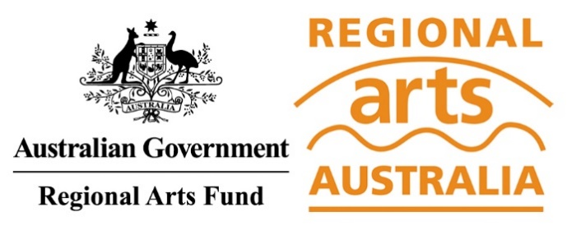
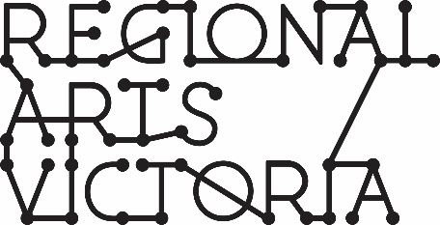

Your Acquittal

After the project an acquittal will need to be submitted.
- For Relief Grants: 6 weeks after the project’s end date
- For Recovery Grants: 13 weeks after the project’s end date
- For Renewal Grants: 13 weeks after the project’s end date

Information about what will be required should an application be successful is available on our website: rav.net.au/funding-opportunities/regional-arts-fund/info

Non-compliance with acquittal conditions may result in the recipient being ineligible for future funding rounds until their acquittal has been submitted and accepted.

Purchase of assets will only be considered where it is demonstrated to be more cost effective than hire.
Regional is defined as a postcode that is MMM Classification 2 or above. Check how your location is classified here: doctorconnect.gov.au/locator
Applicants are encouraged to seek multiple sources of funding, but must not cover the same costs with multiple sources of funding.

