The Joan and Betty Rayner
Australian Children’s Theatre Foundation Commission
2021 Guidelines

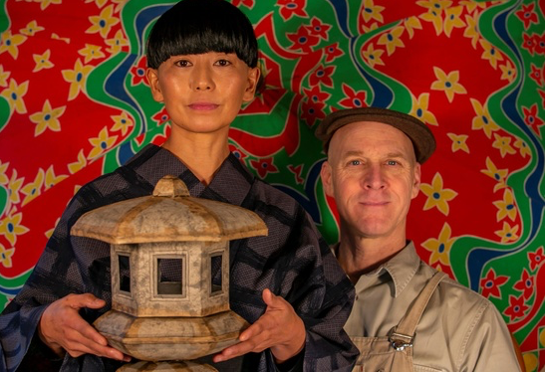

Image: Toro & Rose, by Mark Penzak, (2019 Commission)

Australian Children’s Theatre Foundation
JOAN AND BETTY RAYNER ACTF COMMISSION

COMMISSION GUIDELINES

Background
The Australian Children’s Theatre was created by sisters Joan and Betty Rayner in 1948. Joan and Betty were seasoned performers, touring across Australia and the world. Countless Australian children were introduced to the pleasures of live theatre by attending the widely acclaimed drama, music, mime and puppet productions of the Australian Children's Theatre. The performances were always lively, engaging and uplifting; and did much to build bridges of love and understanding between people from different cultures and traditions. The Australian Children's Theatre also enabled outstanding international artists and companies to perform to delighted audiences in Australia. Joan Rayner established the Australian Children’s Theatre Foundation (ACTF) to keep alive the aims of the Australian Children's Theatre.

The ideals of the Foundation are:

- to foster in children a widening interest in the arts and humanity
- to foster understanding between people of different countries and cultures, and/or the telling of Indigenous stories
- to use theatre to explore and present stories from around the world including those of recent arrivals to Australia

The ACTF continues to be a strong supporter of theatre for young children across Victoria and they will be commissioning or supporting the creative development of a new performance work, up to the amount of $20,000.
Commissioning Guidelines
Expressions of Interest will be called for in the year preceding the commissioning year. Applications will be administered by Regional Arts Victoria’s Arts & Education Manager early in the commissioning year (2021). All applications that meet the guidelines will be forwarded as appropriate to the ACTF Chairperson and Trustees, for discussion in March 2021.

The ACTF will commission (in whole or in part) the production of a small scale theatre piece specifically devised for primary school students, to the point of being tour ready. It is intended that the successful applicant will be able to tour the new work within Regional Arts Victoria’s Arts & Education program in 2022. Should external circumstances require, the timeline of the development of the work and/or the touring timeline can be extended. The new work may already be in early development at the time of application, however, the commission cannot provide funds for the remount of an existing work. The successful commission will enter into a contract with the ACTF and will include provision for royalties payable to the ACTF following the tour. The commission will be paid in stages on the successful completion of each stage or milestone as set out in the commissioning contract and the ACTF reserves the right to terminate the commission in the event that the production or the progress of its development or its timing is considered by the Trustees to be unsatisfactory or is not consistent with the application. ACTF encourages alternative approaches to creative processes and how these will be used in the development and implementation of the work.

Submissions must meet the following guidelines:

- Clearly describe how the project aligns with the ideals of the ACTF (see above)
- Reflect high quality imaginative and creative storytelling in a live performance that is well developed and presented
- Artists need to describe the end product they are aiming for and the stimulus they are aiming to provide
- Reflect the global diverse culture, be uplifting, promote positive messages for children and young people and reflect a sense of humanity
- Stimulate ideas and generate pre and post-performance activities and discussion
- Be suitable for any year level or levels within the foundation to Year 6 (F-6) range (i.e. primary)
- Be designed to be efficient and viable for touring within the Arts & Education touring model of Regional Arts Victoria – ie. small scale, preferably not more than 4 performers
- Include a sound and viable budget
- The project must reflect that the ACTF commission will be the main source of funding. Larger scale projects with multiple funding sources will not be assessed
- If the applicant has previously been successful for an ACTF commission or fellowship they will not be eligible to apply for the next two rounds of each submissions

The successful applicant will be required to sign a Contractual Agreement with the Foundation in respect to the grant based on terms and timelines set down by the Foundation. This will include acknowledgement of the ACTF Commission in all marketing materials produced. The successful applicant will also be aware and compliant with the Child Safe Standards as required by State Government of Victoria from January 2017. For Further information: https://dhhs.vic.gov.au/publications/child-safe-standards
The final decision will be made by the ACTF Trustees.

Australian Children’s Theatre Foundation
APPLICATION PROCESS & MORE INFORMATION

For more information on the ACTF Commission and application support access:
Megan Collier, Arts & Education Coordinator at Regional Arts Victoria
P: 0477 846 014
E: mcollier@rav.net.au
Available: Monday to Wednesday, during business hours

Applications must be submitted by 5pm on Friday 29 January 2021. Late or incomplete applications will not be considered.

Successful applicants will be notified by mid March 2021.

Applications are to be submitted as a PDF in electronic format, by emailing education@rav.net.au using the subject line ‘ACTF 2021 Commission Application’.

Please note, once you have emailed through your submission, you will not be able to make any further edits to the document or support materials. We will email you to confirm your submission.

