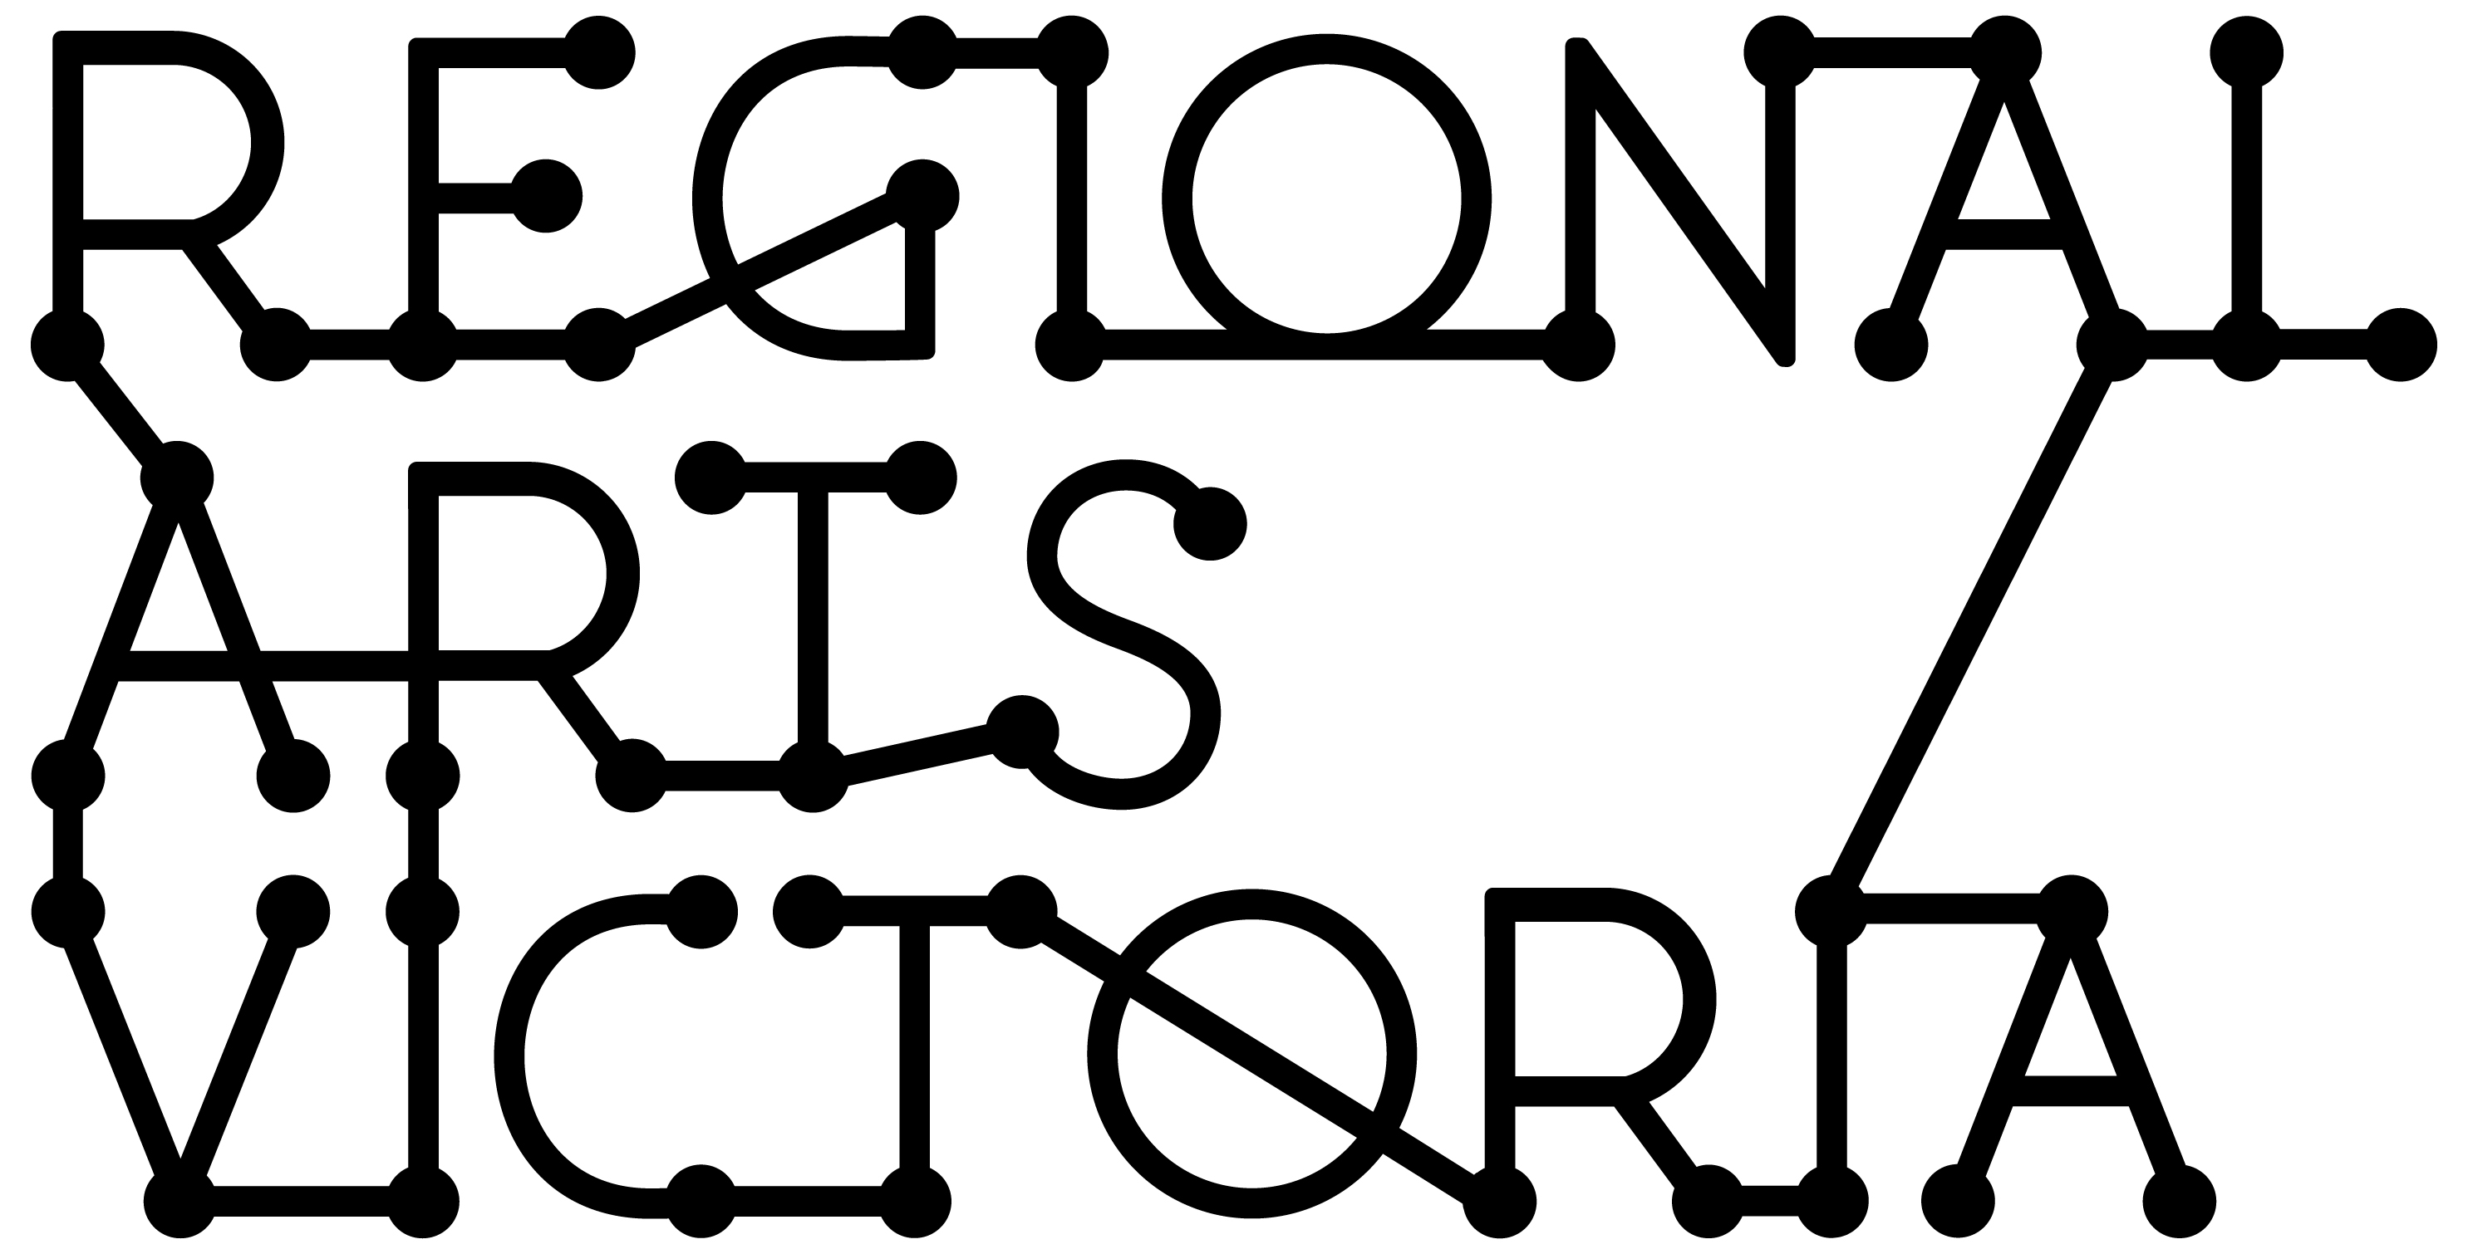

**Presenter Pack**

Big Tops & Tiny Tots Circus Show

# Big Tops & Tiny Tots Workshops on offer

Big Tops & Tiny Tots has an optional accompanying workshop after the show. Workshops are a fun 30 minute class introducing kids to a range of circus and physical skills including skipping, scarf juggling and balancing. With a focus on developing fine and gross motor skills, teamwork & communication, workshops are a great way for kids to put into practice some of the tricks they’ve seen in the show.

Workshop duration: 30 minutes

Maximum number of participants: 30 children

Age range: 3 – 6 Parental supervision: Parents/guardians are encouraged to join in with the workshop, and are required to remain in room to supervise their child.

Space requirement: Clear space approx 8x8m minimum, but the more the better. Usually, the performance space with any chairs cleared back & props tidied is enough room. Standard room height. Floor surface: Anything except concrete or asphalt. Minimum gap between end of show and start of workshop: 15 minutes

Workshop fee: $100 + gst when combined with performance.

# Big Tops & Tiny Tots Technical Specifications

**Theatres**

**Bump in:** 1hr first performance, 15 minute preset for subsequent performances.

**Bump in to first show:** 15 minutes

**Show duration:** 45 minutes

**Bump out:** 30 minutes

**Performing space:** minimum 5m (w) x 4m(d) x 3m(h).

**Audience:** Show works best if children can sit on level surface with performer. Eg, sitting on the floor with a rope line, parents on chairs behind or on floor with kids.

**Lighting:** House rig. Warm wash, no changes. Daylight is excellent, house lights remain up during performance.

**Sound:** House system, or artist can provide for small venues.

A) 3.5m aux jack within 10m of performer (side stage). Audio cues controlled by performer via Bluetooth watch.

B) Radio mic (provided by artist) - Samson Airline - 1/4" jack within 15m of performer

**Preschools / Kindergartens**

**Space:** minimum 4x4m, clear overhead (no hanging artworks or fishing line)

**Sound System:** Provided by artist

**Lighting:** Daylight or normal room lights

**Bump in time:** 30 minutes

**Bump out time:** 15 minutes

