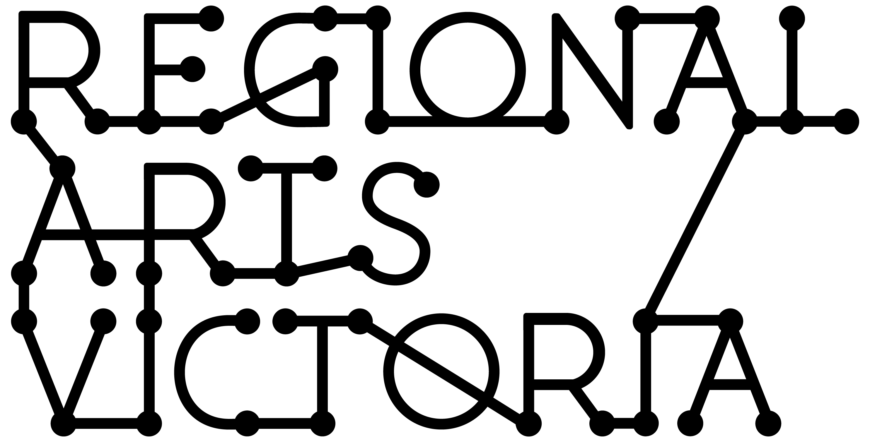

**Presenter Pack**

Mission Songs

Jessie Lloyd Music

# Mission Songs Project Workshops on offer

MSP Presentation: This is where Jessie goes into detail about the research and cultural significance of the project, singing only 4-5 songs and exploring further depth around the importance of these songs in regards to reconciliation and national identity. Group singing and Q&A is encouraged. Up to 50 people, 1-2hrs and fee is $1500.

MSP Kids: Jessie shares Aboriginal and Torres Strait songs and dances suited for children from kindergarten to primary school, fun and engaging and great way to learn about Indigenous culture. Covering basics such as simple language words, meaning of flags, traditional stories and learning songs. Up to 30 children, 50mins and fee is $1500.

MSP Youth: Jessie shares Aboriginal and Torres Strait songs and stories suited for young people in high school, informative and engaging and great way for youths to explore and discuss Indigenous culture. Covering basics such as language words, tribal groups and locations, meaning of flags, Indigenous historic events and learning songs. Up to 30 children, 50mins and fee is $1500.

MSP Choir Masterclass: Jessie facilitates sessions with local choirs and teaches them mission songs and their arrangements, also providing opportunity for song backgrounds and discussions. Encouraging the choirs to continue singing the songs once the session is completed (no restrictions in communities singing songs from MSP collection). Up to 100 singers, 1hr and fee is $1500.

MSP will be releasing a songbook in July 2017 to accompany its recently released album, this will be the main resource when delivering these sessions and will available for purchase.

# Mission Songs Project Technical Specifications



# Mission Songs Project Artist Bios

**Jessie Lloyd:** Originally from the tropics of North Queensland, Jessie Lloyd is an Aboriginal and Torres Strait Islander musician who performs a broad collection of Australian Indigenous songs. A vocalist, guitarist, bassist and ukulele player, Jessie earned her formal qualifications at Abmusic in Perth, WA in 2002.

An award winning composer, performer and creative entrepreneur, Jessie is a cultural practitioner of Aboriginal and Torres Strait Islander music. Dedicated to the continuation of cultural traditions through the presentation of both contemporary and traditional Indigenous music.

Jessie has travelled Australia in search of hidden songs to present this rare Indigenous narrative. From the Bass Strait to the Torres Strait and across the Arafura Sea, Jessie has spent time with Aboriginal and Torres Strait Islander senior song men and women, uncovering precious stories and songs from the mission days.

**Emma Donovan:** Emma Donovan is an Indigenous Australian singer and songwriter. She is a member of the renowned Australian musical

family the Donovan family. She started her singing career at age seven with her uncle's band, The Donovans. In 2000, she became a founding member of Stiff Gins, leaving the band three years later to release the solo album Changes in 2004. She performs with The Black Arm Band, and released a solo EP, Ngaaraanga, in 2009.

Emma is a passionate singer, songwriter and collaborative vocal artist whose musical expression is a fusion of roots, reggae and soul. Her melodic style is widely known for her distinctive husky voice. Her lyrical content speaks of significant stories and personal accounts that she sings with confidence and pride. Emma's connection to her people is a result of her contribution to community initiatives, which is an important commitment to her work.

Today, Emma continues to join ensemble bands such as 'Mission Songs Project', 'The Black Arm Band' and 'Barefoot Divas', and has now embarked in an exciting new collaboration with Melbourne based band 'The Putbacks'.

**Deline Briscoe:** Deline Briscoe is a Strong Yalanji Woman hailing from Far North Queensland, she had called Melbourne home from 2005 2015. Her songs are a delightful mix of roots soul, gospel and tasty rhythmic grooves. Songs that tell stories, empower and inspire ALL that see, hear and feel her intoxicating live performance. The sound of Rainforest Soul can be heard in songs sung in her mother tongue, you will feel her deep connection to spirit and land. Her former outfit The Briscoe Sisters performed across Australia, including at WOMAD and Big Day Out and released their debut EP Check It Out. The Briscoe Sisters were nominated Most Promising New Talent at the Deadly Awards in 2004, and the following year received the Port Fairy Folk Festival award for Maton's Young Talent o the Year. In 2006 they recorded Live @ The Tanks, and went on to play before Jimmy Cliff at WOMADelaide.

Since 2009 Deline has worked with prolific aboriginal artists such as Bart Willoughby, Archie Roach, Lou Bennett, Emma Donovan, also a part of The Black Arm Band ensemble with whom she has toured, selling out shows Australia wide and internationally SINCE 2009.

**Jessica Hitchcock:** Sydney based singer/songwriter Jessica Hitchcock is an up-and-coming performer to keep your eye on. Her charismatic stage presence and versatile performance sphere draw on over 15 years of musical experience. Jessica is a graduate of the Conservatorium of Music and has studied with renowned vocal coaches Joy Yates and Patricia Ortel, following training with Craig Carnella in New York - having won the coveted ASCAP Scholarship. Whilst in the States, Jessica was a featured artist at both "Don't Tell Mamma" and "Birdland".

The last five years have seen Jessica transition from a Jazz background into the world of Opera working with professionals such as Gayle Edwards on the workshopping of "Cloud Street". During this time she has been contracted to the Short Black Opera company, performing the first Indigenous opera, 'Pecan Summer' by Deborah Cheetham. The production has seen four seasons, touring across Australia to places including Shepparton, Melbourne, Perth and Adelaide. Jessica is a true professional. She radiates, having an amazing ability to connect with her audience. Jessica is currently performing and touring with Mission Songs Project.