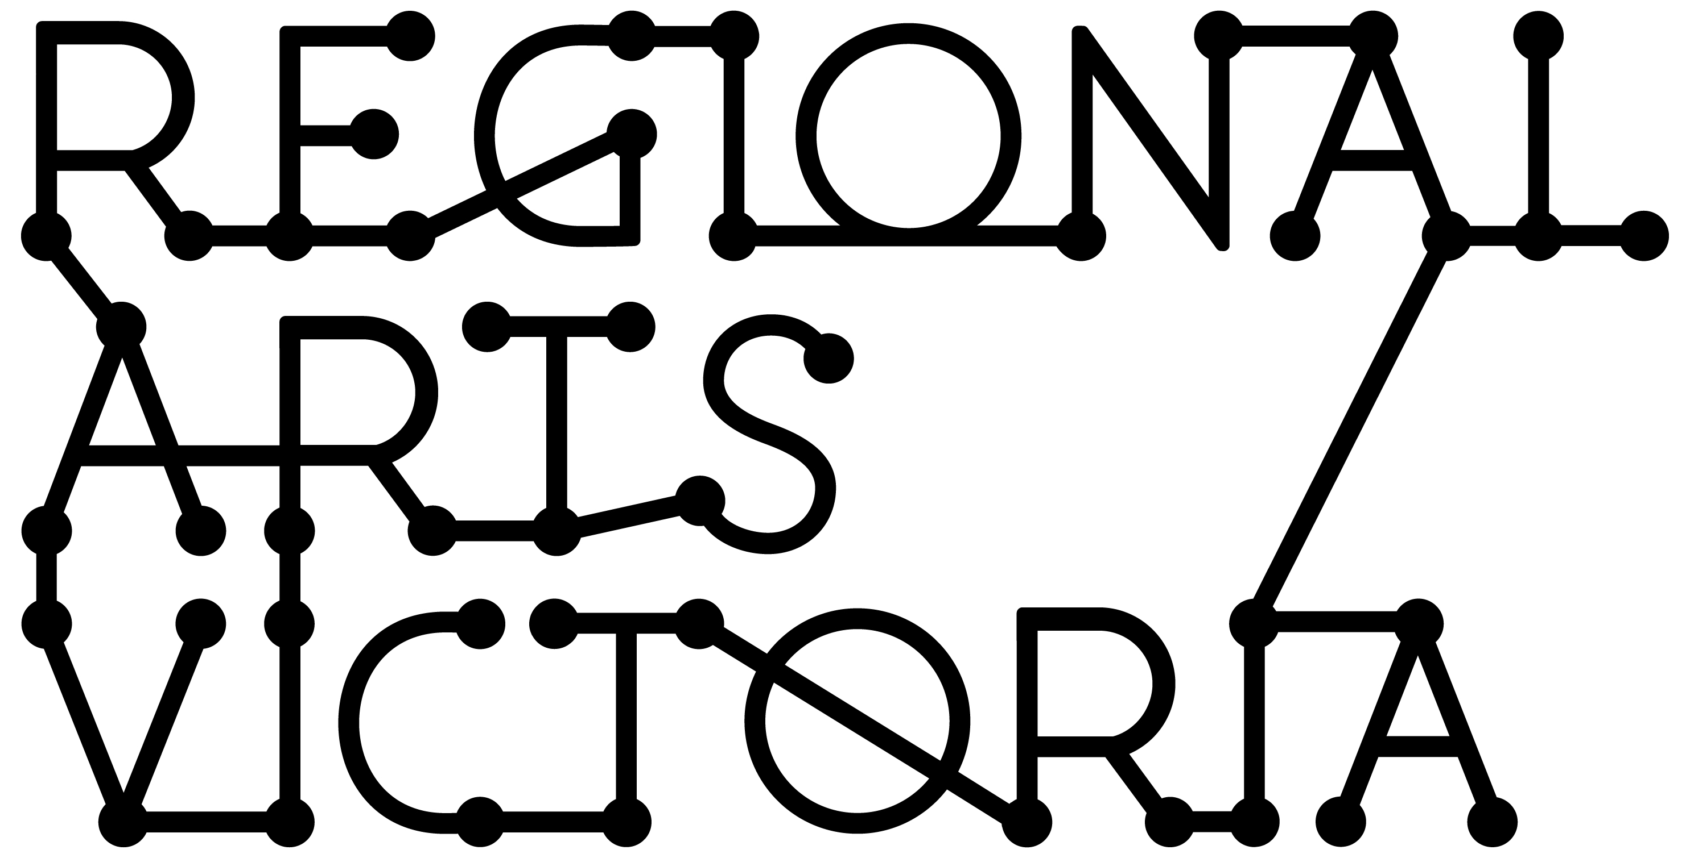

GUIDELINES

Connecting Places Program
Expression of Interest for 2019 touring

2018 Connecting Places Program Guidelines

Regional Arts Victoria’s Connecting Places program delivers high quality arts experiences to community venues across the state. This expression of interest if for touring in 2019

Expressions of interest open on Monday 7 May and close 1pm Monday 11 June 2017

Important Information
The work that forms the Connecting Places program will be able to tour to small halls, churches, libraries, public bars and other community spaces in regional areas. Whilst these venues & locations can be incredibly inspiring, it’s important to note that touring to community run spaces often calls for long days and can involve considerable preparation prior to the tour.
It’s important to note that if you are chosen to be part of Regional Arts Victoria’s Connecting Places program, this will not guarantee you a tour or one off engagements. Regional Arts Victoria will advocate for your project and endeavor to build a tour but it is subject to presenter interest.

Please carefully consider whether Connecting Places is the right fit for you and your project.

Connecting Places Selection Criteria
The following key criteria’s will need to be addressed in order for your expression of interest to be competitive:
- The project is innovative, high-quality and entertaining
- The project is relevant to regional communities
- The company’s technical requirements adapt to a variety of performance spaces with limited technical provision from the venue
- The project is able to bump in and perform on the same day
- The company is able to demonstrate a self-sufficient touring team that will not require much technical support from presenters
- The company has included strong marketing materials, including video
- The company is able to demonstrate the ability to work with volunteer community leaders who are seeking projects that will connect with and enrich their regional communities

Consideration should be given to the scale of the project, Connecting Places is unlikely to be able accommodate large touring parties or project with complex technical requirements
Your application will need to clearly demonstrate an ability to tour to small regional communities.

The Application process

Applying to this programs is a two stage process:
1) Online form - outlining your company, fees and technical elements

2) Downloadable Pitching & Marketing Toolkit document – outlining your work, and how it is best marketed.

Incomplete EOI's will not be eligible and cannot be assessed.

What if I need help?
We strongly encourage you to call Connecting Places Manager Rosie Dwyer on 9644 1807

If you’re stuck on the Pitching & Marketing document, or would like some more detailed information about some of the elements, we have set aside some times to make a phone meeting with our Communication Coordinator, who will be very happy to assist in any issues you may have. Please see the times below, and email to book a time in

Wednesday 9th May 11am -1pm
Wednesday 16th May 11am -1pm
Wednesday 23rd May 11am -1pm
Wednesday 30th May 11am -1pm
Wednesday 6th June 11am -1pm

IMPORTANT DATES
Monday 7 May, 2017 | Expressions of Interest Open | Applications can be made online bit.ly/2019RAVEOIs  and via the downloadable  Pitching & Marketing Toolkit
Monday 11 June, 1pm | Expressions of Interest Close | Late submissions will not be accepted
June 2018 | Shortlisting Process | All applicants will be notified at the end of the shortlisting process.
August 2018 | 2019 Program launched | Program launched to Community Presenter network

Applicants are strongly encouraged to contact Regional Arts Victoria to discuss your application and its suitability for the Connecting Places Program and application process.

People who identify as Aboriginal and Torres Strait islander are strongly encouraged to apply.

For more information, questions or support regarding the application process please contact

Rosie Dwyer
Connecting Places Manager
Phone: (03) 9644 1807
Email: rdwyer@rav.net.au

