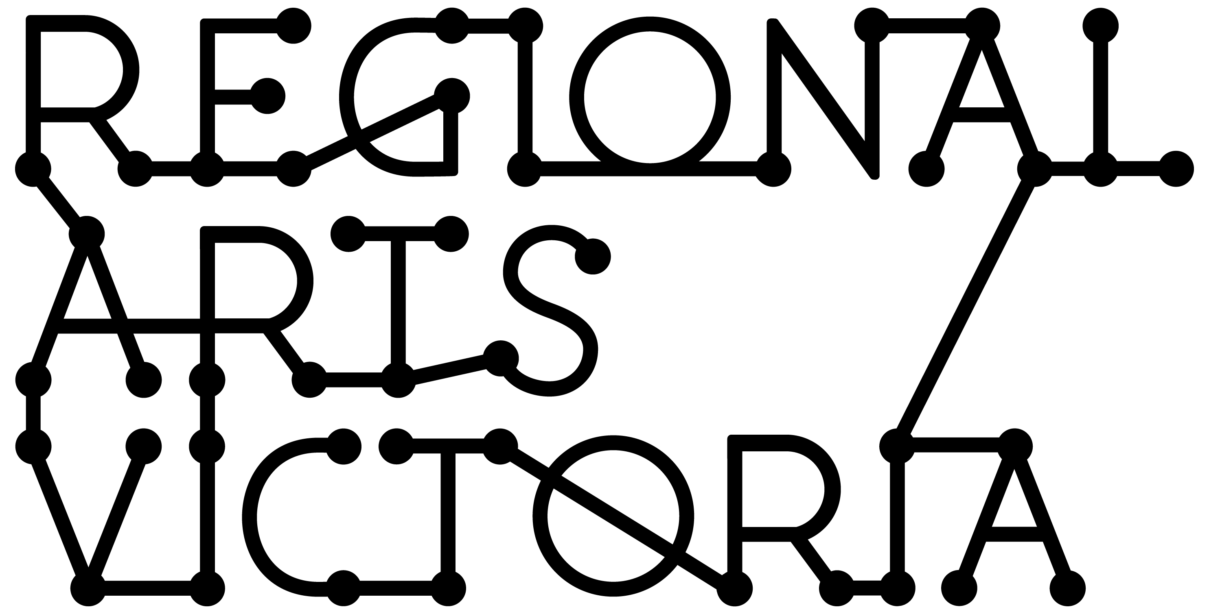

GUIDELINES
Arts & Education Incursion Program
Expressions of Interest for 2019 Program

2019 Arts & Education Program Guidelines

Regional Arts Victoria’s Arts & Education program tours high quality and educationally relevant arts experiences to young people across Victoria from early years through to VCE. We work to provide accessible arts experiences and encourage students to participate in the arts as both artists and audiences.

Expressions of interest open on Monday 7 May and close 1pm Monday 11 June 2017

For almost 50 years Regional Arts Victoria have delivered inspiring arts experiences across Victoria.

The Arts & Education program delivers high-quality arts to young people, so they have opportunities to observe, experience, and make! The program is designed to be child-centred and interactive with links across the Victorian Curriculum. This program firmly focuses on The Arts - Drama, Music, Dance, Visual Arts, Visual Communication and Design. We are keen to enrich the learnings of young people, and put the A into STE(A)M to give them skills for life.

We aim to assist young people to dream, innovate, think, connect and collaborate. We are interested in finding ways for their education to be relevant and meaningful – to develop the whole child and recognise their lifelong learning. The positive impact of a high-quality arts program is that it is stimulating and uplifting, increasing motivation and concentration, creative thinking, and social skills from shared experiences. We pride ourselves on providing relevant and exciting activities that inspire young minds and stimulate critical and creative thinking.

The Arts & Education Program engages young people from early years to VCE, and consists of performances, residencies and workshops which can take place in schools, or clusters, community halls, galleries and performing arts centres, or feature in local events such as festivals, school holiday programs or camps.

The program also focuses on professional development opportunities for teachers and artists. Facilitating opportunities for teachers and artists to develop the tools to deliver impactful and sustainable arts experiences to their students and communities.

The following submission process is for artists / producers and companies who wish to present work on a predominantly INCURSION basis, directly into schools and community venues which do not always have access to professional theatre facilities.

What we are looking for:
- The project is innovative, high-quality and entertaining.
- The project is appropriate to a school and/or community context.
- The project stimulates ideas and generates pre and post-performance discussion.
- The project has a holistic approach to education, including opportunities for deeper engagement – residencies, workshops, forums etc.
- The project embodies excellent practice in the presentation of the arts for children and young people.
- The project is low tech and adaptable to a variety of spaces, consists of a compact touring party, is tour ready and can generally fit inside a single Toyota Hiace van or similar.
- The company has included strong marketing materials, including video and a framework for teacher resource material.
- The project demonstrates clear links to the Victorian curriculum.

Visit Regional Arts Victoria’s website for the works that have been included in the current Arts & Education program.

Important Dates
Monday 7th May 9am – EOIs open
Monday 11th June 1pm – EOIs close
18-20 July – applicants notified
Thursday 6 September – Arts & Education Program launched

Please note: Some dates are subject to change.

Submission Guide
The following guide will assist applicants to prepare for and complete the Arts & Education Program Online Expression of Interest form.

Applicants are strongly encouraged to contact Regional Arts Victoria to discuss your application and its suitability for the Arts & Education program and application process.
Please email Pippin at pdavies@rav.net.au to make an appointment to discuss your application. Appointment times will be available on Monday or Friday mornings between 10am-12pm.

About You

Title of the work
This is the title of the performance or workshop you wish to program into schools.

Company/Producer
This is the name of the Company, Organisation, or Artist/s who are responsible for the work, and who are lodging the application.

Primary contact person
Please include current and correct details for the primary contact in charge of bookings and contract negotiations. The primary contact is the person all correspondence regarding your involvement with the Arts & Education program will go to. If you have more than one contact, delegate one person to act as this primary contact, who will coordinate providing information to the appropriate person within your company.

ABN
Regional Arts Victoria generally requires you to supply us with your Australian Business Number (ABN), or a Statement of Supplier form, in order to provide payment for your services as part of the Arts & Education Program. If you are unsure of your ABN, you can look it up at: http://abr.business.gov.au/

Statement by Supplier forms are available on the ATO site: Statement by Supplier

GST
Please indicate if you are registered for GST. If you are unsure whether you are registered for GST, leave this field blank.

Which state are you or your company based?
Please select the location of where you or your company is based. If you are located in more than one state, please indicate your primary location associated with this work.

Note: The Arts & Education program generally does not program work from companies, organisations and artists who are based outside of Australia.

Victoria Child Safe Standards and Working with Children Checks
The Child Safe Standards are now compulsory minimum standards for all Victorian organisations that provide services for children including Victorian early childhood services and schools. Regional Arts Victoria’s Child Safe Standards Policy (CSS) can be found on our website: Child Safe Standards. All artists who are successfully programmed in the Arts & Education program need to be compliant with the CSS, which includes holding a current Working with Children Check (WWC).

Interstate equivalents to the Victorian WWC are accepted for child related work in Victoria, where the length of engagement is 30 days or less. Teachers who are currently registered with the Victorian Institute of Teaching (VIT) are exempt from completing a Working with Children Check.

To apply for a Working with Children Check, visit: http://www.workingwithchildren.vic.gov.au.

Please attach a scan or photograph of current WWC or VIT for each person in your touring party to your application.

Public Liability Insurance
Regional Arts Victoria requires a valid Public Liability Certificate of Currency covering the activities associated with your work prior to it entering schools and venues. Please attach a copy of this Certificate of Currency in your application.

Current Driver’s License
Regional Arts Victoria recommends that 2 people in your touring party have their full Australian driver's license with at least one driver over 21 years of age to share the load of driving while on tour. Each touring party must have at least one driver who meets these requirements for car hire and insurance purposes.

About the Project

Engagement Type
On The Road
On The Road is a touring format where the artist/s or company is contracted for a set period within the school year and is paid a weekly fee.

On Call
On Call Program is a responsive format that allows schools and venues to book programs on an ‘on demand’ basis throughout the year. On Call programs are generally paid a per show/workshop fee. All applicable travel costs which are passed on to the hirer.

Residency
Residency offerings are generally programs that offer deeper engagement for an extended period of time (more than one day – week, or across a term).

Note: Regional Arts Victoria manages all aspects of marketing and bookings for all Arts & Education programs, including travel, accommodation and itineraries where relevant. For specific information on bookings policy and procedure, please contact the Arts & Education Manager.

Indicate your tour availability
Please select the school terms your work will be available to tour. Outline any dates you know you will NOT be able to present your work.

Offering Type
Please indicate the main format of your work. (Please select one)

- Performance: A work that is ‘viewed’ by an audience. This may include workshop or interactive elements, but it is considered a performance for our purposes if not all audience members are participating.

- Workshop: A work where participants are actively involved in the creation of their own artwork and/or the development of new skills.

- Residency: A work where participants engage intensively with artists over a period of time greater than one day.

Project description
This is where you will introduce us to the work, what it is and why it would work well in an educational setting. This should be no more than 500 words in total, but should provide a comprehensive overview of your work.

Artforms
Please indicate which artforms are involved in this work.

Year Level Appropriate
Please indicate which year levels your work would be appropriate for. Consider the content, themes and complexity of the work. Note: You can create additional options that are more specific to your work by selecting ‘other.’ For example, your work might only be appropriate for Years 4 – Year 8.

Content Warnings
Please indicate if there should be any content warnings associated with the work, so that teachers can prepare their students appropriately.

Additional Offerings
Additional Offerings are not essential as part of the Arts & Education program, however some artists/companies choose to offer optional additional workshops that extend the themes of a performance, a residency, or teacher professional development associated with their main offering.

If you have an additional offering, indicate the format and provide a brief summary of this offering. Tip: Dot points are fine, as long as the person assessing your application has a good idea of what you do, for how long and in what order.

Curriculum Content

Curriculum links and educational content
Our team will provide appropriate curriculum links to relevant learning areas. At this stage, please provide an indication of where you believe your work fits into the Victorian curriculum areas. Please select as many as applicable.
victoriancurriculum.vcaa.vic.edu.au

Technical Specifications

Touring Party
Please list the names and roles of each member of your touring party – performers and Tour Manager / Tech if you have one.

Duration and capacity of Offering
Please indicate the amount of time you need to bump in, the duration of the performance or workshop, the length of time allocated to a Q&A if relevant, and the time required to reset for another performance or workshop in the same venue, the amount of time you’d need to bump out, and any time allocated to a pre-performance talk.

Venue requirements
Arts & Education programming generally should be adaptable to a wide variety of spaces, as not all venues will have purpose built theatres. Please indicate the amount of space you’ll require to deliver your work, including height if Physical performance, seating preference for audience, what types of venues it can be performed in, and any flooring types that are unsuitable for the work.

Additional room requirements
These are items you expect the school to provide, and could include, a whiteboard, tables and chairs, internet access (not always available), a projector and screen, access to water etc. Please select all that apply to your work, or ‘no additional room requirements’ if applicable.

Add any additional comments regarding room requirements can be added in the comments box provided.

Staging Requirements
These are stage elements you intend taking on tour that are not expected to be supplied by Regional Arts Victoria or the school/venue. E.g. Set pieces, props, technology and equipment hire etc. Any costs associated with the hire or purchase of these elements should be factored into your show fee.

Your Fee

Weekly Fee
Your weekly fee is the full fee you expect to be paid for each week that you’re contracted for the ‘On the Road’ or a Residency touring program, less any touring costs. There is no need for full budget breakdown. If you are unsure, please use the LPA or MEAA (if a member) agreements to calculate your costs.
Do not include vehicle hire, petrol, accommodation, meals and incidentals in your weekly fee, these costs are covered by Regional Arts Victoria.

IMPORTANT: The Arts & Education program does not cover remount fees. Our touring shows and workshops need to be fully tour ready.

Once off Fee
A once off fee is what we’ll pay you for each booking, if you are included in the On Call or Residency programs. Additional fees for travel are passed on to the hirer (school/venue), and will be paid on top of this fee where applicable.

IMPORTANT: PLEASE don’t include vehicle hire, petrol, accommodation, meals and incidentals in your engagement fee, these costs are covered by the hirer where applicable.

Additional Information

Can we see your show?
The best way to assess your application’s suitability is for us to see the show or workshop. Please provide any dates and venues where a member of Regional Arts Victoria’s Programming team can see your work – preferably before July 2018.

Other complimentary programs
Tell us where else you’re pitching your work. For VCE level Theatre and Drama studies, Regional Arts Victoria recommends you also apply for the VCAA playlist.

Teacher Resources
Please use the template to provide relevant information relating to your work that can be formulated into a teacher resource.
You can view examples of teacher resources on our website.

Pitching & Marketing Toolkit Document
This is a downloadable word document that you will need to complete and upload as part of your submission application. You can download the document from our website.

This document has been design in a download format, as we recognise some time may be required to prepare everything required in this document. However, once you have completed it, you will have a comprehensive marketing toolkit that you can use for future selling and marketing of your work throughout the life of your project.

For more information, questions or support regarding the application process please contact:
Pippin Davies
Arts & Education Manager
Phone: 9644 1808
Email: pdavies@rav.net.au

